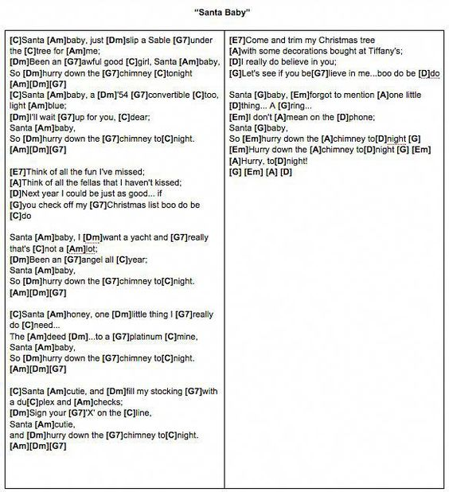

Santa Baby
Michael Buble’ version

C Am Dm G7 C Am
Santa baby, slip a Rolex under the tree, for me
Dm G7 C Am Dm G7 C Am, Dm,G7
I've been an awful good guy, Santa buddy, and hurry down the chimney tonight
C Am Dm G7 C Am Dm G7 C
Santa buddy, a sixty five convertible too Steel blue; I'll wait up for you, dude
Am Dm G7 C Am Dm G7
Santa buddy, and hurry down the chimney tonight

E7 A A7
Think of all the fun I've missed. Think of all the hotties that I never kissed
D G G7 Dm G7 C
Next year I could be just as good, if you check off my Christmas list Boo doo be doo

C Am Dm G7 C Am
Santa pally, I want a yacht and really that's not a lot
Dm G7 C Am Dm G7 C Am Dm G7
I've been a sweetie all year, Santa buddy, so hurry down the chimney tonight
C Am Dm G7 C Am Dm G7 C
Santa buddy, one thing that I really do need: the deed, to a platinum mine
Am Dm G7 C Am Dm G7
Santa pally, so hurry down the chimney tonight

C Am Dm G7 C Am Dm G7 C
Santa buddy, fill my stocking with Canucks tix, for kicks, throw me on the first line
Am Dm G7 C Am Dm G7
Santa baby, so hurry down the chimney tonight

E7 A A7
Come and trim my Christmas tree with some decorations bought at Mercedes
D G G7 Dm G7 C
I really do, believe in you, now let's see if you believe in me Boo do be doo
C Am Dm G7 C Am Dm G7 C
Santa poppy, forgot to mention one little thing: Cha-ching .No I don't mean as a loan
Am Dm G7 C Am Dm G7 C Am
Santa buddy, so hurry down the chimney tonight, Hurry down the chimney tonight
Dm / G7 / C /
Oh hurry down the chimney tonight

Source: LyricFind Songwriters: Joan Javits / Philip Springer / Tony Springer

