Anna Arthur Alexander

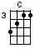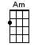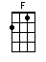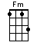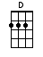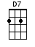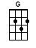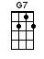
Bridge
INTRO Vamp: C Am C Am repeat  C Am  Anna, you come & ask  C Am  me, girl To set you  C Am  free, girl You say he loves you  C Am F G  more than me; Well, I will set you free  C Am C Am  Go with him (Anna) Go with him (Anna)  C Am  But Anna Girl, before you  C Am  go, now I want you to  C Am  know, now that I still  C Am F G  love you so But if he loves you more,  C C7  go with him | F F F F  All of my life I've been searchin' for a girl  C Csus4 C C7  To love me like I love you-ooo  F F  But every girl that I've ever had  Fm Fm(7)  Breaks my heart and leaves me sad  D7 D7 G <G7>  What am I, what am I supposed to do? Oh-oh-oh-oh  C Am  Anna Just one more  C Am  thing, girl Just give back my  C Am F G  ring to me And darlin' you'll be free  C Am C Am  To go with him Go with him.

