**Feelin’ Groovy – 59th St. Bridge Song**

**By Paul Simon – 1967  
Arrangement by Lisa Kljaich – The Ukulele Fool –** [**Tutorial Video**](https://www.youtube.com/watch?v=KcSCghKg8Uo)

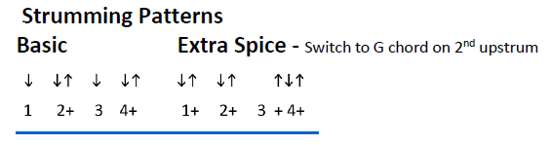*Starting vocal pitch – open E string*

*Each chord gets either half of a basic strum, or half of an extra spice strum.*

**Intro: C G Am7 G - 2x**

**C G Am7 G C G Am7 G**

Slow down you move too fast, You gotta make the morning last

**C G Am7 G C G Am7 G**

Kickin' down the cobble stones, Looking for fun and feeling' groovy

**Refrain**

**C G Am7 G**

**C G Am7 G**

Babada Da da Da da feelin' groovy,

**C G Am7 G**

Da da Da da feelin' groovy

**C G Am7 G C G Am7 G**

Hello lamp post, whatcha knowing? I've come to watch your flowers growin'

**C G Am7 G C G Am7 G**

Ain't cha got no rhymes for me? Dootin doo doo feeling groovy. **Refrain**

**C G Am7 G**

I've got no deeds to do, no promises to keep

**C G Am7 G**

I'm dappled and drowsy and ready to sleep

**C G Am7 G**

Let the morning time drop all its petals on me

**C G Am7 G**

Life, I love you, all is groovy

**C G Am7 G - Repeat 4 times**

**C G Am7 G G G ↓**

Babada Da da Da da feelin' groovy - **Repeat 3 times and fade**