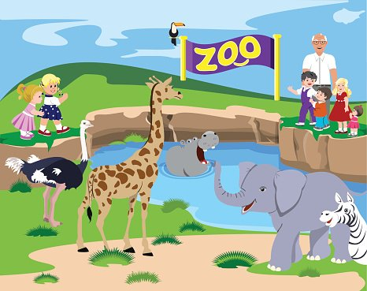
They All They Ask'd for You (The Meters 1976)
Neville Modeliste (T. Miller V. 4)
C / G7 / C / / / / G7 / / C / G7 / C / / / / G7 / / C
C G
I went on down to the Audubon Zoo and they all asked for you.
G7 C
They all asked for you. (for who?) Well, they even inquired about you.
G
I went on down to the Audubon Zoo and they all asked for you (for me?)
G7 C
The monkeys asked, the tigers asked, and the elephant asked me too.
C G7 C G7
Bomp Bomp Bomp BOMP! BOMP! Buh Deeba Doomp Beemp Bomp
C G7 C G7 C
BOMP! BOMP! Buh Deeba Doomp Beemp Bomp

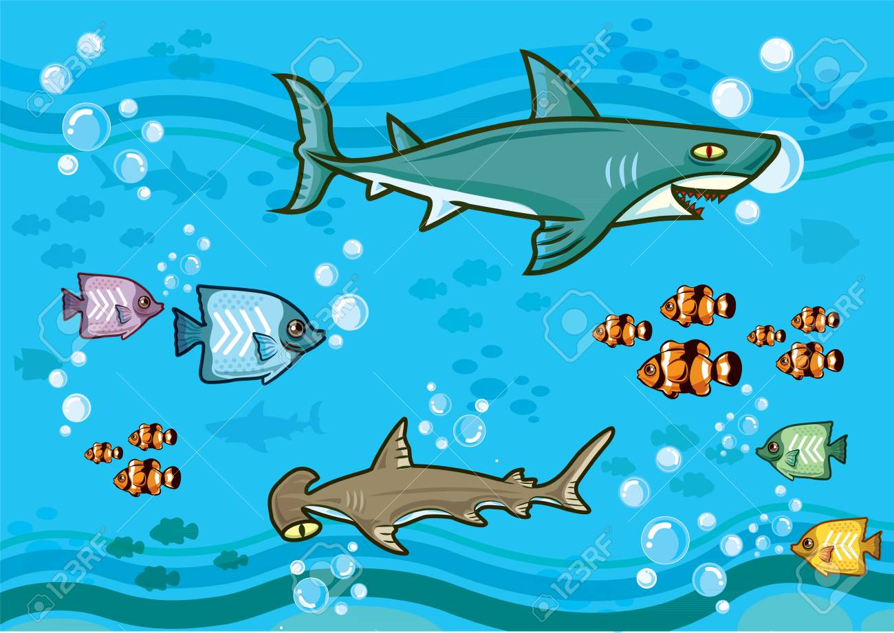
C G
I went on up to the Big Ole Sky, and they all asked for you. (for who?)
G7 C
They all asked for you. (for me?) Well, they even inquired about you.
C G
I went on up to the Big Ole Sky, and they all asked for you.
G7 C
The ducks asked, the eagles asked, and the buzzard asked me too

C G7 C G7
Bomp Bomp Bomp BOMP! BOMP! Buh Deeba Doomp Beemp Bomp
C G7 C G7 C
BOMP! BOMP! Buh Deeba Doomp Beemp Bomp

Page 2 They All Ask’d For You

C G
I went on down to the deep blue sea, and they all asked for you. (for who?)
G7 C
They all asked for you. (for me?) Well, they even inquired about you.
C G
I went on down to the deep blue sea, and they all asked for you. (for me?)
G7 C
The shark asked, the whale asked, and the barracuda asked me too.
C G7 C G7
Bomp Bomp Bomp BOMP! BOMP! Buh Deeba Doomp Beemp Bomp
C G7 C G7 C
BOMP! BOMP! Buh Deeba Doomp Beemp Bomp

C 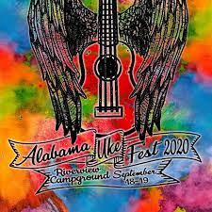 G
I went online to Alabama Uke Fest, and they all asked for you. (for who?)
G7 C
They all asked for you. (for you!) Yeah, they even inquired about you.
C G
I went online to Alabama Uke Fest, and they all asked for you. (for me?)
G7 C
The tenors asked, the sopranos asked, and the banjoleles asked me too.
C G

C G
They all asked for you (in the morning), they all asked for you (in the evening)
G7 C
Everybody there, wanna know where, they all asked for you.

C G
They all asked for you (in the morning), they all asked for you (in the evening)
G7 C G7 / C /
Everybody there, wanna know where, they all asked for you.

They All They Ask'd for You
(The Meters 1976) Neville Modeliste
T. Miller – V. 4
C / G7 / C / / / / G7 / / C / G7 / C / / / / G7 / / C
C G
I went on down to the Audubon Zoo and they all asked for you.
G7 C
They all asked for you. (for who?) Well, they even inquired about you.
G
I went on down to the Audubon Zoo and they all asked for you (for me?)
G7 C
The monkeys asked, the tigers asked, and the elephant asked me too.
C G7 C G7
Bomp Bomp Bomp BOMP! BOMP! Buh Deeba Doomp Beemp Bomp
C G7 C G7 C
BOMP! BOMP! Buh Deeba Doomp Beemp Bomp

C G
I went on up to the Big Ole Sky, and they all asked for you. (for who?)
G7 C
They all asked for you. (for me?) Well, they even inquired about you.
C G
I went on up to the Big Ole Sky, and they all asked for you.
G7 C
The ducks asked, the eagles asked, and the buzzard asked me too

C G7 C G7
Bomp Bomp Bomp BOMP! BOMP! Buh Deeba Doomp Beemp Bomp
C G7 C G7 C
BOMP! BOMP! Buh Deeba Doomp Beemp Bomp

C G
I went on down to the deep blue sea, and they all asked for you. (for who?)
G7 C
They all asked for you. (for me?) Well, they even inquired about you.
C G
I went on down to the deep blue sea, and they all asked for you. (for me?)
G7 C
The shark asked, the whale asked, and the barracuda asked me too.
Page 2 They All Ask’d For You

C G7 C G7
Bomp Bomp Bomp BOMP! BOMP! Buh Deeba Doomp Beemp Bomp
C G7 C G7 C
BOMP! BOMP! Buh Deeba Doomp Beemp Bomp

C G
I went online to Alabama Uke Fest, and they all asked for you. (for who?)
G7 C
They all asked for you. (for you!) Yeah, they even inquired about you.
C G
I went online to Alabama Uke Fest, and they all asked for you. (for me?)
G7 C
The tenors asked, the sopranos asked, and the banjoleles asked me too.
C G

C G
They all asked for you (in the morning), they all asked for you (in the evening)
G7 C
Everybody there, wanna know where, they all asked for you.

C G
They all asked for you (in the morning), they all asked for you (in the evening)
G7 C G7 / C /
Everybody there, wanna know where, they all asked for you.

