River (Bill Staines, circa 1979) (D)
River by Bill Staines from "The Whistle of the Jay" (E)
¾ Time – Tempo 150 bpm

Intro D | G | D | G

D G D
I was born in the path of the winter wind.
A7
I was raised where the mountains are old.
D G D A7 D | D
Their springtime waters came dancing down, and I remember the tales they told.

D G D
The whistling ways of my younger days
A7
Too quickly have faded on by.
D G D A7 D | D
But all of their memories linger on, like the light in a fading sky.

Chorus
D G A7 D G A7
River, take me a-long in your sun-shine, sing me your song.
G D
Ever moving and winding and free.
G D G D
You rolling old river, you changing old river,
G A7 G D | D | D | D
Let's you and me, river, run down to the sea.

D G D
I've been to the city and back again.
A7
I've been moved by some things that I've learned.
D G D
Met a lot of good people an’ I called them friends,
A7 D | D
Felt the change when the seasons turned.

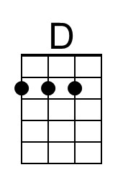 | 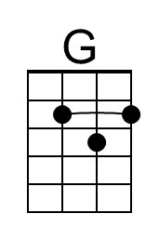 | 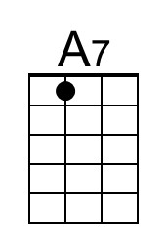 |  | Bari | 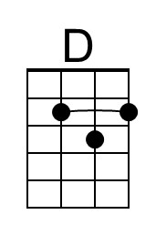 | 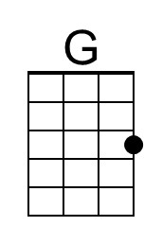 | 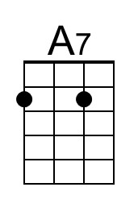
River (D) – Page 2
D G D
I've heard all the songs that the children sing
A7
And listened to love's melo-dies.
D G D A7 D | D
I've felt my own music within me rise, like the wind in the autumn trees.

Chorus
D G A7 D G A7
River, take me a-long in your sun-shine, sing me your song.
G D
Ever moving and winding and free.
G D G D
You rolling old river, you changing old river,
G A7 G D | D | D | D
Let's you and me, river, run down to the sea.

D G D
Some-day when the flowers are blooming still,
A7
Someday when the grass is still green,
D G D A7 D | D
My rolling waters will round the bend, flow into the open sea.

D G D
So, here's to the rainbow that's followed me here.
A7
And here's to the friends that I know.
D G D A7 D | D
And here's to the song that's within me now, I will sing it wher-e’er I go. Chorus

Outro
D G A7 D G A7
River, take me a-long in your sun-shine, sing me your song.
G D G D G D
Ever moving and winding and free. You rolling old river, you changing old river
G A7 | A7
Let's you and me, river,
G (A7 G) D | D | G | A7 | D [Hold]
Run down to the sea.

