Singin’ in the Rain (Nacio Herb Brown and Arthur Freed, 1929) (C)
Singin’ in the Rain by Gene Kelly (1952) (F @ 136)
Singin’ in the Rain by Gene Kelly (Clip from 1952 movie “Singin’ in the Rain”)
Version 1 – Arrangement by Theresa Miller
Moderately in 4/4 Time

Intro (Sung or Kazoo with instrumental open)  | C Am | C Am |  | Doodle-do Do-doodle, Doodle-do Do-doodle,  C Am C Am C Am  Doodle-do Do-doodle, Doodle-do Do-doodle, Doodle-do Do… I’m  C Am C Am  (I'm) singin' in the rain, just singin' in the rain  C C#dim7 Dm G7  What a glorious feel – ing, I'm happy a-gain.  Dm G7 Dm G7  I'm laughing at clouds, so dark up above,  Dm G7 C Am  The sun's in my heart, and I'm ready for love.  C Am C Am  Let the stormy clouds chase. Every-one from the place  C C#dim7 Dm G7  Come on with the rain, I've a smile on my face  Dm G7 Dm G7  I walk down the lane, with a happy re-frain  Dm G7 C Am | C Am  Just singin’, just singin’ in the rain.  C Am C Am  I’m dancin’ in the rain, de dah de ah de dah  C C#dim7 Dm G7  Da de ah de ah dee, dah, I’m happy a-gain  Dm G7 Dm G7  My troubles have fled, a rainbow’s a-head*  Dm G7 C Am | C Am  I’m singin’ and dancin’ in the rain.  Outro (Sung or with Kazoo)  C Am C Am  Doodle-do Do-doodle, Doodle-do Do-doodle,  C Am C ↓ | C2 ↓  Doodle-do Do-doodle, Doo [Single strum - Hold] | 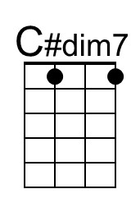
 | 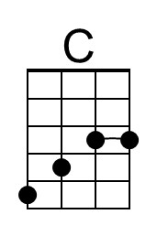
 | Bari
 | 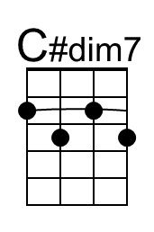
 | 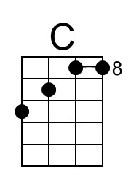

* This line is from a performance of the song by Judy Garland

