Our House (Graham Nash, ca. 1969) (C)
Our House by Crosby, Stills, Nash & Young (1969) (A @ 129) – Our House (Official Video)

Intro (Single Strum) C  C Cmaj7 Am C F  I'll light the fire, you place the flowers in the vase  C Dm7 | F Fmaj7 |  That you bought to-day.  C Cmaj7 Am C F  Staring at the fire for hours and hours, while I listen  C Dm7 Fmaj7 Dm7 Fmaj7 C | Cmaj7  To you play your love songs all night long for me,  Am C | F | Ab  Only for me.  C Cmaj7 Am C  Come to me now and rest your head for just five minutes;  F C Dm7 | F Fmaj7 |  Every - thing is done.  C Cmaj7 Am C F  Such a cozy room the windows are il-lum-inated by the  C Dm7 Fmaj7 Dm7 Fmaj7 C | Cmaj7  Evening sunshine through them: fiery gems for you,  Am C | F | Ab  Only for you.  Chorus  C Cmaj7 Am C  Our house, is a very, very, very fine house,  F C F C  With two cats in the yard. Life used to be so hard,  F6 C F | F | Dm7 | F  Now everything is easy 'cause of you …. and, ah  Bridge  C Cmaj7 Am C  La_la La-la-la-la La-la-la-la La-la-la-la  F C Dm7 F Fmaj7  La-la-la-la La-la-la-la La-la-la-la La-la-la-la  C Cmaj7 Am C  La_la La-la-la-la La-la-la-la La-la-la-la  F Ab  La_la-la-la La-la-la la-la-la. Chorus  Outro (slowly)  C Cmaj7 Am C F  I'll light the fire, while you place the flowers in the vase  Ab C  That you bought to-da-a-a-ay. | 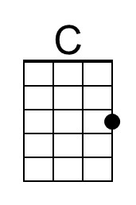 | 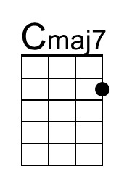
 | 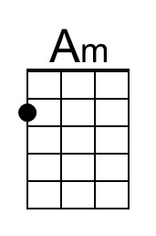 | 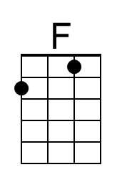
 | 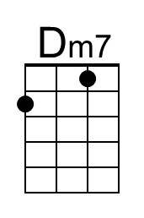 | 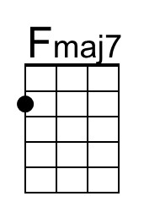
 | 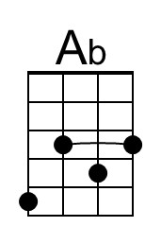 | 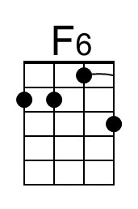
 | 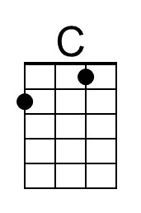 | 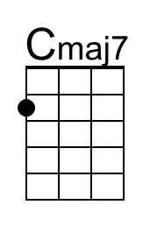
 | 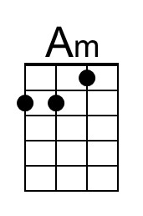 | 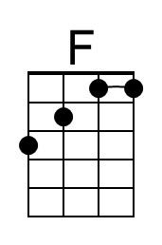
 | 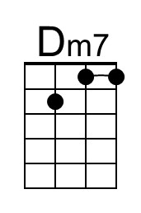 | 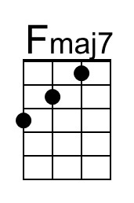
 | 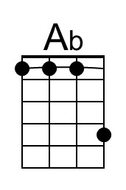 | 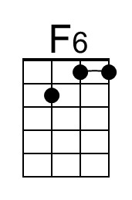

Our House (Graham Nash, ca. 1969) (G)
Our House by Crosby, Stills, Nash & Young (1969) (A @ 129) – Our House (Official Video)

Intro (Single Strum) G  G Gmaj7 Em G C  I'll light the fire, you place the flowers in the vase  G Am | C Cmaj7 |  That you bought to-day.  G Gmaj7 Em G C  Staring at the fire for hours and hours, while I listen  G Am Cmaj7 Am Cmaj7 G | Gmaj7  To you play your love songs all night long for me,  Em G | C | Eb  Only for me.  G Gmaj7 Em G  Come to me now and rest your head for just five minutes;  C G Am | C Cmaj7 |  Every - thing is done.  G Gmaj7 Em G C  Such a cozy room the windows are il-lum-inated by the  G Am Cmaj7 Am Cmaj7 G | Gmaj7  Evening sunshine through them: fiery gems for you,  Em G | C | Eb  Only for you.  Chorus  G Gmaj7 Em G  Our house, is a very, very, very fine house,  C G C G  With two cats in the yard. Life used to be so hard,  C6 G C | C | Am | C  Now everything is easy 'cause of you …. and, ah  Bridge  G Gmaj7 Em G  La_la La-la-la-la La-la-la-la La-la-la-la  C G Am C Cmaj7  La-la-la-la La-la-la-la La-la-la-la La-la-la-la  G Gmaj7 Em G  La_la La-la-la-la La-la-la-la La-la-la-la  C Eb  La_la-la-la La-la-la la-la-la. Chorus  Outro (slowly)  G Gmaj7 Em G C  I'll light the fire, while you place the flowers in the vase  Eb G  That you bought to-da-a-a-ay. | 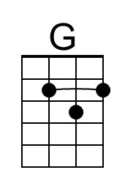 | 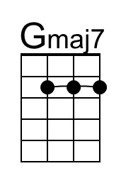
 | 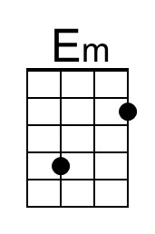
 | 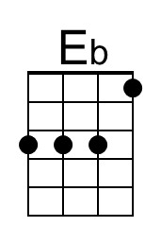 | 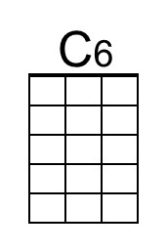
 | 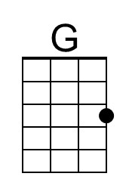 | 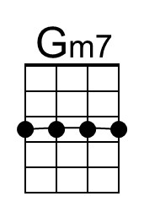
 | 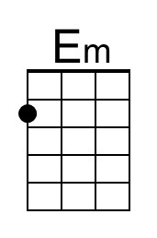
 | 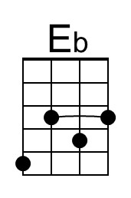 | 