My Blue Heaven (Walter Donaldson, George A. Whiting, 1927) (A)
My Blue Heaven by Gene Austin (1928) (1st Hit Recording) (Eb @ 134)
My Blue Heaven by Fats Domino (1956) (C#) (# 17 Hit) – My Blue Heaven by James Taylor (2020) (C)
My Blue Heaven by Sheet Music Singer (Eb) – Original Ukulele Arrangement by May Singh Breen
2/2 Time

Intro  A B7 E7 A  __ Just Molly and me, and Baby makes three, we're happy in my blue heaven.  A Cdim7 Bm E7 A Ebdim7 E7 F#7  Day is end - ing, birds are wend - ing  B7 E7 A B7 E7  Back to the shelter of each little nest they love.  A Cdim7 Bm E7 A Ebdim7 E7 F#7  Night shades fall – ing, love birds call – ing,  B7 E7  What makes the world go round? Nothing but love!  Chorus  N.C. A  ____ When Whippoorwills call and ev’ning is nigh  B7 E7 A  I hurry to my blue heaven.  N.C. A  ____ I turn to the right, a little white light  B7 E7 A  Will lead you to my blue heaven.  D F#7 Bm | F#7  You’ll see a smiling face, a fireplace, a cozy room,  E7 A  A little nest that's nestled where the roses bloom.  N.C. A  ____ Just Molly and me, and Baby makes three.  B7 E7 A  We're happy in my blue heaven.  A Cdim7 Bm E7 A Ebdim7 E7 F#7  Moon-beams creep – ing, flow'rs are sleep - ing  B7 E7 A B7 E7  Under a starlit way, waiting a-nother day.  A Cdim7 Bm E7 A Ebdim7 E7 F#7  Time for rest - ing, birds are nest - ing,  B7 E7  Resting their weary wings, tired from play. Chorus (2x)  Outro (Ritard.)  B7 E7 A - D | A  We're happy in my blue heaven. | 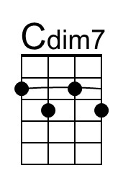
 | 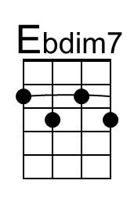
 | Bari
 | 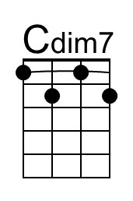
 | 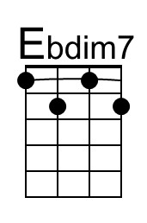

My Blue Heaven (Walter Donaldson, George A. Whiting, 1927) (C)
My Blue Heaven by Gene Austin (1928) (1st Hit Recording) (Eb)
My Blue Heaven by Fats Domino (1956) (#17) – My Blue Heaven by James Taylor (2020)
My Blue Heaven by Sheet Music Singer – Original Ukulele Arrangement by May Singh Breen
2/2 Time

Intro
C D7 G7 C
__ Just Molly and me, and Baby makes three, we're happy in my blue heaven.

C Ebdim7 Dm G7 C F#dim7 G7 A7
Day is end - ing, birds are wend - ing
D7 G7 C D7 G7
Back to the shelter of each little nest they love.
C Ebdim7 Dm G7 C F#dim7 G7 A7
Night shades fall – ing, love birds call – ing,
D7 G7
What makes the world go round? Nothing but love!

Chorus
N.C. C
____ When Whippoorwills call and ev’ning is nigh
D7 G7 C
I hurry to my blue heaven.
N.C. C
____ I turn to the right, a little white light
D7 G7 C
Will lead you to my blue heaven.
F A7 Dm | A7
You’ll see a smiling face, a fireplace, a cozy room,
G7 C
A little nest that's nestled where the roses bloom.
N.C. C
____ Just Molly and me, and Baby makes three.
D7 G7 C
We're happy in my blue heaven.

C Ebdim7 Dm G7 C F#dim7 G7 A7
Moon-beams reep – ing, flow'rs are sleep - ing
D7 G7 C D7 G7
Under a starlit way, waiting a-nother day.
C Ebdim7 Dm G7 C F#dim7 G7 A7
Time for rest - ing, birds are nest - ing,
D7 G7
Resting their weary wings, tired from play. Chorus (2x)

Outro (Ritard.)
D7 G7 C - F | C
We're happy in my blue heaven.
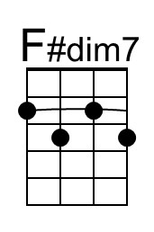
Bari
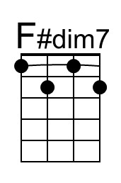

My Blue Heaven (Walter Donaldson, George A. Whiting, 1927) (D)
My Blue Heaven by Gene Austin (1928, with first verse) (1st Hit Recording) (Eb)
My Blue Heaven by Fats Domino (1956) (#17) – My Blue Heaven by James Taylor (2020)
My Blue Heaven by Sheet Music Singer – Original Ukulele Arrangement by May Singh Breen
2/2 Time

Intro  D E7 A7 D  __ Just Molly and me, and Baby makes three, we're happy in my blue heaven.  D Fdim7 Em A7 D G#dim7 A7 B7  Day is end - ing, birds are wend - ing  E7 A7 D E7 A7  Back to the shelter of each little nest they love.  D Fdim7 Em A7 D G#dim7 A7 B7  Night shades fall – ing, love birds call – ing,  E7 A7  What makes the world go round? Nothing but love!  Chorus  N.C. D  ____ When Whippoorwills call and ev’ning is nigh  E7 A7 D  I hurry to my blue heaven.  N.C. D  ____ I turn to the right, a little white light  E7 A7 D  Will lead you to my blue heaven.  G B7 Em | B7  You’ll see a smiling face, a fireplace, a cozy room,  A7 D  A little nest that's nestled where the roses bloom.  N.C. D  ____ Just Molly and me, and Baby makes three.  E7 A7 D  We're happy in my blue heaven.  D Fdim7 Em A7 D G#dim7 A7 B7  Moon-beams creep – ing, flow'rs are sleep - ing  E7 A7 D E7 A7  Under a starlit way, waiting a-nother day.  D Fdim7 Em A7 D G#dim7 A7 B7  Time for rest - ing, birds are nest - ing,  E7 A7  Resting their weary wings, tired from play. Chorus (2x)  Outro (Ritard.)  E7 A7 D - G | D  We're happy in my blue heaven. | 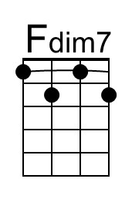
 | 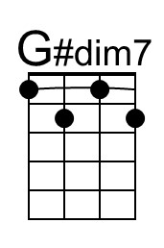
 | Bari
 | 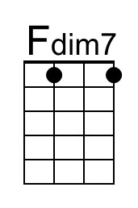

My Blue Heaven (Walter Donaldson, George A. Whiting, 1927) (Eb)
My Blue Heaven by Gene Austin (1928, with first verse) (1st Hit Recording) (Eb)
My Blue Heaven by Fats Domino (1956) (#17) – My Blue Heaven by James Taylor (2020)
My Blue Heaven by Sheet Music Singer – Original Ukulele Arrangement by May Singh Breen
2/2 Time

Intro  Eb F7 Bb7 Eb  __ Just Molly and me, and Baby makes three, we're happy in my blue heaven.  Eb Gbdim7 Fm Bb7 Eb Adim7 Bb7 C7  Day is end - ing, birds are wend - ing  F7 Bb7 Eb F7 Bb7  Back to the shelter of each little nest they love.  Eb Gbdim7 Fm Bb7 Eb Adim7 Bb7 C7  Night shades fall – ing, love birds call – ing,  F7 Bb7  What makes the world go round? Nothing but love!  Chorus  N.C. Eb  ____ When Whippoorwills call and ev’ning is nigh  F7 Bb7 Eb  I hurry to my blue heaven.  N.C. Eb  ____ I turn to the right, a little white light  F7 Bb7 Eb  Will lead you to my blue heaven.  Ab C7 Fm | C7  You’ll see a smiling face, a fireplace, a cozy room,  Bb7 Eb  A little nest that's nestled where the roses bloom.  N.C. Eb  ____ Just Molly and me, and Baby makes three.  F7 Bb7 Eb  We're happy in my blue heaven.  Eb Gbdim7 Fm Bb7 Eb Adim7 Bb7 C7  Moon-beams creep – ing, flow'rs are sleep - ing  F7 Bb7 Eb F7 Bb7  Under a starlit way, waiting a-nother day.  Eb Gbdim7 Fm Bb7 Eb Adim7 Bb7 C7  Time for rest - ing, birds are nest - ing,  F7 Bb7  Resting their weary wings, tired from play. Chorus (2x)  Outro (Ritard.)  F7 Bb7 Eb - Ab | Eb  We're happy in my blue heaven. | 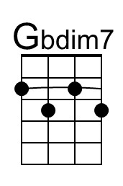
 | 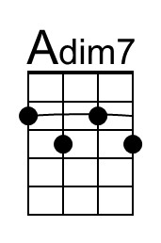
 | Bari
 | 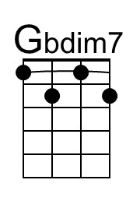
 | 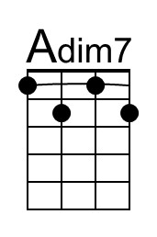

My Blue Heaven (Walter Donaldson, George A. Whiting, 1927) (G)
My Blue Heaven by Gene Austin (1928) (1st Hit Recording) (Eb)
My Blue Heaven by Fats Domino (1956) (#17) – My Blue Heaven by James Taylor (2020)
My Blue Heaven by Sheet Music Singer – Original Ukulele Arrangement by May Singh Breen
2/2 Time

Intro  G A7 D7 G  __ Just Molly and me, and Baby makes three, we're happy in my blue heaven.  G Bbdim7 Am D7 G C#dim7 D7 E7  Day is end - ing, birds are wend - ing  A7 D7 G A7 D7  Back to the shelter of each little nest they love.  G Bbdim7 Am D7 G C#dim7 D7 E7  Night shades fall – ing, love birds call – ing,  A7 D7  What makes the world go round? Nothing but love!  Chorus  N.C. G  ____ When Whippoorwills call and ev’ning is nigh  A7 D7 G  I hurry to my blue heaven.  N.C. G  ____ I turn to the right, a little white light  A7 D7 G  Will lead you to my blue heaven.  C E7 Am | E7  You’ll see a smiling face, a fireplace, a cozy room,  D7 G  A little nest that's nestled where the roses bloom.  N.C. G  ____ Just Molly and me, and Baby makes three.  A7 D7 G  We're happy in my blue heaven.  G Bbdim7 Am D7 G C#dim7 D7 E7  Moon-beams creep – ing, flow'rs are sleep - ing  A7 D7 G A7 D7  Under a starlit way, waiting a-nother day.  G Bbdim7 Am D7 G C#dim7 D7 E7  Time for rest - ing, birds are nest - ing,  A7 D7  Resting their weary wings, tired from play. Chorus (2x)  Outro (Ritard.)  A7 D7 G - C | G  We're happy in my blue heaven. | 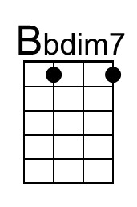
 | 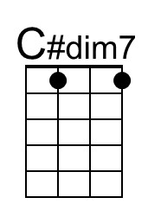
 | Bari
 | 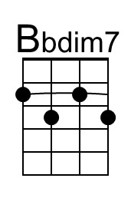
 | 