What A Fool Believes (Db → E)
Michael McDonald & Kenny Loggins, 1978
What A Fool Believes by The Doobie Brothers (Db @ 120) – Second #1 US hit
What A Fool Believes by The Doobie Brothers (Official Music Video)
4/4 Time
Intro
Ab7 F#add2 Db | Db | Ebm9 Fm7 F#add2 Adim Bbm7 |

A9 Ab7 F#add2 Db
__ He came from somewhere back in her long ago
Ebm9 Fm7 F#add2 Adim Bbm7 A9 Ab7 F#add2
____ ____ The sen - ti - men - tal fool don't see, tryin' hard to recre-ate
Db Ebm9 Fm7 F#add2 Adim Bbm7
What had yet to be created ____ ___ once in her life.

A9 Ab7 F#add2 Db
She musters a smile _____ for his nostalgic tale,
Ebm9 Fm7 F#add2 Adim Bbm7 A9 Ab7 - F#add2
____ ___ Never com - in’ near what he wanted to say
Db Ebm9 Fm7 F#add2 Adim Bbm7
Only to realize _____ ___ it never real - ly was.

Bbm7 | - Ab7 | Ab7 | Bbm7 | Ab7
She had a place in his life. He never made her think twice.
Ebm7 F#maj7 Dbmaj7 - B7
As he rises to her a-pology,
Bb7 Ebm7 F#maj7 Bbm7 Gm7b5
An- y -body else would surely know . . . he's watching her go.

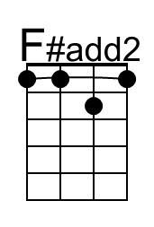 | 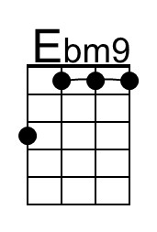 | 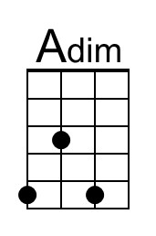 | 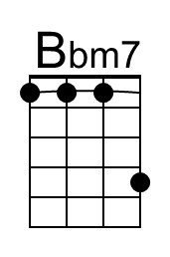 | 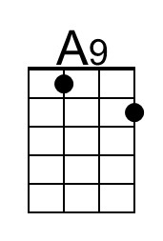 | 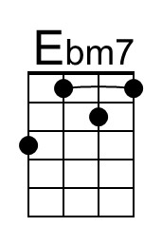
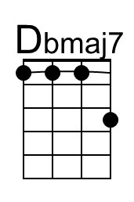 | 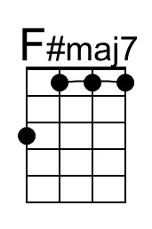 | 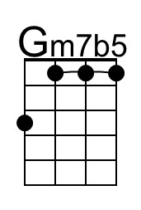 | 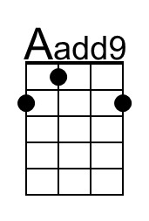 | 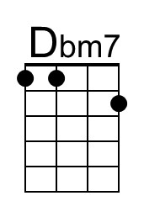
Baritone | 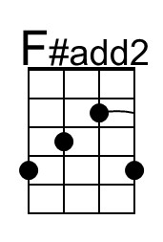 | 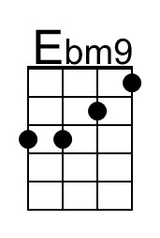 | 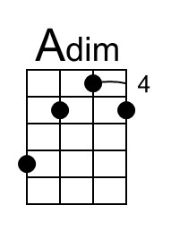 | 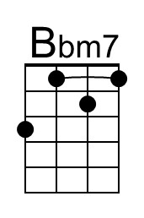 | 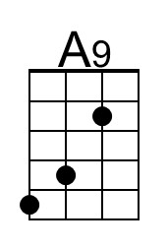 | 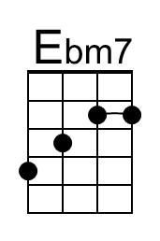
 | 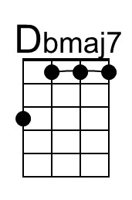 | 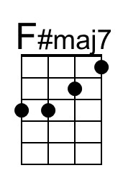 | 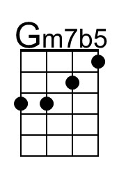 | 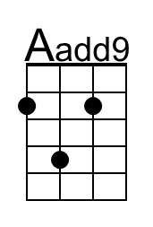 | 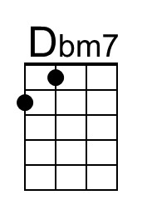

What A Fool Believes (Db → E) – Page 2

F#m7 | % | Aadd9
But what a fool be-lieves, he sees,
E | E Dbm7 | A
No wise man has the power . . . to reason a-way.
E F#m7 Aadd9 E | E
What seems . . . to be . . . is always better than nothing.
Dbm7
And nothing at all keeps sending him

Ab7 F#add2 Db
Somewhere back in her long ago,
Ebm9 Fm7 F#add2 Adim Bbm7 A9 Ab7 - F#add2
____ ___ Where he can still be-lieve there's a place in her life
Db Ebm9 Fm7 F#add2 Adim Bbm7 | Bbm7 |
Some-day, somewhere ___ ___ she will re - turn.

Bbm7 | Ab7 | Ab7 | Bbm7 | Ab7
She had a place in his life. He never made her think twice.
Ebm7 F#maj7 Dbmaj7 - B7
As he rises to her a-pology,
Bb7 Ebm7 F#maj7 Bbm7 Gm7b5
An- y -body else would surely know . . . he's watching her go.
F#m7 | % | Aadd9
But what a fool be-lieves, he sees,
E | E Dbm7 | A
No wise man has the power . . . to reason a-way.
E F#m7 Aadd9 E | E
What seems . . . to be . . . is always better than nothing.
Dbm7
And nothing at all.

Outro (2x then ‘Instrumental Close’)
||: A F#m7 | F#m7 | Aadd9 | Aadd9
__ What a fool be-lieves, he sees
E | E Dbm7 | A
No wise man has the power to reason a-way.
A↓↓ E F#m7 | F#m7 Aadd9 | E
___ __ What seems . . . to be is always better than nothing.
Dbm7
And nothing at all. :||

Instrumental Close
| A A E F#m7 | F#m7 | E B A E

