Another Park, Another Sunday (Tom Johnston, ca. 1973) (A)
Another Park, Another Sunday by The Doobie Brothers (Album Version, 1974) (E @ 113)
Another Park, Another Sunday by The Doobie Brothers (45 Version, 1974)
Another Park, Another Sunday by The Doobie Brothers (Live at Wolf Trap, 2004)

Intro  A | Amaj7 | A7sus4 | A | Amaj7 | A7sus4 |  A Amaj7  I’m sittin' in my room, I’m starin' out the window,  A7sus4 | A7sus4  And I wonder where you've gone.  A Amaj7 A7sus4 | A7sus4  Thinkin' back on the happy hours , just be – fore the dawn.  D Dsus4 D Bm7 G A  Outside the wind is blow-in', ____ it seems to call your name … a-gain.  Eadd4 Dadd2 E | A | Amaj7 | A7sus4 |  _____ Where _____ have you gone?  A Amaj7 A7sus4  __ City streets __ and lonely highways I've travelled down.  A Amaj7 A7sus4 | A7sus4  My car is empty and the radio just seems to bring me down.  D Dsus4 D Bm7 G A  I'm just tryin' to find me ____ a pretty smile that I can get in-to.  Eadd4 Dadd2 E  It's true. I'm lost without you.  Amaj7 Am7  An - other park, another Sunday, ____ why is it life turns out that way?  Bm7 Dsus4 - D  ___ Just when you think you got a good thing,  C G A  It seems to slip a – way.  A7sus4 A  _______It's warm outside, no clouds are in the sky,  Em7 A  But I need myself a place to go and hide  A7sus4 A G A  _______I keep it to myself, I don't want nobody else to see me cryin'  D Esus4 | E  All those tears in my eyes. |  |  |  |  |  |  |  | 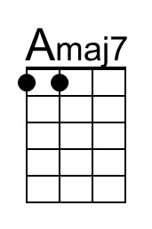
 |  |  |  |  |  |  |  | 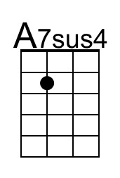
 |  |  |  |  |  |  |  | 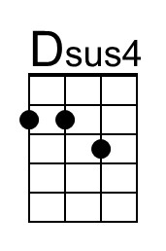
 |  |  |  |  |  |  |  | 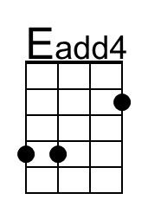
 |  |  |  |  |  |  |  | 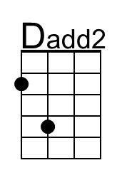
 |  |  |  |  |  |  |  | 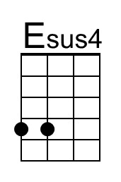
Baritone | 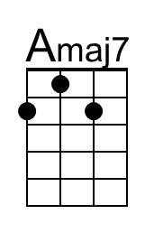 | 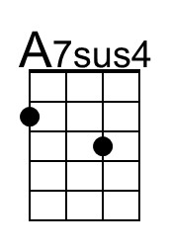 | 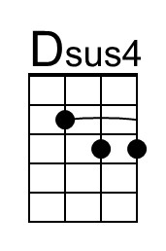 | 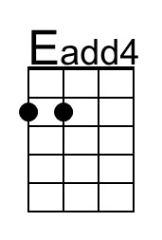 | 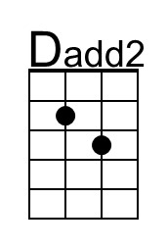 | 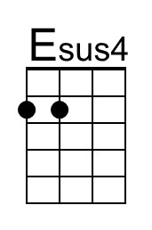

Another Park, Another Sunday (A) – Page 2

Amaj7 Am7
_____ Another park, another Sunday; ___ why is it life turns out that way?
Bm7 Dsus4 - D C G A | C G A A |
_____ Just when you think you got a good thing, it seems to slip a – way.

Amaj7 Am7
_____ Another park, another Sunday; ___ its dark and empty, thanks to you
Bm7 Dsus4 - D C G A | C G A A |
____ I got to get my-self to-gether, but it's hard to do.

Instrumental Verse
Amaj7 | Amaj7 | Am7 | Am7 |
Bm7 | Dsus4 D | C G A A | C G A A |

Amaj7 Am7
_____ Another park, another Sunday; ___ why is it life turns out that way?
Bm7 Dsus4 - D C G A | C G A A |
___ Just when you think you got a good thing, it seems to slip a – way.

Amaj7 Am7
_____ Another park, another Sunday; ___ its dark and empty, thanks to you
Bm7 Dsus4 - D C G A | C G A A |
____ I've got to get myself to-gether, but it's hard to do.

Outro to Fade
A | Amaj7 | A7sus4 | A | Amaj7 | A7sus4 | A

Another Park, Another Sunday (Tom Johnston, ca. 1973) (C)
Another Park, Another Sunday by The Doobie Brothers (Album Version, 1974) (E @ 113)
Another Park, Another Sunday by The Doobie Brothers (45 Version, 1974)
Another Park, Another Sunday by The Doobie Brothers (Live at Wolf Trap, 2004)

Intro  C | Cmaj7 | C7sus4 | C | Cmaj7 | C7sus4 |  C Cmaj7  I’m sittin' in my room, I’m starin' out the window,  C7sus4 | C7sus4  And I wonder where you've gone.  C Cmaj7 C7sus4 | C7sus4  Thinkin' back on the happy hours , just be – fore the dawn.  F Fsus4 F Dm7 Bb C  Outside the wind is blow-in', ____ it seems to call your name … a-gain.  Gadd4 Fadd2 G | C | Cmaj7 | C7sus4 |  _____ Where _____ have you gone?  C Cmaj7 C7sus4  __ City streets __ and lonely highways I've travelled down.  C Cmaj7 C7sus4 | C7sus4  My car is empty and the radio just seems to bring me down.  F Fsus4 F Dm7 Bb C  I'm just tryin' to find me ____ a pretty smile that I can get in-to.  Gadd4 Fadd2 G  It's true. I'm lost without you.  Cmaj7 Cm7  An - other park, another Sunday, ____ why is it life turns out that way?  Dm7 Fsus4 - F  ___ Just when you think you got a good thing,  Eb Bb C  It seems to slip a – way.  C7sus4 C  _______It's warm outside, no clouds are in the sky,  Gm7 C  But I need myself a place to go and hide  C7sus4 C Bb C  _______I keep it to myself, I don't want nobody else to see me cryin'  F Gsus4 | G  All those tears in my eyes. |  |  |  |  |  |  |  | 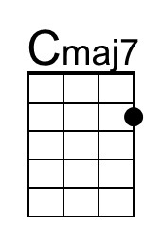
 |  |  |  |  |  |  |  | 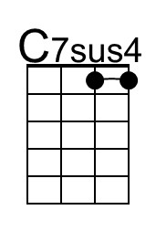
 |  |  |  |  |  |  |  | 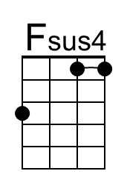
 |  |  |  |  |  |  |  | 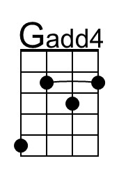
 |  |  |  |  |  |  |  | 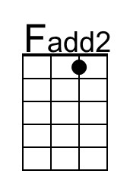
 |  |  |  |  |  |  |  | 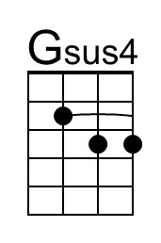
Baritone | 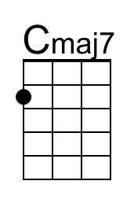 | 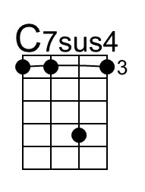 | 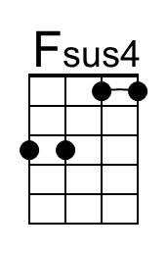 | 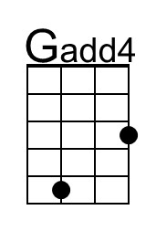 | 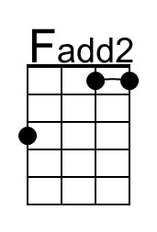 | 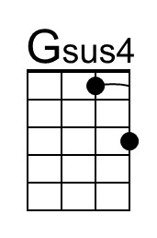

Another Park, Another Sunday (C) – Page 2

Cmaj7 Cm7
_____ Another park, another Sunday; ___ why is it life turns out that way?
Dm7 Fsus4 - F Eb Bb C | Eb Bb C C |
___ Just when you think you got a good thing, it seems to slip a – way.

Cmaj7 Cm7
_____ Another park, another Sunday; ___ its dark and empty, thanks to you
Dm7 Fsus4 - F Eb Bb C | Eb Bb C C |
____ I got to get my-self to-gether, but it's hard to do.

Instrumental Verse
Cmaj7 | Cmaj7 | Cm7 | Cm7 |
Dm7 | Fsus4 F | Eb Bb C C | Eb Bb C C |

Cmaj7 Cm7
_____ Another park, another Sunday; ___ why is it life turns out that way?
Dm7 Fsus4 - F Eb Bb C | Eb Bb C C |
___ Just when you think you got a good thing, it seems to slip a – way.

Cmaj7 Cm7
_____ Another park, another Sunday; ___ its dark and empty, thanks to you
Dm7 Fsus4 - F Eb Bb C | Eb Bb C C |
___ I've got to get myself to-gether, but it's hard to do.

Outro to Fade
C | Cmaj7 | C7sus4 | C | Cmaj7 | C7sus4 | C
Another Park, Another Sunday (Tom Johnston, ca. 1973) (E)
Another Park, Another Sunday by The Doobie Brothers (Album Version, 1974) (E @ 113)
Another Park, Another Sunday by The Doobie Brothers (45 Version, 1974)
Another Park, Another Sunday by The Doobie Brothers (Live at Wolf Trap, 2004)

Intro  E | Emaj7 | E7sus4 | E | Emaj7 | E7sus4 |  E Emaj7  I’m sittin' in my room, I’m starin' out the window,  E7sus4 | E7sus4  And I wonder where you've gone.  E Emaj7 E7sus4 | E7sus4  Thinkin' back on the happy hours , just be – fore the dawn.  A Asus4 A F#m7 D E  Outside the wind is blow-in', ____ it seems to call your name … a-gain.  Badd4 Aadd2 B | E | Emaj7 | E7sus4 |  _____ Where _____ have you gone?  E Emaj7 E7sus4  __ City streets __ and lonely highways I've travelled down.  E Emaj7 E7sus4 | E7sus4  My car is empty and the radio just seems to bring me down.  A Asus4 A F#m7 D E  I'm just tryin' to find me ____ a pretty smile that I can get in-to.  Badd4 Aadd2 B  It's true. I'm lost without you.  Emaj7 Em7  An - other park, another Sunday, ____ why is it life turns out that way?  F#m7 Asus4 - A  ___ Just when you think you got a good thing,  G D E  It seems to slip a – way.  E7sus4 E  _______It's warm outside, no clouds are in the sky,  Bm7 E  But I need myself a place to go and hide  E7sus4 E D E  _______I keep it to myself, I don't want nobody else to see me cryin'  A Bsus4 | B  All those tears in my eyes. |  |  |  |  |  |  |  | 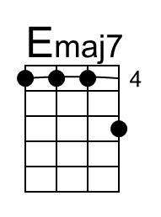
 |  |  |  |  |  |  |  | 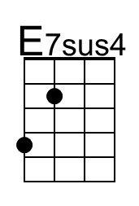
 |  |  |  |  |  |  |  | 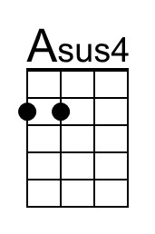
 |  |  |  |  |  |  |  | 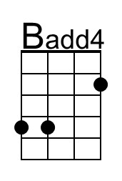
 |  |  |  |  |  |  |  | 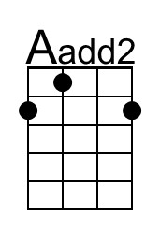
 |  |  |  |  |  |  |  | 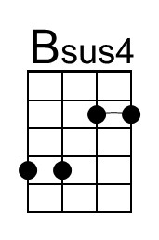
Baritone | 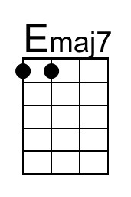 |  | 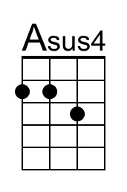 |  | 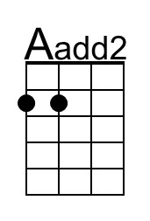 | 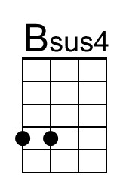

Another Park, Another Sunday (E) – Page 2

Emaj7 Em7
_____ Another park, another Sunday; ___ why is it life turns out that way?
F#m7 Asus4 - A G D E | G D E E |
_____ Just when you think you got a good thing, it seems to slip a – way.

Emaj7 Em7
_____ Another park, another Sunday; ___ its dark and empty, thanks to you
F#m7 Asus4 - A G D E | G D E E |
____ I got to get my-self to-gether, but it's hard to do.

Instrumental Verse
Emaj7 | Emaj7 | Em7 | Em7 |
F#m7 | Asus4 A | G D E E | G D E E |

Emaj7 Em7
_____ Another park, another Sunday; ___ why is it life turns out that way?
F#m7 Asus4 - A G D E | G D E E |
____ Just when you think you got a good thing, it seems to slip a – way.

Emaj7 Em7
_____ Another park, another Sunday; ___ its dark and empty, thanks to you
F#m7 Asus4 - A G D E | G D E E |
____ I've got to get myself to-gether, but it's hard to do.

Outro to Fade
E | Emaj7 | E7sus4 | E | Emaj7 | E7sus4 | E

“Another Park, Another Sunday” was the A-side release; it’s B-side was “Black Water” which eventually became the first #1 hit for The Doobie Brothers.

Another Park, Another Sunday (Tom Johnston, ca. 1973) (G)
Another Park, Another Sunday by The Doobie Brothers (Album Version, 1974) (E @ 113)
Another Park, Another Sunday by The Doobie Brothers (45 Version, 1974)
Another Park, Another Sunday by The Doobie Brothers (Live at Wolf Trap, 2004)

Intro  G | Gmaj7 | G7sus4 | G | Gmaj7 | G7sus4 |  G Gmaj7  I’m sittin' in my room, I’m starin' out the window,  G7sus4 | G7sus4  And I wonder where you've gone.  G Gmaj7 G7sus4 | G7sus4  Thinkin' back on the happy hours , just be – fore the dawn.  C Csus4 C Am7 F G  Outside the wind is blow-in', ____ it seems to call your name … a-gain.  Dadd4 Cadd2 D | G | Gmaj7 | G7sus4 |  _____ Where _____ have you gone?  G Gmaj7 G7sus4  __ City streets __ and lonely highways I've travelled down.  G Gmaj7 G7sus4 | G7sus4  My car is empty and the radio just seems to bring me down.  C Csus4 C Am7 F G  I'm just tryin' to find me ____ a pretty smile that I can get in-to.  Dadd4 Cadd2 D  It's true. I'm lost without you.  Gmaj7 Gm7  An - other park, another Sunday, ____ why is it life turns out that way?  Am7 Csus4 - C  ___ Just when you think you got a good thing,  Bb F G  It seems to slip a – way.  G7sus4 G  _______It's warm outside, no clouds are in the sky,  Dm7 G  But I need myself a place to go and hide  G7sus4 G F G  _______I keep it to myself, I don't want nobody else to see me cryin'  C Dsus4 | D  All those tears in my eyes. |  |  |  |  |  |  |  | 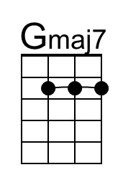
 |  |  |  |  |  |  |  | 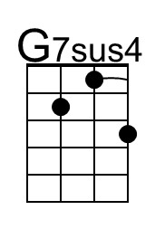
 |  |  |  |  |  |  |  | 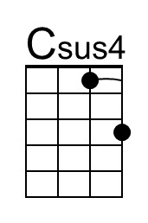
 |  |  |  |  |  |  |  | 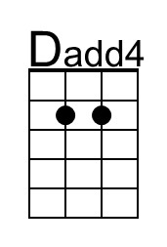
 |  |  |  |  |  |  |  | 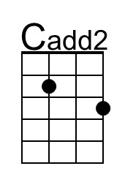
Baritone | 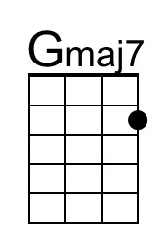 | 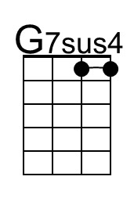 | 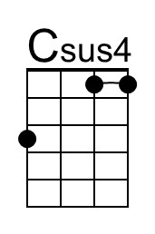 | 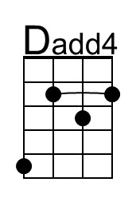 | 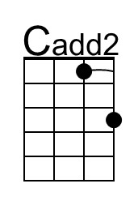

Another Park, Another Sunday (G) – Page 2

Gmaj7 Gm7
_____ Another park, another Sunday; ___ why is it life turns out that way?
Am7 Csus4 - C Bb F G | Bb F G G |
_____ Just when you think you got a good thing, it seems to slip a – way.

Gmaj7 Gm7
_____ Another park, another Sunday; ___ its dark and empty, thanks to you
Am7 Csus4 - C Bb F G | Bb F G G |
____ I got to get my-self to-gether, but it's hard to do.

Instrumental Verse
Gmaj7 | Gmaj7 | Gm7 | Gm7 |
Am7 | Csus4 C | Bb F G G | Bb F G G |

Gmaj7 Gm7
_____ Another park, another Sunday; ___ why is it life turns out that way?
Am7 Csus4 - C Bb F G | Bb F G G |
____ Just when you think you got a good thing, it seems to slip a – way.

Gmaj7 Gm7
_____ Another park, another Sunday; ___ its dark and empty, thanks to you
Am7 Csus4 - C Bb F G | Bb F G G |
____ I've got to get myself to-gether, but it's hard to do.

Outro to Fade
G | Gmaj7 | G7sus4 | G | Gmaj7 | G7sus4 | G

