As Time Goes By
Words & Music by Herman Hupfeld (1931)

Notes
Originally written by Herman Hupfeld for the Broadway musical "Everybody's Welcome" which opened in October, 1931, and performed by Frances Williams; two nights after the stage play opened, the song became "a major hit in Manhattan nightclubs" according to a review in the New York Times. The song was originally published in the key of E-flat major. The opening verse is heard in a few recordings (marked “the full lyric” below). It was first recorded by Rudy Vallée on July 25, 1931 for Victor Records.
The song was re-introduced in the 1942 film Casablanca where it was sung by “Sam”, portrayed by Dooley Wilson. Because Wilson was a drummer, the piano accompaniment was played by a studio pianist, Jean Vincent Plummer. The movie won 3 Academy Awards including Best Picture, and has appeared in at least five other films. "Casablanca" was based on an unstaged play, "Everybody Comes to Rick’s", by Murray Bernett and Joan Alison. The script specifies that when Ilsa first comes into Rick’s bar she asks the black piano player to play ‘As Times Goes By.’”
It is frequently heard as an instrumental in the opening credits of Warner Brothers movies and has been covered by more than 800 performers.
- As Time Goes By by Dooley Wilson (Db @ 78) (4:14) from "Casablana" (1942), the complete vocal with clips from the movie
- As Time Goes By by Dooley Wilson (Db @ 78) (Decca Recording #L3218, 1943)
- As Time Goes By by Rudy Vallee and His Connecticut Yankees (Ab @ 81), the first recording (Victor #22773; July 25, 1931); the full lyric.
- As Time Goes By by Natalie Cole (Ab @ 94) from “Take A Look”; the full lyric.
- As Time Goes By by Carly Simon (Ab @ 99) from “”Coming Around Again”
- As Time Goes By by Vera Lynn (Bb @ 70) from "For all World War II Sweethearts"
- As Time Goes By by Tony Bennett (C @ 82) from “Life Is Beautiful”; the full lyric.
- As Time Goes By by Andy Williams (C @ 86) from “Moon River and Other Great Movie Themes”
- As Time Goes By by Harry Nillson (C @ 60) from "A Little Touch of Schmilsson in the Night"
- As Time Goes By by Johnny Mathis (F @ 90) (Live) from his 1978 Concert at The Royal Albert Hall, UK; the full lyric.
- As Time Goes By by Rod Stewart (F @ 82) from “The Great American Songbook, Vol. II”; the full lyric.
- As Time Goes By by Barbra Streisand (F @ 75) from “The Third Album”
As Time Goes By (A)
Herman Hupfeld (1931) from the movie "Casablanca" (1942)
As Time Goes By performed by "Sam" (Dooley Wilson) (Db @ 78)
Slightly Simplified
4/4 Time – 80 BPM
Intro
| A C#m | D E7 |

Bm E7 Em E7 A F#m – A | C#m
You must remember this, a kiss is just a kiss, a sigh is just a sigh.
B B7 E E7 A – C#m | D – E7 |
The fundamental things ap-ply as time goes by.

Bm E7 Em E7 A F#m – A | C#m
And when two lovers woo, they still say “I love you”, on that you can re-ly.
B B7 E E7 A – D | A A7 |
No matter what the future brings as time goes by.

Bridge
D F#7
Moonlight and love songs never out of date.
Bm Cdim7
Hearts full of passion, jealousy and hate.
F#m D7 B B7 E7 F#7 Bm – E7
Woman needs man and man must have his mate that no one can de-ny.

Bm E7 Em E7 A F#m – A | C#m
It’s still the same old story, a fight for love and glory, a case of do or die.
___________________________________________________________________
| B B7 E E7 A – D | E7 A7
| 1. The world will always welcome lovers as time goes by. Repeat From Bridge
___________________________________________________________________
| B B7 E E7 A – D | E7 A
| 2. The world will always welcome lovers (Rit.) as time goes by.

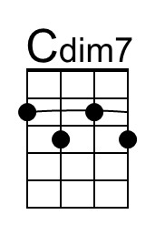 | 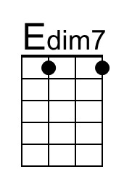 | Bari | 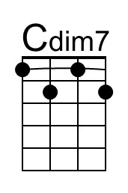 | 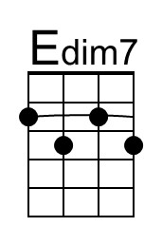

As Time Goes By (C)
Herman Hupfeld (1931) from the movie "Casablanca" (1942)
As Time Goes By performed by "Sam" (Dooley Wilson) (Db @ 78)
Slightly Simplified
4/4 Time – 80 BPM
Intro
| C Dm7 | Em A7 |

Dm7 G7 Dm7 G7 C Am – C | C
You must remember this, a kiss is just a kiss, a sigh is just a sigh.
Em Dm7 G7 C Dm7 | Em A7 |
The fundamental things ap-ply as time goes by.

Dm7 G7 Dm7 G7 C Am – C | C
And when two lovers woo, they still say “I love you”, on that you can re-ly.
Em Dm7 G7 C Am | C C7
No matter what the future brings as time goes by.

Bridge
F A7
Moonlight and love songs never out of date
Dm D#dim7
Hearts full of passion, jealousy and hate
Am F D#dim7 D Dm7 Gdim7 G7
Woman needs man and man must have his mate that no one can de-ny.

Dm7 G7 Dm7 G7 C Am – C
It’s still the same old story, a fight for love and glory, a case of do or die.
___________________________________________________________________
| Em7 D#dim7 Dm Dm7 C Am | C C7
| 1. The world will always welcome lovers as time goes by. Repeat From Bridge
___________________________________________________________________
| Em7 D#dim7 Dm Dm7 G7 C Dm7 | Em G7 | C
| 2. The world will always welcome lovers (Rit.) as time goes by. (Hold)

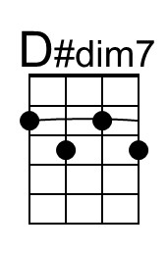 | 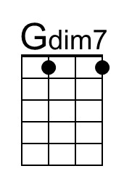 | Bari | 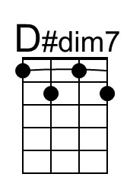 | 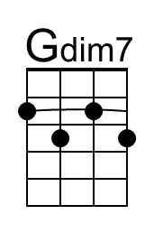

As Time Goes By (D)
Herman Hupfeld (1931) from the movie "Casablanca" (1942)
As Time Goes By performed by "Sam" (Dooley Wilson) (Db @ 78)
Slightly Simplified
4/4 Time – 80 BPM
Intro
| D F#m | G A7 |

Em A7 Am A7 D Bm – D – F#m
You must remember this, a kiss is just a kiss, a sigh is just a sigh.
E E7 A A7 D – F#m | G – A7 |
The fundamental things ap-ply as time goes by.

Em A7 Am A7 D Bm – D – F#m
And when two lovers woo, they still say “I love you”, on that you can re-ly.
E E7 A A7 D – G – D – D7
No matter what the future brings as time goes by.

Bridge
G B7
Moonlight and love songs never out of date
Em Fdim7
Hearts full of passion, jealousy and hate
Bm G7 E E7
Woman needs man and man must have his mate
A7 B7 Em – A7
That no one can de-ny.

Em A7 Am A7 D Bm – D – F#m
It’s still the same old story, a fight for love and glory, a case of do or die.
___________________________________________________________________
| E E7 A A7 D G | A7 D7
| 1. The world will always welcome lovers as time goes by. Repeat From Bridge
___________________________________________________________________
| E E7 A A7 D | G | A7 | D
| 2. The world will always welcome lovers (Rit.) as time goes by.

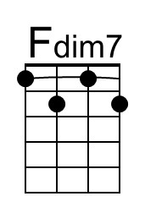 | 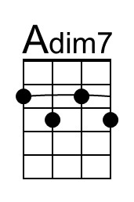 | Bari | 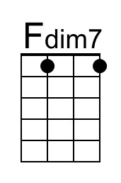 | 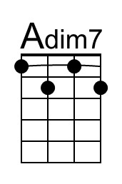

As Time Goes By (F)
Herman Hupfeld (1931) from the movie "Casablanca" (1942)
As Time Goes By performed by "Sam" (Dooley Wilson) (Db @ 78)
Slightly Simplified
4/4 Time – 80 BPM
Intro
| F Am | Bb C7 |

Gm C7 Cm C7 F Dm – F – Am
You must remember this, a kiss is just a kiss, a sigh is just a sigh.
G G7 C C7 F – Am | Bb – C7 |
The fundamental things ap-ply as time goes by.

Gm C7 Cm C7 F Dm – F – Am
And when two lovers woo, they still say “I love you”, on that you can re-ly.
G G7 C C7 F – Bb – F – F7
No matter what the future brings as time goes by.

Bridge
Bb D7
Moonlight and love songs never out of date
Gm Abdim7
Hearts full of passion, jealousy and hate
Dm Bb7 G G7
Woman needs man and man must have his mate
C7 D7 Gm – C7
That no one can de-ny.

Gm C7 Cm C7 F Dm – F – Am
It’s still the same old story, a fight for love and glory, a case of do or die.
___________________________________________________________________
| G G7 C C7 F Bb | C7 F7
| 1. The world will always welcome lovers as time goes by. Repeat From Bridge
___________________________________________________________________
| G G7 C C7 F | Bb | C7 | F
| 2. The world will always welcome lovers (Rit.) as time goes by.

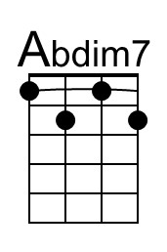 |  | Bari | 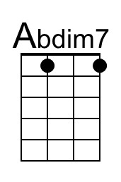

As Time Goes By (G)
Herman Hupfeld (1931) from the movie "Casablanca" (1942)
As Time Goes By performed by "Sam" (Dooley Wilson) (Db @ 78)
Slightly Simplified
4/4 Time – 80 BPM
Intro
| G Am7 | Bm E7 |

Am7 D7 Am7 D7 G Em – G | G
You must remember this, a kiss is just a kiss, a sigh is just a sigh.
Bm Am7 D7 G Am7 | Bm E7 |
The fundamental things ap-ply as time goes by.

Am7 D7 Am7 D7 G Em – G | G
And when two lovers woo, they still say “I love you”, on that you can re-ly.
Bm Am7 D7 G Em | G G7
No matter what the future brings as time goes by.

Bridge
C E7
Moonlight and love songs never out of date
Am A#dim7
Hearts full of passion, jealousy and hate
Em C A#dim7 A Am7 Ddim7 D7
Woman needs man and man must have his mate that no one can de-ny.

Am7 D7 Am7 D7 G Em – G
It’s still the same old story, a fight for love and glory, a case of do or die.
___________________________________________________________________
| Bm7 A#dim7 Am Am7 G Em | G G7
| 1. The world will always welcome lovers as time goes by. Repeat From Bridge
___________________________________________________________________
| Bm7 A#dim7 Am Am7 D7 G Am7 | Bm D7 | G
| 2. The world will always welcome lovers (Rit.) as time goes by. (Hold)

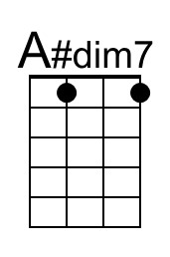 | 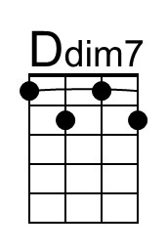 | Bari | 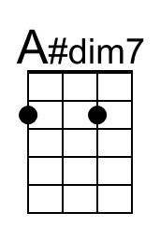 | 