Better Days (John Rzeznik, 2005) (Ver. 2) (A)
Better Days by The Goo Goo Dolls (D @ 110) (Official Audio)
Better Days by The Goo Goo Dolls (D @ 110) (Official Music Video)
Better Days by The Goo Goo Dolls (D @ 110) (Live at Red Rocks, 2008)

Intro  | A5 | A5 | D5 | D5 | E5 | E5 | A5 | A5  A5 D5  And you ask me what I want this year, and I try to make this kind and clear.  E5 A5 - Asus4 | A5  Just a chance that maybe we'll find better days.  A5 Dsus2  ‘Cause I don't need boxes wrapped in strings, and de-signer love and empty things.  Esus4 Dsus2 A5 - Asus4 | A5  Just a chance that maybe we'll find better days.  Chorus  D5 E5 D5 E5  So take these words, and sing out loud ‘cause ev'ryone is for-given now.  F#m7 Dsus2 A5 | A5 | A5 | A5  ‘Cause to-night's the night the world begins a-gain.  A5 Dsus2  I need someplace simple where we could live and somethin' only you can give  Esus4 Dsus2 A5 - Asus4 | A5  And that’s faith and trust and peace while we're a-live.  A5  And the one poor child that saved this world  Dsus2  And there's ten million more who probably could  Esus4 Dsus2 A5 - Asus4 | A5 | A5  If we all just stopped and said a prayer for them. Chorus  Optional Instrumental  A5 | A5 | D5 | D5 | F#m7 | D5 | A5 | A5  A5 D5  I wish ev'ryone was loved tonight and somehow stop this endless fight.  Esus4 Dsus2 A5 | A5  Just a chance that maybe we'll find better days.  Outro  D5 E5 D5 E5  So take these words, and sing out loud ‘cause ev'ryone is for-given now.  F#m7 Dsus2 A5 - Asus4 | A5  ‘Cause to-night's the night the world begins a-gain.  F#m7 Dsus2 A5  ‘Cause to-night's the night the world begins a-gain. (Hold) |  |  |  |  |  |  |  | 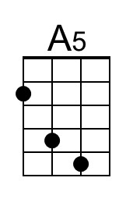
 |  |  |  |  |  |  |  | 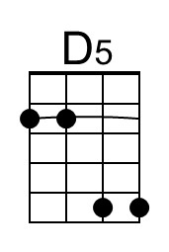
 |  |  |  |  |  |  |  | 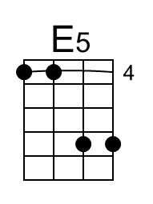
 |  |  |  |  |  |  |  | 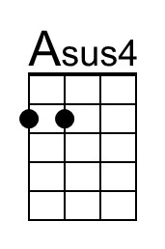
 |  |  |  |  |  |  |  | 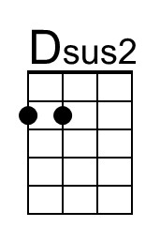
 |  |  |  |  |  |  |  | 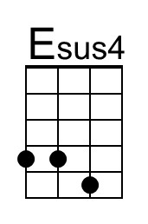
 |  |  |  |  |  |  |  | 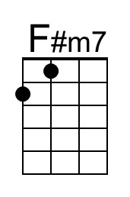
Baritone | 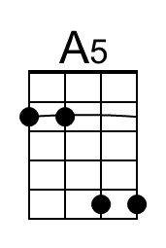 | 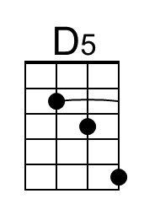 | 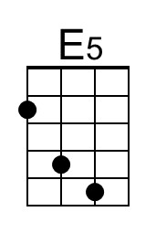 | 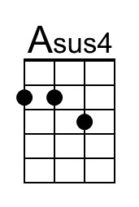 | 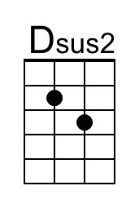 | 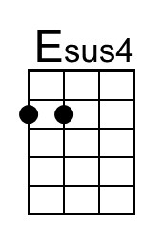 | 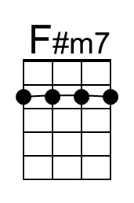

Better Days (John Rzeznik, 2005) (Ver. 2) (C)
Better Days by The Goo Goo Dolls (D @ 110) (Official Audio)
Better Days by The Goo Goo Dolls (D @ 110) (Official Music Video)
Better Days by The Goo Goo Dolls (D @ 110) (Live at Red Rocks, 2008)

Intro  | C5 | C5 | F5 | F5 | G5 | G5 | C5 | C5  C5 F5  And you ask me what I want this year, and I try to make this kind and clear.  G5 C5 - Csus4 | C5  Just a chance that maybe we'll find better days.  C5 Fsus2  ‘Cause I don't need boxes wrapped in strings, and de-signer love and empty things.  Gsus4 Fsus2 C5 - Csus4 | C5  Just a chance that maybe we'll find better days.  Chorus  F5 G5 F5 G5  So take these words, and sing out loud ‘cause ev'ryone is for-given now.  Am7 Fsus2 C5 | C5 | C5 | C5  ‘Cause to-night's the night the world begins a-gain.  C5 Fsus2  I need someplace simple where we could live and somethin' only you can give  Gsus4 Fsus2 C5 - Csus4 | C5  And that’s faith and trust and peace while we're a-live.  C5  And the one poor child that saved this world  Fsus2  And there's ten million more who probably could  Gsus4 Fsus2 C5 - Csus4 | C5 | C5  If we all just stopped and said a prayer for them. Chorus  Optional Instrumental  C5 | C5 | F5 | F5 | Am7 | F5 | C5 | C5  C5 F5  I wish ev'ryone was loved tonight and somehow stop this endless fight.  Gsus4 Fsus2 C5 | C5  Just a chance that maybe we'll find better days.  Outro  F5 G5 F5 G5  So take these words, and sing out loud ‘cause ev'ryone is for-given now.  Am7 Fsus2 C5 - Csus4 | C5  ‘Cause to-night's the night the world begins a-gain.  Am7 Fsus2 C5  ‘Cause to-night's the night the world begins a-gain. (Hold) |  |  |  |  |  |  |  | 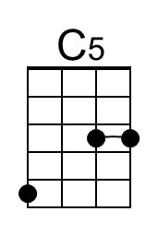
 |  |  |  |  |  |  |  | 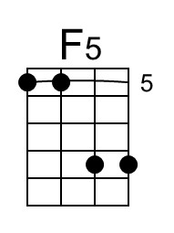
 |  |  |  |  |  |  |  | 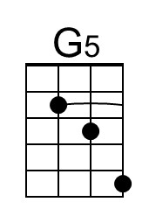
 |  |  |  |  |  |  |  | 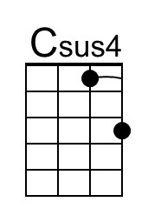
 |  |  |  |  |  |  |  | 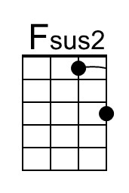
 |  |  |  |  |  |  |  | 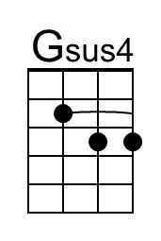
 |  |  |  |  |  |  |  | 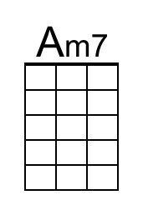
Baritone | 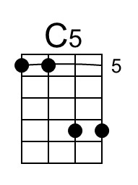 | 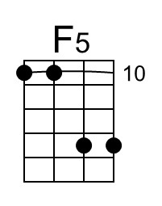 | 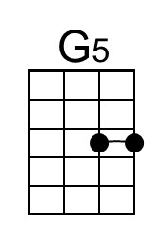 | 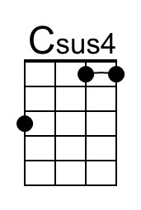 | 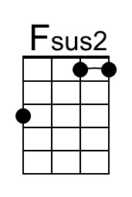 | 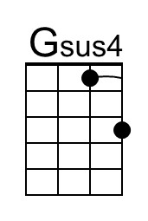 | 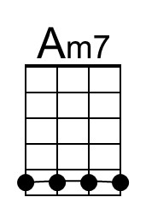
Better Days (John Rzeznik, 2005) (Ver. 2) (D)
Better Days by The Goo Goo Dolls (D @ 110) (Official Audio)
Better Days by The Goo Goo Dolls (D @ 110) (Official Music Video)
Better Days by The Goo Goo Dolls (D @ 110) (Live at Red Rocks, 2008)

Intro
| D5 | D5 | G5 | G5 | A5 | A5 | D5 | D5

D5 G5
And you ask me what I want this year, and I try to make this kind and clear.
A5 D5 - Dsus4 | D5
Just a chance that maybe we'll find better days.
D5 Gsus2
‘Cause I don't need boxes wrapped in strings, and de-signer love and empty things.
Asus4 Gsus2 D5 - Dsus4 | D5
Just a chance that maybe we'll find better days.

Chorus
G5 A5 G5 A5
So take these words, and sing out loud ‘cause ev'ryone is for-given now.
Bm7 Gsus2 D5 | D5 | D5 | D5
‘Cause to-night's the night the world begins a-gain.

D5 Gsus2
I need someplace simple where we could live and somethin' only you can give
Asus4 Gsus2 D5 - Dsus4 | D5
And that’s faith and trust and peace while we're a-live.
D5
And the one poor child that saved this world
Gsus2
And there's ten million more who probably could
Asus4 Gsus2 D5 - Dsus4 | D5 | D5
If we all just stopped and said a prayer for them. Chorus

Optional Instrumental
D5 | D5 | G5 | G5 | Bm7 | G5 | D5 | D5

D5 G5
I wish ev'ryone was loved tonight and somehow stop this endless fight.
Asus4 Gsus2 D5 | D5
Just a chance that maybe we'll find better days.

Outro
G5 A5 G5 A5
So take these words, and sing out loud ‘cause ev'ryone is for-given now.
Bm7 Gsus2 D5 - Dsus4 | D5
‘Cause to-night's the night the world begins a-gain.
Bm7 Gsus2 D5
‘Cause to-night's the night the world begins a-gain. (Hold)
 |  |  |  |  |  |  |  | 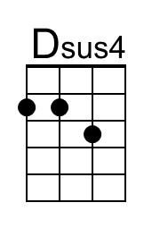
 |  |  |  |  |  |  |  | 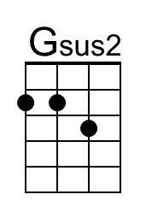
 |  |  |  |  |  |  |  | 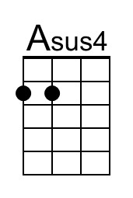
 |  |  |  |  |  |  |  | 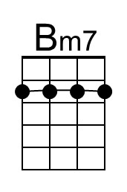
Baritone |  |  |  | 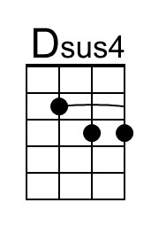 | 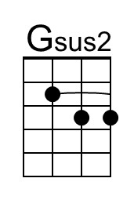 |  | 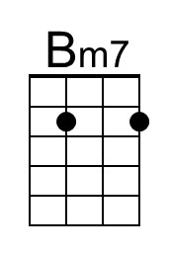
Better Days (John Rzeznik, 2005) (Ver. 2) (G)
Better Days by The Goo Goo Dolls (D @ 110) (Official Audio)
Better Days by The Goo Goo Dolls (D @ 110) (Official Music Video)
Better Days by The Goo Goo Dolls (D @ 110) (Live at Red Rocks, 2008)

Intro
| G5 | G5 | C5 | C5 | D5 | D5 | G5 | G5

G5 C5
And you ask me what I want this year, and I try to make this kind and clear.
D5 G5 - Gsus4 | G5
Just a chance that maybe we'll find better days.
G5 Csus2
‘Cause I don't need boxes wrapped in strings, and de-signer love and empty things.
Dsus4 Csus2 G5 - Gsus4 | G5
Just a chance that maybe we'll find better days.

Chorus
C5 D5 C5 D5
So take these words, and sing out loud ‘cause ev'ryone is for-given now.
Em7 Csus2 G5 | G5 | G5 | G5
‘Cause to-night's the night the world begins a-gain.

G5 Csus2
I need someplace simple where we could live and somethin' only you can give
Dsus4 Csus2 G5 - Gsus4 | G5
And that’s faith and trust and peace while we're a-live.
G5
And the one poor child that saved this world
Csus2
And there's ten million more who probably could
Dsus4 Csus2 G5 - Gsus4 | G5 | G5
If we all just stopped and said a prayer for them. Chorus

Optional Instrumental
G5 | G5 | C5 | C5 | Em7 | C5 | G5 | G5

G5 C5
I wish ev'ryone was loved tonight and somehow stop this endless fight.
Dsus4 Csus2 G5 | G5
Just a chance that maybe we'll find better days.

Outro
C5 D5 C5 D5
So take these words, and sing out loud ‘cause ev'ryone is for-given now.
Em7 Csus2 G5 - Gsus4 | G5
‘Cause to-night's the night the world begins a-gain.
Em7 Csus2 G5
‘Cause to-night's the night the world begins a-gain. (Hold)
 |  |  |  |  |  |  |  | 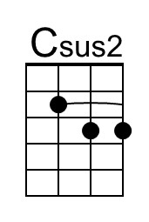
 |  |  |  |  |  |  |  | 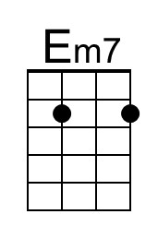
Baritone |  |  | 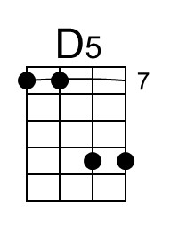 |  | 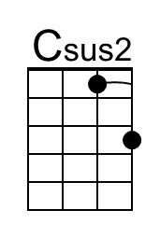 |  | 