Better Days (John Rzeznik, 2005) (Ver. 3) (A)
Better Days by The Goo Goo Dolls (D @ 110) (Official Audio)
Better Days by The Goo Goo Dolls (D @ 110) (Official Music Video)
Better Days by The Goo Goo Dolls (D @ 110) (Live at Red Rocks, 2008)

Intro  | A | A | D | D | E | E | A | A  A D  And you ask me what I want this year, and I try to make this kind and clear.  E A - Asus4 | A  Just a chance that maybe we'll find better days.  A Dsus2  ‘Cause I don't need boxes wrapped in strings, and de-signer love and empty things.  Esus4 Dsus2 A - Asus4 | A  Just a chance that maybe we'll find better days.  Chorus  D E D E  So take these words, and sing out loud ‘cause ev'ryone is for-given now.  F#m7 Dsus2 A | A | A | A  ‘Cause to-night's the night the world begins a-gain.  A Dsus2  I need someplace simple where we could live and somethin' only you can give  Esus4 Dsus2 A - Asus4 | A  And that’s faith and trust and peace while we're a-live.  A  And the one poor child that saved this world  Dsus2  And there's ten million more who probably could  Esus4 Dsus2 A - Asus4 | A | A  If we all just stopped and said a prayer for them. Chorus  Optional Instrumental  A | A | D | D | F#m7 | D | A | A  A D  I wish ev'ryone was loved tonight and somehow stop this endless fight.  Esus4 Dsus2 A | A  Just a chance that maybe we'll find better days.  Outro  D E D E  So take these words, and sing out loud ‘cause ev'ryone is for-given now.  F#m7 Dsus2 A - Asus4 | A  ‘Cause to-night's the night the world begins a-gain.  F#m7 Dsus2 A  ‘Cause to-night's the night the world begins a-gain. (Hold) |  |  |  |  |  |  |  | 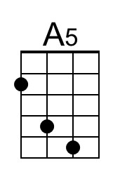
 |  |  |  |  |  |  |  | 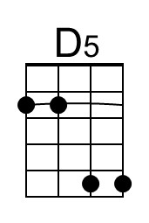
 |  |  |  |  |  |  |  | 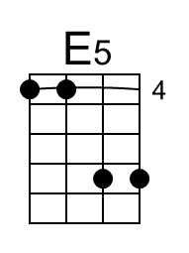
 |  |  |  |  |  |  |  | 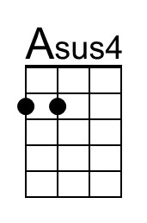
 |  |  |  |  |  |  |  | 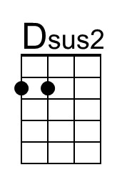
 |  |  |  |  |  |  |  | 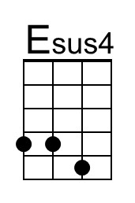
 |  |  |  |  |  |  |  | 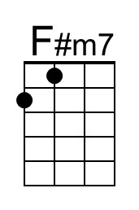
Baritone | 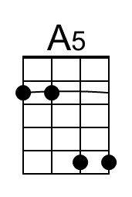 | 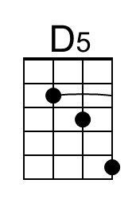 | 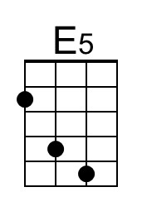 | 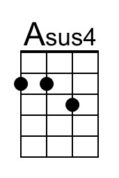 | 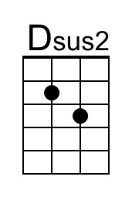 | 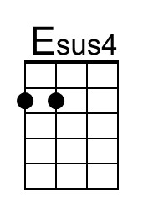 | 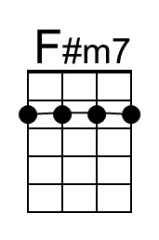

Better Days (John Rzeznik, 2005) (Ver. 3) (C)
Better Days by The Goo Goo Dolls (D @ 110) (Official Audio)
Better Days by The Goo Goo Dolls (D @ 110) (Official Music Video)
Better Days by The Goo Goo Dolls (D @ 110) (Live at Red Rocks, 2008)

Intro  | C | C | F | F | G | G | C | C  C F  And you ask me what I want this year, and I try to make this kind and clear.  G C - Csus4 | C  Just a chance that maybe we'll find better days.  C Fsus2  ‘Cause I don't need boxes wrapped in strings, and de-signer love and empty things.  Gsus4 Fsus2 C - Csus4 | C  Just a chance that maybe we'll find better days.  Chorus  F G F G  So take these words, and sing out loud ‘cause ev'ryone is for-given now.  Am7 Fsus2 C | C | C | C  ‘Cause to-night's the night the world begins a-gain.  C Fsus2  I need someplace simple where we could live and somethin' only you can give  Gsus4 Fsus2 C - Csus4 | C  And that’s faith and trust and peace while we're a-live.  C  And the one poor child that saved this world  Fsus2  And there's ten million more who probably could  Gsus4 Fsus2 C - Csus4 | C | C  If we all just stopped and said a prayer for them. Chorus  Optional Instrumental  C | C | F | F | Am7 | F | C | C  C F  I wish ev'ryone was loved tonight and somehow stop this endless fight.  Gsus4 Fsus2 C | C  Just a chance that maybe we'll find better days.  Outro  F G F G  So take these words, and sing out loud ‘cause ev'ryone is for-given now.  Am7 Fsus2 C - Csus4 | C  ‘Cause to-night's the night the world begins a-gain.  Am7 Fsus2 C  ‘Cause to-night's the night the world begins a-gain. (Hold) |  |  |  |  |  |  |  | 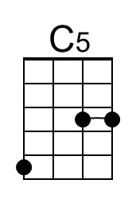
 |  |  |  |  |  |  |  | 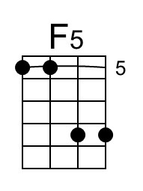
 |  |  |  |  |  |  |  | 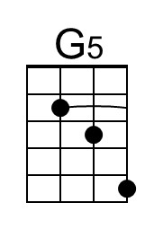
 |  |  |  |  |  |  |  | 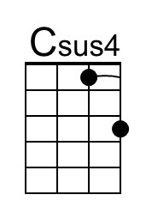
 |  |  |  |  |  |  |  | 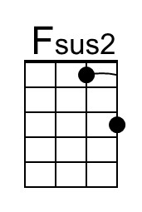
 |  |  |  |  |  |  |  | 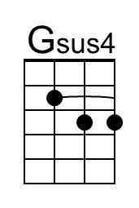
 |  |  |  |  |  |  |  | 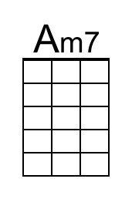
Baritone | 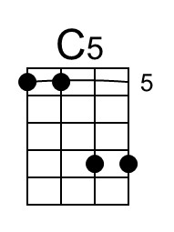 | 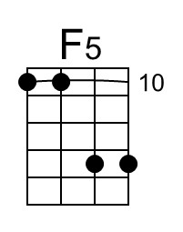 | 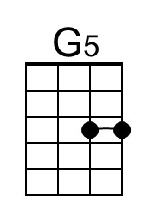 | 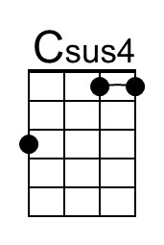 | 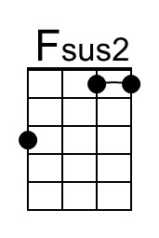 | 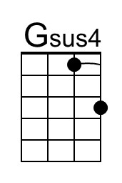 | 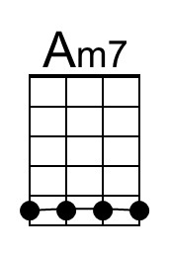
Better Days (John Rzeznik, 2005) (Ver. 3) (D)
Better Days by The Goo Goo Dolls (D @ 110) (Official Audio)
Better Days by The Goo Goo Dolls (D @ 110) (Official Music Video)
Better Days by The Goo Goo Dolls (D @ 110) (Live at Red Rocks, 2008)

Intro
| D | D | G | G | A | A | D | D

D G
And you ask me what I want this year, and I try to make this kind and clear.
A D - Dsus4 | D
Just a chance that maybe we'll find better days.
D Gsus2
‘Cause I don't need boxes wrapped in strings, and de-signer love and empty things.
Asus4 Gsus2 D - Dsus4 | D
Just a chance that maybe we'll find better days.

Chorus
G A G A
So take these words, and sing out loud ‘cause ev'ryone is for-given now.
Bm7 Gsus2 D | D | D | D
‘Cause to-night's the night the world begins a-gain.

D Gsus2
I need someplace simple where we could live and somethin' only you can give
Asus4 Gsus2 D - Dsus4 | D
And that’s faith and trust and peace while we're a-live.
D
And the one poor child that saved this world
Gsus2
And there's ten million more who probably could
Asus4 Gsus2 D - Dsus4 | D | D
If we all just stopped and said a prayer for them. Chorus

Optional Instrumental
D | D | G | G | Bm7 | G | D | D

D G
I wish ev'ryone was loved tonight and somehow stop this endless fight.
Asus4 Gsus2 D | D
Just a chance that maybe we'll find better days.

Outro
G A G A
So take these words, and sing out loud ‘cause ev'ryone is for-given now.
Bm7 Gsus2 D - Dsus4 | D
‘Cause to-night's the night the world begins a-gain.
Bm7 Gsus2 D
‘Cause to-night's the night the world begins a-gain. (Hold)
 |  |  |  |  |  |  |  | 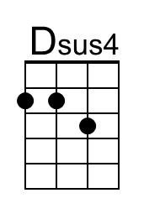
 |  |  |  |  |  |  |  | 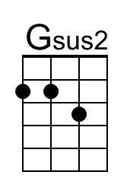
 |  |  |  |  |  |  |  | 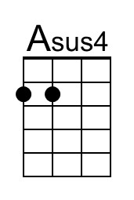
 |  |  |  |  |  |  |  | 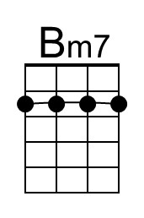
Baritone |  |  |  | 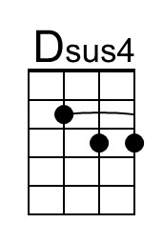 | 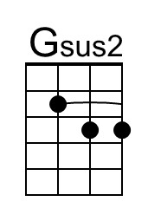 |  | 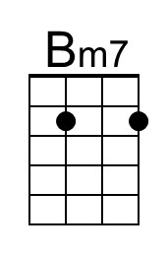
Better Days (John Rzeznik, 2005) (Ver. 3) (G)
Better Days by The Goo Goo Dolls (D @ 110) (Official Audio)
Better Days by The Goo Goo Dolls (D @ 110) (Official Music Video)
Better Days by The Goo Goo Dolls (D @ 110) (Live at Red Rocks, 2008)

Intro
| G | G | C | C | D | D | G | G

G C
And you ask me what I want this year, and I try to make this kind and clear.
D G - Gsus4 | G
Just a chance that maybe we'll find better days.
G Csus2
‘Cause I don't need boxes wrapped in strings, and de-signer love and empty things.
Dsus4 Csus2 G - Gsus4 | G
Just a chance that maybe we'll find better days.

Chorus
C D C D
So take these words, and sing out loud ‘cause ev'ryone is for-given now.
Em7 Csus2 G | G | G | G
‘Cause to-night's the night the world begins a-gain.

G Csus2
I need someplace simple where we could live and somethin' only you can give
Dsus4 Csus2 G - Gsus4 | G
And that’s faith and trust and peace while we're a-live.
G
And the one poor child that saved this world
Csus2
And there's ten million more who probably could
Dsus4 Csus2 G - Gsus4 | G | G
If we all just stopped and said a prayer for them. Chorus

Optional Instrumental
G | G | C | C | Em7 | C | G | G

G C
I wish ev'ryone was loved tonight and somehow stop this endless fight.
Dsus4 Csus2 G | G
Just a chance that maybe we'll find better days.

Outro
C D C D
So take these words, and sing out loud ‘cause ev'ryone is for-given now.
Em7 Csus2 G - Gsus4 | G
‘Cause to-night's the night the world begins a-gain.
Em7 Csus2 G
‘Cause to-night's the night the world begins a-gain. (Hold)
 |  |  |  |  |  |  |  | 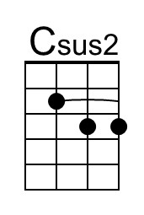
 |  |  |  |  |  |  |  | 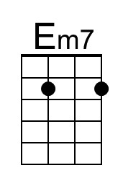
Baritone |  |  | 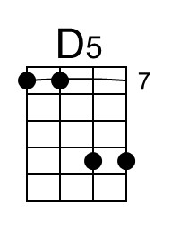 |  | 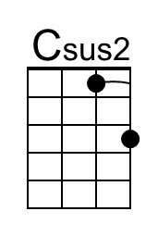 |  | 