Can't Help Falling In Love (D)
Hugo Peretti, Luigi Creatore, and George David Weiss (1961)
based on "Plaisir d'amour", a popular French love song by Jean-Paul-Égide Martini (1784)
Can't Help Falling In Love by Elvis Presley from the movie "Blue Hawaii" (1961) (D @ 100)
Can't Help Falling In Love by Elvis Presley (Live in Vegas, 1970)
Plaisir D'Amour by Joan Baez (1966)
12/8 Time
Intro
A | E | A | E

A C#m F#m Bm7 D A E
Wise men say __ only fools rush in,
D E F#m Bm A E A
But I can't help falling in love with you.

A C#m Bm F#m7 D A E
Shall I stay? ___ Would it be a sin?
D E F#m Bm A E A
If I can't help falling in love with you.

Chorus
C#m G#7 C#m G#7
Like a river flows surely to the sea,
C#m G#7 C#m F# Bm - E
Darling so it goes some things __ are meant to be.

A C#m Bm F#m7 D A E
Take my hand, ___ take my whole life too.
D E F#m Bm A E A
For I can't help falling in love with you.

Repeat from Chorus

Outro
D E F#m Bm A E A
For I can't help falling in love with you.

Can't Help Falling In Love (C)
Hugo Peretti, Luigi Creatore, and George David Weiss (1961)
based on "Plaisir d'amour", a popular French love song by Jean-Paul-Égide Martini (1784)
Can't Help Falling In Love by Elvis Presley from the movie "Blue Hawaii" (1961) (D @ 100)
Can't Help Falling In Love by Elvis Presley (Live in Vegas, 1970)
Plaisir D'Amour by Joan Baez (1966)
12/8 Time
Intro
C | G | C | G

C Em Am Am7 F C G
Wise men say __ only fools rush in,
F G Am Dm C G C
But I can't help falling in love with you.

C Em Am Am7 F C G
Shall I stay? ___ Would it be a sin?
F G Am Dm C G C
If I can't help falling in love with you.

Chorus
Em B7 Em B7
Like a river flows surely to the sea,
Em B7 Em A Dm - G
Darling so it goes some things _ are meant to be.

C Em Am Am7 F C G
Take my hand, ___ take my whole life too.
F G Am Dm C G C
For I can't help falling in love with you.

Repeat from Chorus

Outro
F G Am Dm C G C
For I can't help falling in love with you.

Can't Help Falling In Love (D)
Hugo Peretti, Luigi Creatore, and George David Weiss (1961)
based on "Plaisir d'amour", a popular French love song by Jean-Paul-Égide Martini (1784)
Can't Help Falling In Love by Elvis Presley from the movie "Blue Hawaii" (1961) (D @ 100)
Can't Help Falling In Love by Elvis Presley (Live in Vegas, 1970)
Plaisir D'Amour by Joan Baez (1966)
12/8 Time
Intro
D | A | D | A

D F#m Bm Bm7 G D A
Wise men say __ only fools rush in,
G A Bm Em D A D
But I can't help falling in love with you.

D F#m Bm Bm7 G D A
Shall I stay? ___ Would it be a sin?
G A Bm Em D A D
If I can't help falling in love with you.

Chorus
F#m C#7 F#m C#7
Like a river flows surely to the sea,
F#m C#7 F#m B Em - A
Darling so it goes some things __ are meant to be.

D F#m Bm Bm7 G D A
Take my hand, ___ take my whole life too.
G A Bm Em D A D
For I can't help falling in love with you.

Repeat from Chorus

Outro
G A Bm Em D A D
For I can't help falling in love with you.

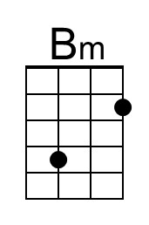 | 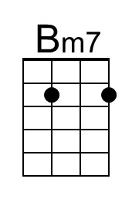 | 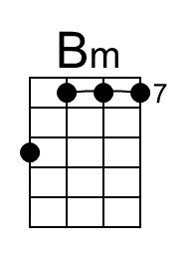 | 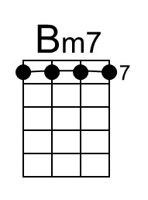

Can't Help Falling In Love (G)
Hugo Peretti, Luigi Creatore, and George David Weiss (1961)
based on "Plaisir d'amour", a popular French love song by Jean-Paul-Égide Martini (1784)
Can't Help Falling In Love by Elvis Presley from the movie "Blue Hawaii" (1961) (D @ 100)
Can't Help Falling In Love by Elvis Presley (Live in Vegas, 1970)
Plaisir D'Amour by Joan Baez (1966)
12/8 Time
Intro
G | D | G | D

G Bm Em Em7 C G D
Wise men say __ only fools rush in,
C D Em Am G D G
But I can't help falling in love with you.

G Bm Em Em7 C G D
Shall I stay? ___ Would it be a sin?
C D Em Am G D G
If I can't help falling in love with you.

Chorus
Bm F#7 Bm F#7
Like a river flows surely to the sea,
Bm F#7 Bm E Am - D
Darling so it goes some things __ are meant to be.

G Bm Em Em7 C G D
Take my hand, ___ take my whole life too.
C D Em Am G D G
For I can't help falling in love with you.

Repeat from Chorus

Outro
C D Em Am G D G
For I can't help falling in love with you.

