Coney Island Washboard (A)
Tune by Hampton Durand & Jerry Adams (1926);
Lyrics by Claude Shugart & Ned Nestor (by 1932)
Coney Island Washboard by the Five Harmaniacs (Instrumental, 1927) (D @ 126)
Coney Island Washboard by The Mills Brothers (1932)
Coney Island Washboard Woman by Israel Kamakawiwoole from his album "Ka Lāhui o Hawai'i Nei"(1989); IZ is playing this on a low g ukulele.
2/2 Time
Intro  B7 E7 A - E7  Coney Island Washboard rounde-lay.  A F#7 | F#7  On her Coney Island washboard she would play,  B7 | B7  You could hear her on the boardwalk every day.  E7 A F#7  Soap suds all around, bubbles on the ground,  B7 E7  Rub-a-dub-a-dub in her little tub all those tunes she found.  A F#7 | F#7  Thimbles on her fingers made a noise,  B7 | B7  She played “Charleston” with the laundry for the boys  Adim7  She could rag a tune right through the knees  A Gdim7 F#7  Of your brand new silk B. V. Ds,  B7 E7 A Adim7 | E7 |  With her Coney Island Washboard rounde-lay.  Instrumental Verse (Kazoo optional)  Repeat Verse 1  A F#7 | F#7  Thimbles on her fingers made a noise,  B7 | B7  She played “Charleston” with the laundry for the boys  Adim7  She could rag a tune right through the knees  A Gdim7 F#7  Of your brand new silk B. V. Ds,  B7 E7 B7 E7  Coney Island Washboard, Coney Island Washboard,  B7 E7 A Gdim7 E7 | A  Coney Island Washboard rounde-lay. | 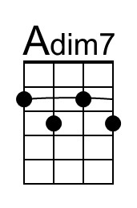
 | 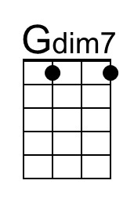
 | Bari
 | 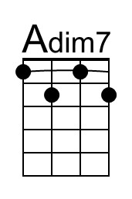
 | 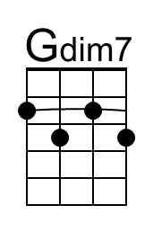

Coney Island Washboard (C)
Tune by Hampton Durand & Jerry Adams (1926);
Lyrics by Claude Shugart & Ned Nestor (by 1932)
Coney Island Washboard by the Five Harmaniacs (Instrumental, 1927) (D @ 126)
Coney Island Washboard by The Mills Brothers (1932)
Coney Island Washboard Woman by Israel Kamakawiwoole from his album "Ka Lāhui o Hawai'i Nei"(1989); IZ is playing this on a low g ukulele.
2/2 Time
Intro  D7 G7 C - G7  Coney Island Washboard rounde-lay.  C A7 | A7  On her Coney Island washboard she would play,  D7 | D7  You could hear her on the boardwalk every day.  G7 C A7  Soap suds all around, bubbles on the ground,  D7 G7  Rub-a-dub-a-dub in her little tub all those tunes she found.  C A7 | A7  Thimbles on her fingers made a noise,  D7 | D7  She played “Charleston” with the laundry for the boys  Cdim7  She could rag a tune right through the knees  C A#dim7 A7  Of your brand new silk B. V. Ds,  D7 G7 C Cdim7 | G7 |  With her Coney Island Washboard rounde-lay.  Instrumental Verse (Kazoo optional)  Repeat Verse 1  C A7 | A7  Thimbles on her fingers made a noise,  D7 | D7  She played “Charleston” with the laundry for the boys  Cdim7  She could rag a tune right through the knees  C A#dim7 A7  Of your brand new silk B. V. Ds,  D7 G7 D7 G7  Coney Island Washboard, Coney Island Washboard,  D7 G7 C A#dim7 G7 | C  Coney Island Washboard rounde-lay. | 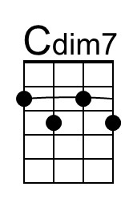
 | 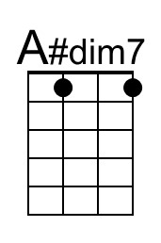
 | Bari
 | 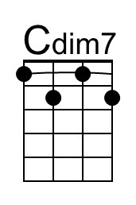
 | 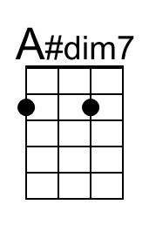

Coney Island Washboard (D)
Tune by Hampton Durand & Jerry Adams (1926);
Lyrics by Ned Nestor & Claude Shugart (by 1932)
Coney Island Washboard by the Five Harmaniacs (Instrumental, 1927) (D @ 126)
Coney Island Washboard by The Mills Brothers (1932)
Coney Island Washboard Woman by Israel Kamakawiwoole from his album "Ka Lāhui o Hawai'i Nei"(1989); IZ is playing this on a low g ukulele.
2/2 Time
Intro
E7 A7 D - A7
Coney Island Washboard rounde-lay.

D B7 | B7
On her Coney Island washboard she would play,
E7 | E7
You could hear her on the boardwalk every day.
A7 D B7
Soap suds all around, bubbles on the ground,
E7 A7
Rub-a-dub-a-dub in her little tub all those tunes she found.

D B7 | B7
Thimbles on her fingers made a noise,
E7 | E7
She played “Charleston” with the laundry for the boys
Ddim7
She could rag a tune right through the knees
D Cdim7 B7
Of your brand new silk B. V. Ds,
E7 A7 D Ddim7 | A7 |
With her Coney Island Washboard rounde-lay.

Instrumental Verse (Kazoo optional)

Repeat Verse 1

D B7 | B7
Thimbles on her fingers made a noise,
E7 | E7
She played “Charleston” with the laundry for the boys
Ddim7
She could rag a tune right through the knees
D Cdim7 B7
Of your brand new silk B. V. Ds,
E7 A7 E7 A7
Coney Island Washboard, Coney Island Washboard,
E7 A7 D Cdim7 A7 | D
Coney Island Washboard rounde-lay.
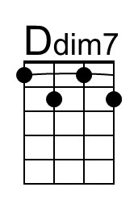
Bari
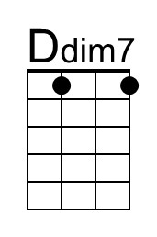

Coney Island Washboard (F)
Tune by Hampton Durand & Jerry Adams (1926);
Lyrics by Claude Shugart & Ned Nestor (by 1932)
Coney Island Washboard by the Five Harmaniacs (Instrumental, 1927) (D @ 126)
Coney Island Washboard by The Mills Brothers (1932)
Coney Island Washboard Woman by Israel Kamakawiwoole from his album "Ka Lāhui o Hawai'i Nei"(1989); IZ is playing this on a low g ukulele.
2/2 Time
Intro  G7 C7 F - C7  Coney Island Washboard rounde-lay.  F D7 | D7  On her Coney Island washboard she would play,  G7 | G7  You could hear her on the boardwalk every day.  C7 F D7  Soap suds all around, bubbles on the ground,  G7 C7  Rub-a-dub-a-dub in her little tub all those tunes she found.  F D7 | D7  Thimbles on her fingers made a noise,  G7 | G7  She played “Charleston” with the laundry for the boys  Fdim7  She could rag a tune right through the knees  F Ebdim7 D7  Of your brand new silk B. V. Ds,  G7 C7 F Fdim7 | C7 |  With her Coney Island Washboard rounde-lay.  Instrumental Verse (Kazoo optional)  Repeat Verse 1  F D7 | D7  Thimbles on her fingers made a noise,  G7 | G7  She played “Charleston” with the laundry for the boys  Fdim7  She could rag a tune right through the knees  F Ebdim7 D7  Of your brand new silk B. V. Ds,  G7 C7 G7 C7  Coney Island Washboard, Coney Island Washboard,  G7 C7 F Ebdim7 C7 | F  Coney Island Washboard rounde-lay. | 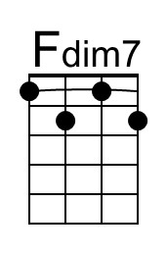
 | 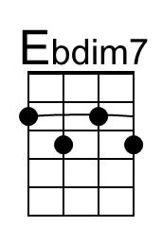
 | Bari
 | 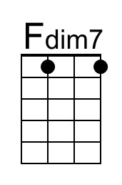
 | 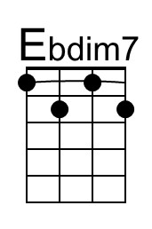

Coney Island Washboard (G)
Tune by Hampton Durand & Jerry Adams (1926);
Lyrics by Claude Shugart & Ned Nestor (by 1932)
Coney Island Washboard by the Five Harmaniacs (Instrumental, 1927) (D @ 126)
Coney Island Washboard by The Mills Brothers (1932)
Coney Island Washboard Woman by Israel Kamakawiwoole from his album "Ka Lāhui o Hawai'i Nei"(1989); IZ is playing this on a low g ukulele.
2/2 Time
Intro
A7 D7 G - D7
Coney Island Washboard rounde-lay.

G E7 | E7
On her Coney Island washboard she would play,
A7 | A7
You could hear her on the boardwalk every day.
D7 G E7
Soap suds all around, bubbles on the ground,
A7 D7
Rub-a-dub-a-dub in her little tub all those tunes she found.

G E7 | E7
Thimbles on her fingers made a noise,
A7 | A7
She played “Charleston” with the laundry for the boys
Gdim7
She could rag a tune right through the knees
G Fdim7 E7
Of your brand new silk B. V. Ds,
A7 D7 G Gdim7 | D7 |
With her Coney Island Washboard rounde-lay.

Instrumental Verse (Kazoo optional)

Repeat Verse 1

G E7 | E7
Thimbles on her fingers made a noise,
A7 | A7
She played “Charleston” with the laundry for the boys
Gdim7
She could rag a tune right through the knees
G Fdim7 E7
Of your brand new silk B. V. Ds,
A7 D7 A7 D7
Coney Island Washboard, Coney Island Washboard,
A7 D7 G Fdim7 D7 | G
Coney Island Washboard rounde-lay.
Bari

Notes & YouTube Links

The melody was written by two members of The Five Harmaniacs in 1926 who recorded the first instrumental version which was released the next year; the lyrics were created by two other members by 1932 when it was recorded by The Mills Brothers. According to a post at the Mudcat Cafe, The Five Harmaniacs were:
- Jerry Adams (real name: Harold Whitacre)
- Wayne Durand
- Walter Howard
- Ned Nestor
- Clyde Shugart

According to Second Hand Songs, 80 versions have been recorded by individuals, groups, dixieland jazz bands, and jug bands. Title and lyrics vary. This version based on 1926 sheet music, which passed into the public domain in 2021. A second version including both original verses is pending.

YouTube Links
- Coney Island Washboard by the Five Harmaniacs (1927) (D @ 126)
- Coney Island Washboard by The Mills Brothers (1932)
  - Download Coney Island Washboard by The Mills Brothers from Internet Archive
- by Hoagy Carmichael with Four Hits and a Miss (1953)
- Coney Island Washboard by the Firehouse Five Plus Two (1962) (Bb @ 111)
- Coney Island Washboard by Spanky and Our Gang on the Ed Sullivan Show (June 18, 1967) (C# @ 119)
- Coney Island Washboard by The Nitty Gritty Dirt Band from their album "Ricochet" (August 1967) (D @ 117)
- Coney Island Washboard Woman by Israel Kamakawiwoole from his album "Ka Lāhui o Hawai'i Nei"(1989) IZ is playing this on a low g ukulele.
  - Arrangement of Coney Island Washboard Woman by Israel Kamakawiwoole at Ultimate Guitar
- Coney Island Washboard Shore by Tom Degney, who has a cool strum that would be fun to aspire to!
- Coney Island Washboard by The Dapper Dans (the same Barbership quartet that was featured in “The Music Man”)
- Coney Island Washboard by Judith Durham & The Hottest Band In Town (Judith was formerly with The Seekers)
- Coney Island Washboard by Benko Dixieland Band
- Coney Island Washboard by Turk Murphy from "The Best Of New Orleans Jazz" (2010) including the rarely heard first verse.
- Coney Island Washboard Roundelay by the Trailer Trash Jazz Band (2012). Parking lot jam but later performed at the Americas Classic Jazz Festival: Coney Island Washboard Roundelay which also includes the first verse; starts out a little rough but the group pulls it together.

