Coney Island Washboard (A)
Tune: Hampton Durand & Jerry Adams (1926); Lyrics: Ned Nestor & Claude Shugart (by 1932)
Coney Island Washboard by the Five Harmaniacs (Instrumental, 1927) (D @ 126)
Coney Island Washboard by The Mills Brothers (1932)
Coney Island Washboard Woman by Israel Kamakawiwoole on a low G ukulele from his album "Ka Lāhui o Hawai'i Nei"(1989)

2/2 Time
Intro
E7 A7 D | A7
Coney Island Washboard rounde-lay.

A B7 Adim A E7 A
1. Down by the beach lived the sweetest little peach,
A B7 Adim A E7 A Gdim7 Bm F#7 Bm
And I must say she just had the cutest way, playing a chord up-on a washboard.
B7 E7
Folks would gather ‘round, from ev'rywhere in town, why just to hear her play.

Chorus
A F#7 | F#7
On her Coney Island washboard she would play,
B7 | B7
You could hear her on the boardwalk every day.
E7 A F#7
Soap suds all around, bubbles on the ground,
B7 E7
Rub-a-dub-a-dub in her little tub all her tunes she found.

A F#7 | F#7
Thimbles on her fingers made a noise,
B7 | B7
She played “Charleston” with the laundry for the boys.
Adim7
She could rag a tune right through the knees
A C#7 Gdim7 F#7
Of your brand new silk B. V. Ds,
B7 E7 A Adim7 E7 Gdim7 | E7
With her Coney Island Washboard rounde-lay.

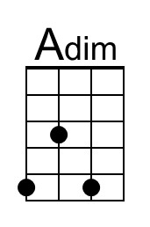 | 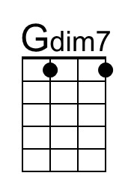 | 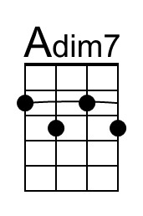 |  | Baritone | 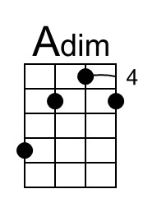 | 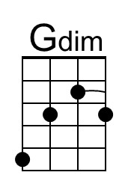 | 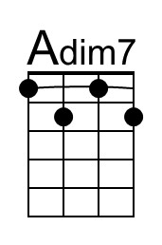

Coney Island Washboard (A) – Page 2

A B7 Adim A E7 A
2. You never heard sweeter notes from a song-bird.
A B7 Adim A E7 A
Can’t get e-nough when this baby does her stuff.
Gdim7 Bm F#7 Bm
She croons a-long when she plays a song.
B7 E7
She’s more than wonderful and more than marvelous. She just can’t go wrong.

Chorus
A F#7 | F#7
On her Coney Island washboard she would play,
B7 | B7
You could hear her on the boardwalk every day.
E7 A F#7
Soap suds all around, bubbles on the ground,
B7 E7
Rub-a-dub-a-dub in her little tub all her tunes she found.

A F#7 | F#7
Thimbles on her fingers made a noise,
B7 | B7
She played “Charleston” with the laundry for the boys.
Adim7
She could rag a tune right through the knees
A C#7 Gdim7 F#7
Of your brand new silk B. V. Ds,
B7 E7 A Adim7 E7 | A
With her Coney Island Washboard rounde-lay.

Coney Island Washboard sheet music is located at York University, Toronto, Canada.
It came into the public domain in the United States on January 1, 2022.
Chords for C-tuned ukulele (GCEA) from sheet music in the key of G published by Lewis Music Publishing Company, 1926. The name of the ukulele arranger was not given.

Coney Island Washboard (C)
Tune: Hampton Durand & Jerry Adams (1926); Lyrics: Ned Nestor & Claude Shugart (by 1932)
Coney Island Washboard by the Five Harmaniacs (Instrumental, 1927) (D @ 126)
Coney Island Washboard by The Mills Brothers (1932)
Coney Island Washboard Woman by Israel Kamakawiwoole on a low G ukulele from his album "Ka Lāhui o Hawai'i Nei"(1989)

2/2 Time
Intro
G7 C7 F | C7
Coney Island Washboard rounde-lay.

C D7 Cdim C G7 C
1. Down by the beach lived the sweetest little peach,
C D7 Cdim C G7 C Bbdim7 Dm A7 Dm
And I must say she just had the cutest way, playing a chord up-on a washboard.
D7 G7
Folks would gather ‘round, from ev'rywhere in town, why just to hear her play.

Chorus
C A7 | A7
On her Coney Island washboard she would play,
D7 | D7
You could hear her on the boardwalk every day.
G7 C A7
Soap suds all around, bubbles on the ground,
D7 G7
Rub-a-dub-a-dub in her little tub all her tunes she found.

C A7 | A7
Thimbles on her fingers made a noise,
D7 | D7
She played “Charleston” with the laundry for the boys.
Cdim7
She could rag a tune right through the knees
C E7 Bbdim7 A7
Of your brand new silk B. V. Ds,
D7 G7 C Cdim7 G7 Bbdim7 | G7
With her Coney Island Washboard rounde-lay.

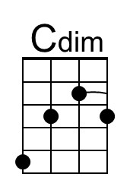 | 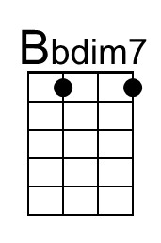 | 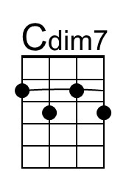 |  | Baritone | 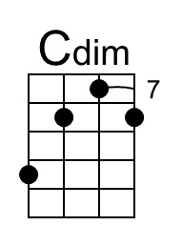 | 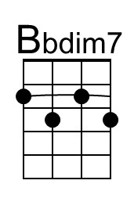 | 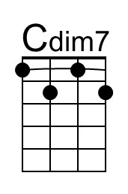

Coney Island Washboard (C) – Page 2

C D7 Cdim C G7 C
2. You never heard sweeter notes from a song-bird.
C D7 Cdim C G7 C
Can’t get e-nough when this baby does her stuff.
Bbdim7 Dm A7 Dm
She croons a-long when she plays a song.
D7 G7
She’s more than wonderful and more than marvelous. She just can’t go wrong.

Chorus
C A7 | A7
On her Coney Island washboard she would play,
D7 | D7
You could hear her on the boardwalk every day.
G7 C A7
Soap suds all around, bubbles on the ground,
D7 G7
Rub-a-dub-a-dub in her little tub all her tunes she found.

C A7 | A7
Thimbles on her fingers made a noise,
D7 | D7
She played “Charleston” with the laundry for the boys.
Cdim7
She could rag a tune right through the knees
C E7 Bbdim7 A7
Of your brand new silk B. V. Ds,
D7 G7 C Cdim7 G7 | C
With her Coney Island Washboard rounde-lay.

Coney Island Washboard sheet music is located at York University, Toronto, Canada.
It came into the public domain in the United States on January 1, 2022.
Chords for C-tuned ukulele (GCEA) from sheet music in the key of G published by Lewis Music Publishing Company, 1926. The name of the ukulele arranger was not given.

Coney Island Washboard (D)
Tune: Hampton Durand & Jerry Adams (1926); Lyrics: Claude Shugart & Ned Nestor (by 1932)
Coney Island Washboard by the Five Harmaniacs (Instrumental, 1927) (D @ 126)
Coney Island Washboard by The Mills Brothers (1932)
Coney Island Washboard Woman by Israel Kamakawiwoole on a low G ukulele from his album "Ka Lāhui o Hawai'i Nei"(1989)

2/2 Time
Intro
E7 A7 D | A7
Coney Island Washboard rounde-lay.

D E7 Ddim D A7 D
1. Down by the beach lived the sweetest little peach,
D E7 Ddim D A7 D Cdim7 Em B7 Em
And I must say she just had the cutest way, playing a chord up-on a washboard.
E7 A7
Folks would gather ‘round, from ev'rywhere in town, why just to hear her play.

Chorus
D B7 | B7
On her Coney Island washboard she would play,
E7 | E7
You could hear her on the boardwalk every day.
A7 D B7
Soap suds all around, bubbles on the ground,
E7 A7
Rub-a-dub-a-dub in her little tub all her tunes she found.

D B7 | B7
Thimbles on her fingers made a noise,
E7 | E7
She played “Charleston” with the laundry for the boys.
Ddim7
She could rag a tune right through the knees
D F#7 Cdim7 B7
Of your brand new silk B. V. Ds,
E7 A7 D Ddim7 A7 Cdim7 | A7
With her Coney Island Washboard rounde-lay.

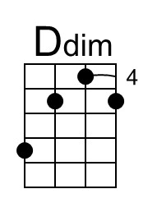 |  | 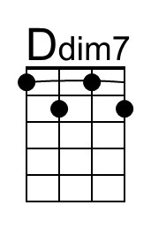 |  | Baritone | 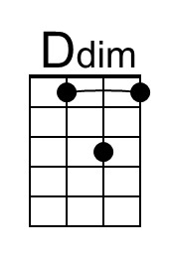 |  | 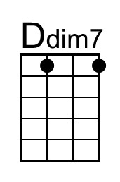

Coney Island Washboard (D) – Page 2

D E7 Ddim D A7 D
2. You never heard sweeter notes from a song-bird.
D E7 Ddim D A7 D
Can’t get e-nough when this baby does her stuff.
Cdim7 Em B7 Em
She croons a-long when she plays a song.
E7 A7
She’s more than wonderful and more than marvelous. She just can’t go wrong.

Chorus
D B7 | B7
On her Coney Island washboard she would play,
E7 | E7
You could hear her on the boardwalk every day.
A7 D B7
Soap suds all around, bubbles on the ground,
E7 A7
Rub-a-dub-a-dub in her little tub all her tunes she found.

D B7 | B7
Thimbles on her fingers made a noise,
E7 | E7
She played “Charleston” with the laundry for the boys.
Ddim7
She could rag a tune right through the knees
D F#7 Cdim7 B7
Of your brand new silk B. V. Ds,
E7 A7 D Ddim7 A7 | D
With her Coney Island Washboard rounde-lay.

Coney Island Washboard sheet music is located at York University, Toronto, Canada.
It came into the public domain in the United States on January 1, 2022.
Chords for C-tuned ukulele (GCEA) from sheet music in the key of G published by Lewis Music Publishing Company, 1926. The name of the ukulele arranger was not given.

Coney Island Washboard (F)
Tune: Hampton Durand & Jerry Adams (1926); Lyrics: Ned Nestor & Claude Shugart (by 1932)
Coney Island Washboard by the Five Harmaniacs (Instrumental, 1927) (D @ 126)
Coney Island Washboard by The Mills Brothers (1932)
Coney Island Washboard Woman by Israel Kamakawiwoole on a low G ukulele from his album "Ka Lāhui o Hawai'i Nei"(1989)

2/2 Time
Intro
C7 F7 Bb | F7
Coney Island Washboard rounde-lay.

F G7 Fdim F C7 F
1. Down by the beach lived the sweetest little peach,
F G7 Fdim F C7 F Ebdim7 Gm D7 Gm
And I must say she just had the cutest way, playing a chord up-on a washboard.
G7 C7
Folks would gather ‘round, from ev'rywhere in town, why just to hear her play.

Chorus
F D7 | D7
On her Coney Island washboard she would play,
G7 | G7
You could hear her on the boardwalk every day.
C7 F D7
Soap suds all around, bubbles on the ground,
G7 C7
Rub-a-dub-a-dub in her little tub all her tunes she found.

F D7 | D7
Thimbles on her fingers made a noise,
G7 | G7
She played “Charleston” with the laundry for the boys.
Fdim7
She could rag a tune right through the knees
F A7 Ebdim7 D7
Of your brand new silk B. V. Ds,
G7 C7 F Fdim7 C7 Ebdim7 | C7
With her Coney Island Washboard rounde-lay.

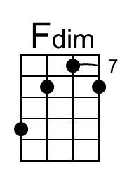 | 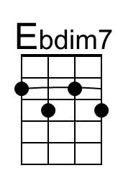 | 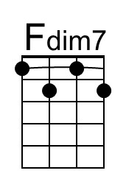 |  | Baritone | 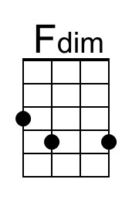 | 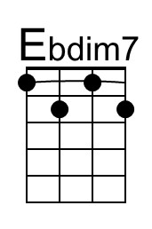 | 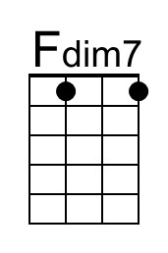

Coney Island Washboard (F) – Page 2

F G7 Fdim F C7 F
2. You never heard sweeter notes from a song-bird.
F G7 Fdim F C7 F
Can’t get e-nough when this baby does her stuff.
Ebdim7 Gm D7 Gm
She croons a-long when she plays a song.
G7 C7
She’s more than wonderful and more than marvelous. She just can’t go wrong.

Chorus
F D7 | D7
On her Coney Island washboard she would play,
G7 | G7
You could hear her on the boardwalk every day.
C7 F D7
Soap suds all around, bubbles on the ground,
G7 C7
Rub-a-dub-a-dub in her little tub all her tunes she found.

F D7 | D7
Thimbles on her fingers made a noise,
G7 | G7
She played “Charleston” with the laundry for the boys.
Fdim7
She could rag a tune right through the knees
F A7 Ebdim7 D7
Of your brand new silk B. V. Ds,
G7 C7 F Fdim7 C7 | F
With her Coney Island Washboard rounde-lay.

Coney Island Washboard sheet music is located at York University, Toronto, Canada.
It came into the public domain in the United States on January 1, 2022.
Chords for C-tuned ukulele (GCEA) from sheet music in the key of G published by Lewis Music Publishing Company, 1926. The name of the ukulele arranger was not given.

Coney Island Washboard (G)
Tune: Hampton Durand & Jerry Adams (1926); Lyrics: Ned Nestor & Claude Shugart (by 1932)
Coney Island Washboard by the Five Harmaniacs (Instrumental, 1927) (D @ 126)
Coney Island Washboard by The Mills Brothers (1932)
Coney Island Washboard Woman by Israel Kamakawiwoole on a low G ukulele from his album "Ka Lāhui o Hawai'i Nei"(1989)

2/2 Time
Intro
D7 G7 C | G7
Coney Island Washboard rounde-lay.

G A7 Gdim G D7 G
1. Down by the beach lived the sweetest little peach,
G A7 Gdim G D7 G Fdim7 Am E7 Am
And I must say she just had the cutest way, playing a chord up-on a washboard.
A7 D7
Folks would gather ‘round, from ev'rywhere in town, why just to hear her play.

Chorus
G E7 | E7
On her Coney Island washboard she would play,
A7 | A7
You could hear her on the boardwalk every day.
D7 G E7
Soap suds all around, bubbles on the ground,
A7 D7
Rub-a-dub-a-dub in her little tub all her tunes she found.

G E7 | E7
Thimbles on her fingers made a noise,
A7 | A7
She played “Charleston” with the laundry for the boys.
Gdim7
She could rag a tune right through the knees
G B7 Fdim7 E7
Of your brand new silk B. V. Ds,
A7 D7 G Gdim7 D7 Fdim7 | D7
With her Coney Island Washboard rounde-lay.

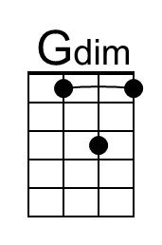 |  |  |  | Baritone |  |  | 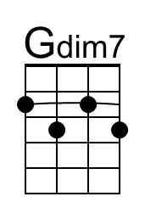

Coney Island Washboard (G) – Page 2

G A7 Gdim G D7 G
2. You never heard sweeter notes from a song-bird.
G A7 Gdim G D7 G
Can’t get e-nough when this baby does her stuff.
Fdim7 Am E7 Am
She croons a-long when she plays a song.
A7 D7
She’s more than wonderful and more than marvelous. She just can’t go wrong.

Chorus
G E7 | E7
On her Coney Island washboard she would play,
A7 | A7
You could hear her on the boardwalk every day.
D7 G E7
Soap suds all around, bubbles on the ground,
A7 D7
Rub-a-dub-a-dub in her little tub all her tunes she found.

G E7 | E7
Thimbles on her fingers made a noise,
A7 | A7
She played “Charleston” with the laundry for the boys.
Gdim7
She could rag a tune right through the knees
G B7 Fdim7 E7
Of your brand new silk B. V. Ds,
A7 D7 G Gdim7 D7 | G
With her Coney Island Washboard rounde-lay.

Coney Island Washboard sheet music is located at York University, Toronto, Canada.
It came into the public domain in the United States on January 1, 2022.
Chords for C-tuned ukulele (GCEA) from sheet music in the key of G published by Lewis Music Publishing Company, 1926. The name of the ukulele arranger was not given.

