I Love Those J-I-N-G-L-E Bells (Alt.) (C)
James Pierpont, 1857, adapted by Gordon Jenkins, ca. 1957
I Love Those J-I-N-G-L-E Bells by Frank Sinatra (1957)
Arrangement by Theresa Miller – Shortened version, without the verses.

Intro: Bells Jingling: ↓ ↓ ↓ ↓ ↓ ↓ ↓ ↓
F↓ ↓ ↓ ↓ C ↓ ↓ ↓ ↓ G ↓ ↓ G7 ↓ ↓ C ↓ ↓
Oh, what fun it is to ride in a one horse open sleigh

Chorus
G7 C G7↓ G7 C Am G G7↓
I love those J-I-N--G-L-E bells, Oh, those holiday J-I-N--G-L-E bells, Oh,
G7 C C7 F D7
Those happy J-I-N--G-L-E B-E-double-L-S
C G7 C G7 → (or G7#5)
I love those J-I-N--G-L-E bells Oh,

C C7
Jingle bells, jingle bells, jingle all the way
F C D7 G7
Oh, what fun it is to ride in a one horse open sleigh
C C7
Jingle bells, jingle bells, jingle all the way
F C G G7 C
Oh, what fun it is to ride in a one horse open sleigh. Chorus

Bridge
C C7
Ho, ho, ho Ho, ho ho, Ho ho ho ho ho
F C D7 G7 (or G7#5)
Ho, ho, ho, ho Ho ho ho Ho, ho, ho, ho Ho

C C7
Jingle bells, jingle bells, jingle all the way
F C G G7 C
Oh, what fun it is to ride in a one horse open sleigh.

Outro
G7 C G7↓ G7 C Am G G7↓
I love those J-I-N--G-L-E bells, Oh, Those holiday J-I-N--G-L-E bells, Oh,
G7 C C7 F D7
Those happy J-I-N--G-L-E B-E-double-L-S
C G7 C ↓ ↓ ↓ ↓ B↓↓ C↓
I love those jingle bells _ all the way!

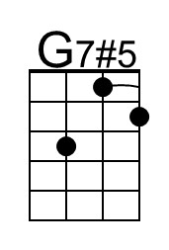 | 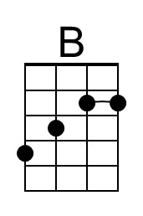 | 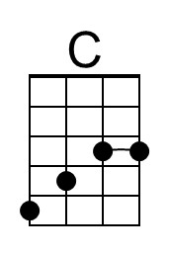 |  | Baritone | 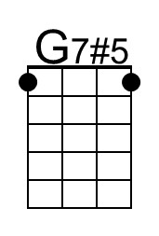 | 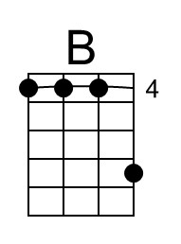 | 