I'll Be Seeing You (Sammy Fain and Irving Kahal, 1938) (C)
Version 1
I’ll Be Seeing You by Liberace – I’ll Be Seeing You by Vera Lynn (with Intro verse)

Intro  D7 Dm Fm C | G7 |  I'll be looking at the moon, but I'll be seeing you.  C E7 Dm A7 Dm A7  1. I'll be seeing you, in all the old fa-miliar places  Dm A7 Dm G7 C  That this heart of mine em-braces, all day through  Am Dm  In that small cafe, the park across the way  G7 C G7  The children's carousel, the chestnut trees, the wishing well  C E7 Dm A7 Dm A7  2. I'll be seeing you, in every lovely summer's day  Dm A7 Dm G7 Gm A7  In every-thing that's light and gay, I'll always think of you that way.  Dm E7 Am D7  I'll find you in the morning sun, and when the night is new  ______________________________________________________  │ Dm Fm C | G7  │ 1. I'll be looking at the moon, _ but I'll be seeing you. Repeat 2nd Verse  ______________________________________________________  │ Dm Fm C Dm | Fm | C  │ 2. I'll be looking at the moon, _ but I'll be seeing you. |  |  |  |  |  |  | 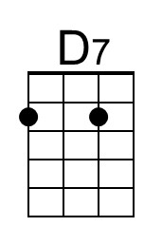 | 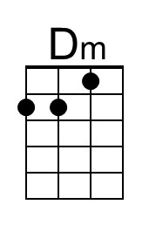
 |  |  |  |  |  |  | 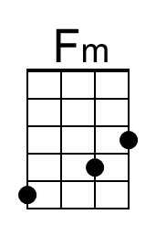 | 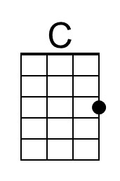
 |  |  |  |  |  |  | 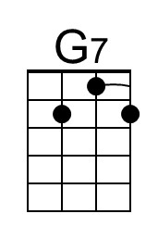 | 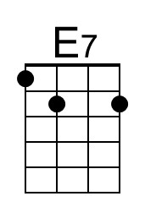
 |  |  |  |  |  |  | 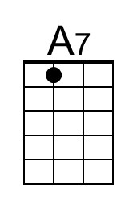 | 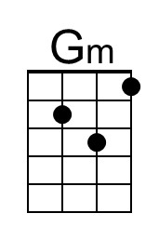
 |  |  |  |  |  |  | 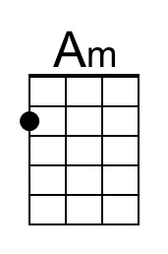
Bari
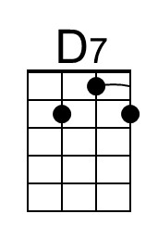 | 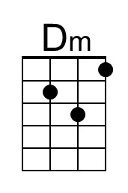 | 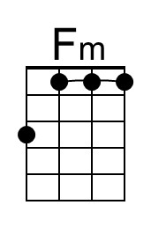 | 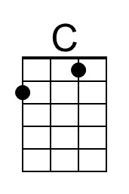 | 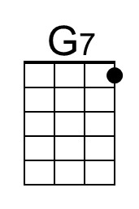 | 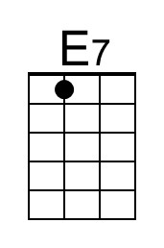 | 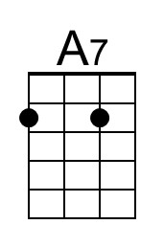 | 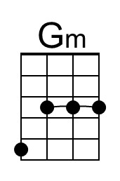 | 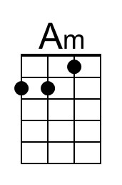

I'll Be Seeing You (Sammy Fain and Irving Kahal, 1938) (F)
Version 1
I’ll Be Seeing You by Liberace – I’ll Be Seeing You by Vera Lynn (with Intro verse)

Intro
G7 Gm Bbm F | C7 |
I'll be looking at the moon, but I'll be seeing you.

F A7 Gm D7 Gm D7
1. I'll be seeing you, in all the old fa-miliar places
Gm D7 Gm C7 F
That this heart of mine em-braces, all day through
Dm Gm
In that small cafe, the park across the way
C7 F C7
The children's carousel, the chestnut trees, the wishing well

F A7 Gm D7 Gm D7
2. I'll be seeing you, in every lovely summer's day
Gm D7 Gm C7 Cm D7
In every-thing that's light and gay, I'll always think of you that way.
Gm A7 Dm G7
I'll find you in the morning sun, and when the night is new
______________________________________________________
│ Gm Bbm F | C7
│ 1. I'll be looking at the moon, _ but I'll be seeing you. Repeat 2nd Verse
______________________________________________________
│ Gm Bbm F Gm | Bbm | F
│ 2. I'll be looking at the moon, _ but I'll be seeing you.

 |  |  |  |  |  |  | 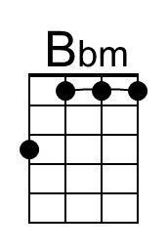 | 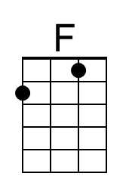
 |  |  |  |  |  |  | 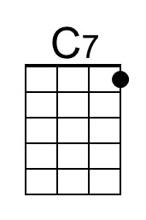
 |  |  |  |  |  |  | 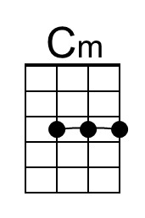
Bari
 |  | 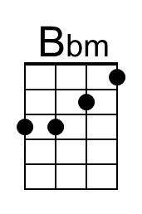 | 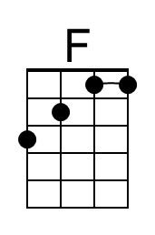 | 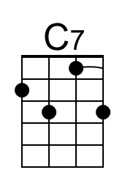 |  |  |  | 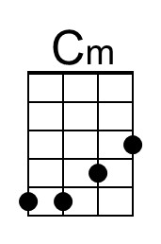

I'll Be Seeing You (Sammy Fain and Irving Kahal, 1938) (G)
Version 1
I’ll Be Seeing You by Liberace – I’ll Be Seeing You by Vera Lynn (with Intro verse)

Intro
A7 Am Cm G | D7 |
I'll be looking at the moon, but I'll be seeing you.

G B7 Am E7 Am E7
1. I'll be seeing you, in all the old fa-miliar places
Am E7 Am D7 G
That this heart of mine em-braces, all day through
Em Am
In that small cafe, the park across the way
D7 G D7
The children's carousel, the chestnut trees, the wishing well

G B7 Am E7 Am E7
2. I'll be seeing you, in every lovely summer's day
Am E7 Am D7 Dm E7
In every-thing that's light and gay, I'll always think of you that way.
Am B7 Em A7
I'll find you in the morning sun, and when the night is new
______________________________________________________
│ Am Cm G | D7
│ 1. I'll be looking at the moon, _ but I'll be seeing you. Repeat 2nd Verse
______________________________________________________
│ Am Cm G Am | Cm | G
│ 2. I'll be looking at the moon, _ but I'll be seeing you.

 |  |  |  |  |  |  |  | 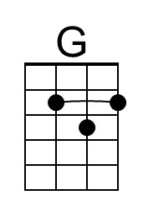
 |  |  |  |  |  |  |  | 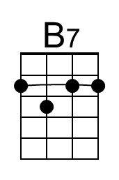
 |  |  |  |  |  |  | 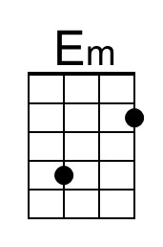
Bari
 |  |  | 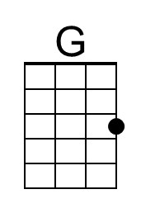 |  | 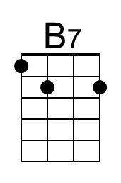 |  |  | 