Music! Music! Music! (Bernie Baum and Stephen Weiss, 1949) (A)
Music! Music! Music! by Theresa Brewer & The Dixieland All Stars featuring Jack Pleis on piano (1949) (C) [the 1st of five versions recorded by Ms. Brewer]
Music! Music! Music! by Guy Mitchell (D)
"Put Another Nickel In - Music, Music, Music (The Nickelodeon Song)" by Etienne Paree with Eddie "Piano" Miller (1949) (1st Recording)
4/4 Time
Intro
B7 E7 A E7 A (E7)
All I want is having you and music! music! music!

A F#m
Put another nickel in, in the nickelodeon
B7 E7 A - E7
All I want is having you and music! music! music!
A F#m
I’d do anything for you, anything you want me to
B7 E7 A - A7
All I want is kissing you and music, music, music!

Bm A
Closer, my dear, come closer
E7
The nicest part of any melody
A C#dim7 Bm7 E7
is when you’re dancing close to me

E7#5 A F#m
So, put another nickel in, in the nickelodeon
B7 E7 A - E7
All I want is having you and music! music! music!

Repeat from top (Kazoo first two lines)

Outro
B7 E7 A ↓↓ E7 ↓↓ A ↓↓ - E7 ↓ ↓ A ↓
All I want is having you and music! music! music!

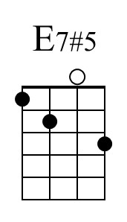 | 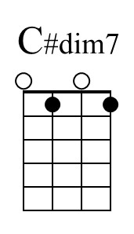 |  | Baritone | 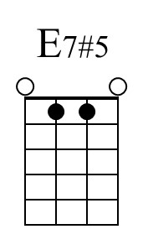 | 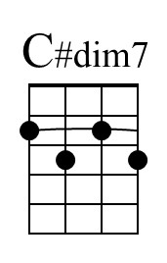

Music! Music! Music! (Bernie Baum and Stephen Weiss, 1949) (C)
Music! Music! Music! by Theresa Brewer & The Dixieland All Stars featuring Jack Pleis on piano (1949) (C) [the 1st of five versions recorded by Ms. Brewer]
Music! Music! Music! by Guy Mitchell (D)
"Put Another Nickel In - Music, Music, Music (The Nickelodeon Song)" by Etienne Paree with Eddie "Piano" Miller (1949) (1st Recording)
4/4 Time
Intro
D7 G7 C G7 C (G7)
All I want is having you and music! music! music!

C Am
Put another nickel in, in the nickelodeon
D7 G7 C - G7
All I want is having you and music! music! music!
C Am
I’d do anything for you, anything you want me to
D7 G7 C - C7
All I want is kissing you and music, music, music!

Dm C
Closer, my dear, come closer
G7
The nicest part of any melody
C Edim7 Dm7 G7
is when you’re dancing close to me

G7#5 C Am
So, put another nickel in, in the nickelodeon
D7 G7 C - G7
All I want is having you and music! music! music!

Repeat from top (Kazoo first two lines)

Outro
D7 G7 C ↓↓ G7 ↓↓ C ↓↓ - G7 ↓ ↓ C ↓
All I want is having you and music! music! music!

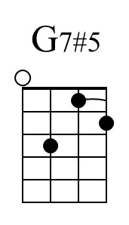 | 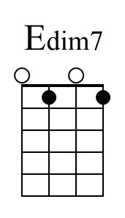 |  | Baritone | 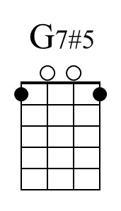 | 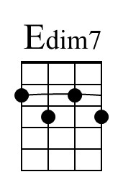

Music! Music! Music! (Bernie Baum and Stephen Weiss, 1949) (G)
Music! Music! Music! by Theresa Brewer & The Dixieland All Stars featuring Jack Pleis on piano (1949) (C) [the 1st of five versions recorded by Ms. Brewer]
Music! Music! Music! by Guy Mitchell (D)
"Put Another Nickel In - Music, Music, Music (The Nickelodeon Song)" by Etienne Paree with Eddie "Piano" Miller (1949) (1st Recording)
4/4 Time
Intro
A7 D7 G D7 G (D7)
All I want is having you and music! music! music!

G Em
Put another nickel in, in the nickelodeon
A7 D7 G - D7
All I want is having you and music! music! music!
G Em
I’d do anything for you, anything you want me to
A7 D7 G - G7
All I want is kissing you and music, music, music!

Am G
Closer, my dear, come closer
D7
The nicest part of any melody
G Bdim7 Am7 D7
is when you’re dancing close to me.

D7#5 G Em
So, put another nickel in, in the nickelodeon
A7 D7 G - D7
All I want is having you and music! music! music!

Repeat from top (Kazoo first two lines)

Outro
A7 D7 G ↓↓ D7 ↓↓ G ↓↓ - D7 ↓ ↓ G ↓
All I want is having you and music! music! music!

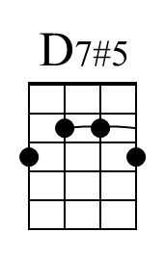 | Or | 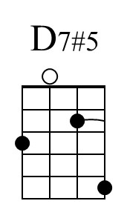 | 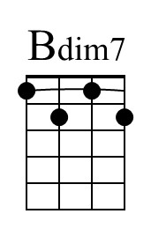 |  | Baritone | 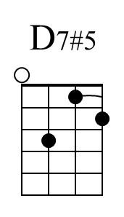 | 