Reindeer Rising (A)
Tune: Bad Moon Rising by John C. Fogerty (ca. 1969)
Words: Parody by Keith Fukumitsu (2023)

Intro (2x)  A | E D | A | A |  A E D A  I see rein-deer a-rising.  A E D A  I see Santa on the way.  A E D A  I see tin-sel and stockings  A E D A  I see Christ-mas to-day.  Chorus  D A  Well, go out Christmas night, you’re bound to see a sight,  E D A  There’s some reindeer on the rise.  A E D A  I see snow-flakes a-blowing.  A E D A  I know that Santa’s coming soon.  A E D A  I hope the gifts are over-flowing.  A E D A  I hear the sound of ho-ho-hoin’. Chorus  A E D A  Hope Santa’s got the team to-gether.  A E D A  Hope they are quite prepared to fly.  A E D A  Looks like we’re in for snowy weather.  A E D A  Hope I can spot them in the sky. Chorus (2x)  Note  A good interpretation of the strumming patterns in this song can be seen at Ultimate Guitar, Bad Moon Rising (Version 1). | 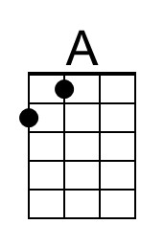
 | 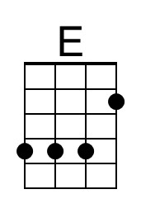
 | 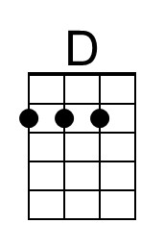
 | Baritone
 | 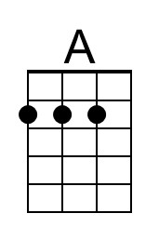
 | 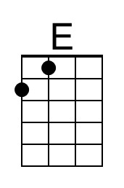
 | 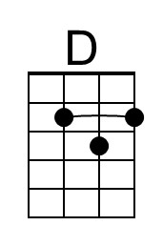

Reindeer Rising (C)
Tune: Bad Moon Rising by John C. Fogerty (ca. 1969)
Words: Parody by Keith Fukumitsu (2023)

Intro (2x)  C | G F | C | C |  C G F C  I see rein-deer a-rising.  C G F C  I see Santa on the way.  C G F C  I see tin-sel and stockings  C G F C  I see Christ-mas to-day.  Chorus  F C  Well, go out Christmas night, you’re bound to see a sight,  G F C  There’s some reindeer on the rise.  C G F C  I see snow-flakes a-blowing.  C G F C  I know that Santa’s coming soon.  C G F C  I hope the gifts are over-flowing.  C G F C  I hear the sound of ho-ho-hoin’. Chorus  C G F C  Hope Santa’s got the team to-gether.  C G F C  Hope they are quite prepared to fly.  C G F C  Looks like we’re in for snowy weather.  C G F C  Hope I can spot them in the sky. Chorus (2x)  Note  A good interpretation of the strumming patterns in this song can be seen at Ultimate Guitar, Bad Moon Rising (Version 1). | 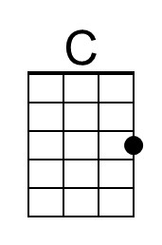
 | 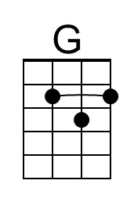
 | 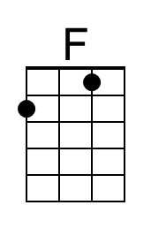
 | Baritone
 | 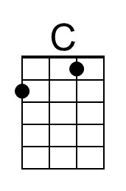
 | 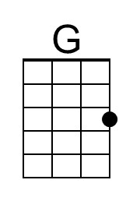
 | 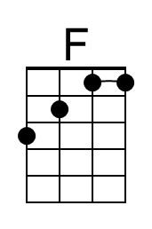
Reindeer Rising (D)
Tune: Bad Moon Rising by John C. Fogerty (ca. 1969)
Words: Parody by Keith Fukumitsu (2023)

Intro (2x)
D | A G | D | D |

D A G D
I see rein-deer a-rising.
D A G D
I see Santa on the way.
D A G D
I see tin-sel and stockings
D A G D
I see Christ-mas to-day.

Chorus
G D
Well, go out Christmas night, you’re bound to see a sight,
A G D
There’s some reindeer on the rise.

D A G D
I see snow-flakes a-blowing.
D A G D
I know that Santa’s coming soon.
D A G D
I hope the gifts are over-flowing.
D A G D
I hear the sound of ho-ho-hoin’. Chorus

D A G D
Hope Santa’s got the team to-gether.
D A G D
Hope they are quite prepared to fly.
D A G D
Looks like we’re in for snowy weather.
D A G D
Hope I can spot them in the sky. Chorus (2x)

Note
A good interpretation of the strumming patterns in this song can be seen at Ultimate Guitar, Bad Moon Rising (Version 1).
Baritone
Reindeer Rising (F)
Tune: Bad Moon Rising by John C. Fogerty (ca. 1969)
Words: Parody by Keith Fukumitsu (2023)

Intro (2x)
F | C Bb | F | F |

F C Bb F
I see rein-deer a-rising.
F C Bb F
I see Santa on the way.
F C Bb F
I see tin-sel and stockings
F C Bb F
I see Christ-mas to-day.

Chorus
Bb F
Well, go out Christmas night, you’re bound to see a sight,
C Bb F
There’s some reindeer on the rise.

F C Bb F
I see snow-flakes a-blowing.
F C Bb F
I know that Santa’s coming soon.
F C Bb F
I hope the gifts are over-flowing.
F C Bb F
I hear the sound of ho-ho-hoin’. Chorus

F C Bb F
Hope Santa’s got the team to-gether.
F C Bb F
Hope they are quite prepared to fly.
F C Bb F
Looks like we’re in for snowy weather.
F C Bb F
Hope I can spot them in the sky. Chorus (2x)

Note
A good interpretation of the strumming patterns in this song can be seen at Ultimate Guitar, Bad Moon Rising (Version 1).
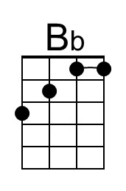
Baritone
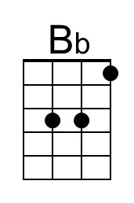
Reindeer Rising (G)
Tune: Bad Moon Rising by John C. Fogerty (ca. 1969)
Words: Parody by Keith Fukumitsu (2023)

Intro (2x)
G | D C | G | G |

G D C G
I see rein-deer a-rising.
G D C G
I see Santa on the way.
G D C G
I see tin-sel and stockings
G D C G
I see Christ-mas to-day.

Chorus
C G
Well, go out Christmas night, you’re bound to see a sight,
D C G
There’s some reindeer on the rise.

G D C G
I see snow-flakes a-blowing.
G D C G
I know that Santa’s coming soon.
G D C G
I hope the gifts are over-flowing.
G D C G
I hear the sound of ho-ho-hoin’. Chorus

G D C G
Hope Santa’s got the team to-gether.
G D C G
Hope they are quite prepared to fly.
G D C G
Looks like we’re in for snowy weather.
G D C G
Hope I can spot them in the sky. Chorus (2x)

Note
A good interpretation of the strumming patterns in this song can be seen at Ultimate Guitar, Bad Moon Rising (Version 1).
Baritone

