Sentimental Journey (C)
Les Brown, Ben Homer, Bud Green (ca. 1942)
Sentimental Journey by Les Brown & His Band of Renown featuring Doris Day (1944)
Sentimental Journey by The Merry Macs (1944)
Adapted from the original sheet music.

Intro
C F7 C F Em Adim7 G7
__ Gonna make a sentimental journey __to renew old mem – o – ries.

C Em Ab7 G7
__ Gonna take a sentimental journey, __ gonna set my heart at ease,
C F7 C F Em Adim7 C
__ Gonna make a sentimental journey __ to renew old mem – o – ries.

C Em Ab7 G7
__ Got my bag, got my reservation; __ spent each dime I could af – ford.
C F7 C F Em - Adim7 G7 C
__ Like a child in wild anticipation, __ long to hear that “All a – board.”

Bridge
Fdim7 - F Fdim7 F Cdim7 C
Sev - en, that’s the time we leave, at sev – en.
Cdim7 D7
I’ll be waitin’ up for Heaven,
G7 Dm7 Gdim7 G7
Countin’ ev’ry mile of railroad track that takes me back.

C Em Ab7 G7
__ Never thought my heart could be so yearny. __ Why did I de-cide to roam?
C F7 C F Em - Adim7 G7 C
__ Gonna take this sentimental journey, __ Senti-mental jour - ney home.

Repeat from Bridge

Outro
C Em - Adim7 G7 C
__ Senti-mental jour - ney home.

 | 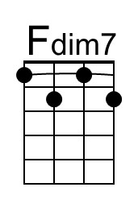 | 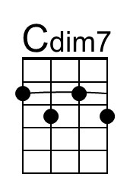 | 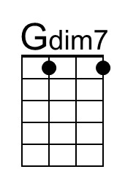 |  | Baritone |  | 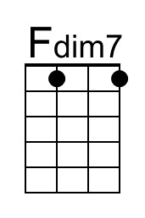 | 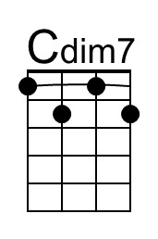 | 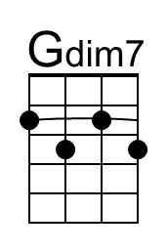

First recording (there was a musician’s strike, 1942-1944) and first #1 hit for Doris Day.
The group modulates or augments the verse eight times in the last half of the song – in one take!

