Sentimental Journey (C)
Les Brown, Ben Homer, Bud Green (1942)
Sentimental Journey by Les Brown & His Band of Renown featuring Doris Day (1944)
Sentimental Journey by The Merry Macs (1944)
Arrangement from the original sheet music.

Intro
C F9 - Fm6 C F Em Adim7 G7
__ Gonna make a sentimental journey __to renew old mem – o – ries.

C Em Ab9 G7
__ Gonna take a sentimental journey, __ gonna set my heart at ease,
C F9 - Fm6 C F Em Adim7 C
__ Gonna make a sentimental journey __to renew old mem – o – ries.

C Em Ab9 G7
__ Got my bag, got my reservation; __ spent each dime I could af – ford.
C F9 - Fm6 C F Em - Adim7 G7 C
__ Like a child in wild antici-pation, __ long to hear that “All a – board.”

Bridge
Fdim7 - F Fdim7 F Cdim7 C
Seven, that’s the time we leave, at sev – en.
Cdim7 C#7 D7
I’ll be waitin’ up for Hea – ven,
C#7 D9 G7 G6 Dm7 G6 Gdim7 G9
Countin’ ev’ry mile of rail - road track that takes me back.

C Em Ab9 G7
__ Never thought my heart could be so yearny. __ Why did I de-cide to roam?
C F9 - Fm6 C - F Em - Adim7 G7 C
__ Gonna take this sentimental journey, __ Senti-mental jour - ney home.

Repeat from Bridge

Outro
C Em - Adim7 G7 C
__ Senti-mental jour - ney home.

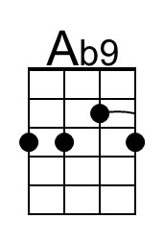 | 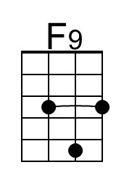 | 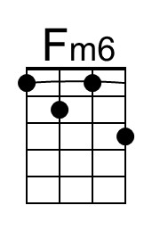 |  | 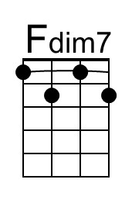 | 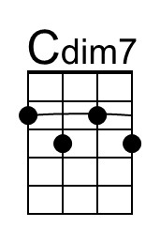 | 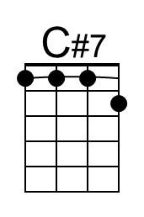 | 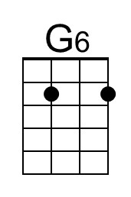 | 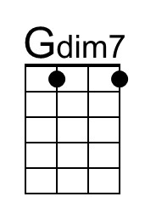 | 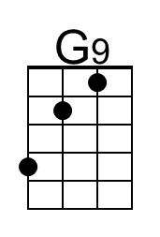
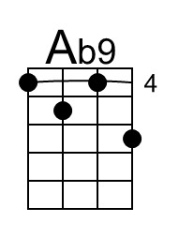 | 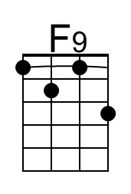 | 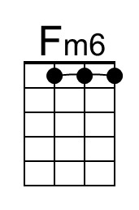 |  | 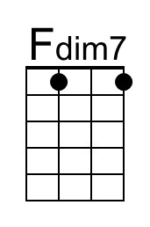 | 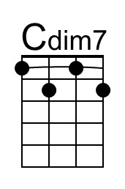 | 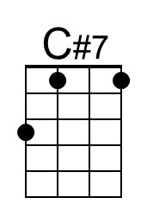 | 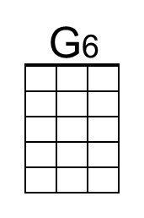 | 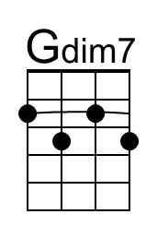 | 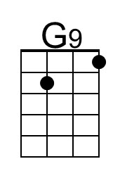

The group modulates or augments the verse eight times in the last half of the song – in one take!

