Spooky (Am)
Buddy Buie, Harry Middlebrooks, James R. Cobb, & Mike Shapiro, 1967
Spooky by the Classics IV (1967) (Cm @ 107)
Spooky by the Atlanta Rhythm Section (1979) (Cm @ 106)

Intro | ↓ _ ↓ ↑ _ ↓ | ↓ ↑ . ↓ | ↓ _ ↓ ↑ _ ↓ | ↓ ↑ . ↓
 | Am7 | D6 | Am7 | D6

Am7 D6 Am7 | D6
In the cool of the evening when everything is gettin’ kind of groovy.
Am7 D6 Am7 | D6
I call you up and ask you would I like to go with you and see a movie.
Am7
First you say no you’ve got some plans for the night.
D6 Ebm7
And then you stop ( Stop ) .… and say – “all right”
Am7 D6 Am7 | Em
Love is kinda crazy with a spooky little girl like you.

Am7 D6 Am7 | D6
You always keep me guessin’, I never seem to know what you are thinkin’.
Am7 D6 Am7 | D6
And if a fella looks at you it's for sure your little eye will be a winkin’.
Am7
I get confused; I never know where I stand.
D6 Ebm7
And then you smile ( Stop ) .... and hold my hand.
Am7 D6 Am7 Em
Love is kinda crazy with a spooky little girl like you. Spooky, yeah.

Optional Instrumental ( 8 Measures ) (Same strumming pattern as above.)
| Am7 | D6 | Am7 | D6 | Am7 | D6 | Am7 | D6 |

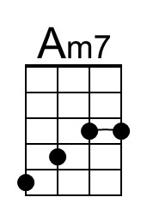 | 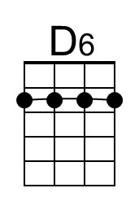 | 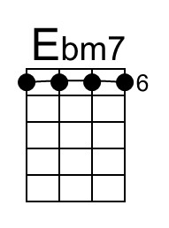 | 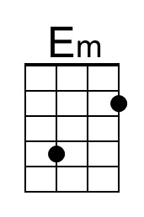 | Baritone | 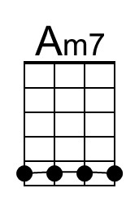 | 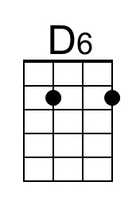 | 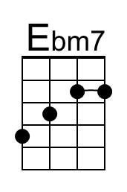 | 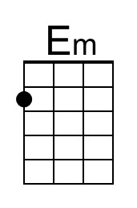
Spooky (Am) – Page 2

Am7 D6 Am7 | D6
If you decide some day to stop this little game that you are playin’.
Am7 D6 Am7 | D6
I'm gonna tell you all the things my heart's been a dyin’ to be sayin’.
Am7
Just like a ghost you've been a-hauntin’ my dreams,
D6 Ebm7
So I’ll pro-pose. ( Stop ) …. on Halloween.
Am7 D6 Am7 Em
Love is kinda crazy with a spooky little girl like you. Spooky, yeah.

Outro
Am7 D6 Am7 D6
Spooky, mmm. Spooky, yeah yeah.
Am7 D6 Am7 D6 | Am7
Spooky, ah ha ha oo. Spooky, ah ha ha.

