Wellerman (Traditional “Sea Song” Ballad) (Am)
Wellerman by The Longest Johns (2018) – Wellerman by Nathan Evans (2022)
4/4 Time
Intro
F C E7 Am
One day, when the tonguin' is done, we'll take our leave and go.

Am Dm Am
There once was a ship that put to sea, and the name of the ship was the Billy of Tea.
Am C E7 Am
The winds blew hard, her bow dipped down. Oh blow, my bully boys, blow (Hup!)

Chorus
F C Dm Am
Soon may the Wellerman come to bring us sugar and tea and rum.
F C E7 Am
One day, when the tonguin' is done, we'll take our leave and go.

Am Dm Am
She had not been two weeks from shore when down on her a right whale bore.
Am C E7 Am
The captain called “all hands” and swore he'd take that whale in tow (Hup!) Chorus

Am Dm Am
Before the boat had hit the water, the whale's tail came up and caught her.
Am C E7 Am
All hands to the side, har-pooned and fought her when she dived down below (Hup!) Chorus

Am Dm Am
No line was cut, no whale was freed; the Captain's mind was not of greed
Am C E7 Am
But he belonged to the whaleman's creed; she took the ship in tow (Hup!) Chorus

Am Dm Am
For forty days, or even more, the line went slack, then tight once more.
Am C E7 Am
All boats were lost (there were only four) but still that whale did go (Hup!) Chorus

Am Dm Am
As far as I've heard, the fight's still on; the line's not cut and the whale's not gone.
Am C E7 Am
The Wellerman makes his regular call to encourage the Captain, crew, and all. Chorus (2x)

Outro (Ritard.)
E7 G Am
Take- our - leave - and – Goooooooo-oh!

For a “cups” rhythm see Wellerman Cups Practice Video.
Notes:
For lyrics, the melody line, and an explanation of the lyrics, see Soon May The Wellerman Come (Anon., c. 1860-1870), New Zealand Folk Song; the sheet music is reproduced below. The song is also known as “The Wellerman.” For the general background of the song, see Wellerman, Wikipedia.
New Zealand–based music teacher and folk music compiler Neil Colquhoun claimed to have collected the song around 1966 from one F. R. Woods. Woods, who was in his 80s at the time, had said that he heard the song from his uncle. First known publication was In 1973 when "Soon May the Wellerman Come" was included in Colquhoun's book, New Zealand Folksongs: Songs of a Young Country. Since then there have been more than 20 known recordings. In addition to the two at the top of the song sheet, here are two additional recordings at YouTube:
- Wellerman by Amadeus Electric Quartet
- The Wellerman by The Irish Rovers
The history of whaling in New Zealand stretches from the late eighteenth century to 1965. In 1831, the British-born Weller brothers Edward, George and Joseph, who had immigrated to Sydney in 1829, founded a whaling station at Otakou near modern Dunedin in the South Island of New Zealand. The sailors who worked on their ships became known as “Weller men.”
Properly speaking, this is a ballad of the ‘sea song’ variety, not a ‘sea shanty’ per se. For the difference, see at Wikipedia Ballad and Sea Shanty (with an excellent listing of resources under “External Links”). Numerous collections of sea shanties have been published; a dozen or so have been reproduced on the website Music and More under the heading "Seasonal & Special Collections and Web Pages."
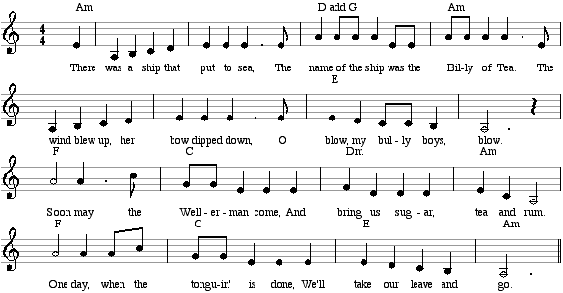

One song in our collection that is described as a “walk away” shanty is Drunken Sailor.

