Wellerman (Traditional “Sea Song” Ballad) - Notes

For lyrics, the melody line, and an explanation of the lyrics, see Soon May The Wellerman Come (Anon., c. 1860-1870), New Zealand Folk Song; the sheet music is reproduced below. The song is also known as “The Wellerman.” For the general background of the song, see Wellerman, Wikipedia. For a “cups” rhythm see Wellerman Cups Practice Video.
New Zealand–based music teacher and folk music compiler Neil Colquhoun claimed to have collected the song around 1966 from one F. R. Woods. Woods, who was in his 80s at the time, had said that he heard the song from his uncle. First known publication was In 1973 when "Soon May the Wellerman Come" was included in Colquhoun's book, New Zealand Folksongs: Songs of a Young Country. Since then there have been more than 20 known recordings. In addition to the two at the top of the song sheet, here are two additional recordings at YouTube:
- Wellerman by Amadeus Electric Quartet
- The Wellerman by The Irish Rovers
The history of whaling in New Zealand stretches from the late eighteenth century to 1965. In 1831, the British-born Weller brothers Edward, George and Joseph, who had immigrated to Sydney in 1829, founded a whaling station at Otakou near modern Dunedin in the South Island of New Zealand. The sailors who worked on their ships became known as “Weller men.”
Properly speaking, this is a ballad of the ‘sea song’ variety, not a ‘sea shanty’ per se. For the difference, see at Wikipedia Ballad and Sea Shanty (with an excellent listing of resources under “External Links”). Numerous collections of sea shanties have been published; a dozen or so have been reproduced on the website Music and More under the heading "Seasonal & Special Collections and Web Pages."
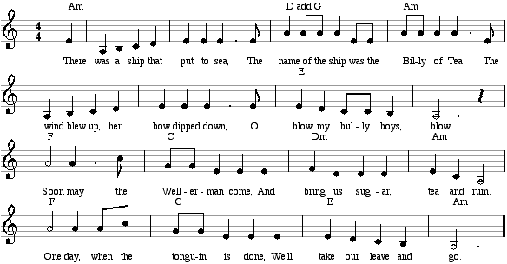

One song in our collection that is described as a “walk away” shanty is Drunken Sailor.

