
100 Year Old Moon Medley (C)
Songs published between 1908 and 1912
Moonlight Bay by the American Quartet (1912) – Moonlight Bay by Leon Redbone (2004)
Shine On, Harvest Moon by Macdonough & Stevenson (1908) – Shine On, Harvest Moon by Leon Redbone
By The Light of the Silvery Moon by Billy Murray & the Haydn Quartet (1909) – By The Light of the Silvery Moon by Al Jolson (1946)

Intro:  G7 C#dim7 G7 C | F7 C  As we sang love’s old sweet song on Moonlight Bay.  Cdim7 C Dm C Cdim7 C  We were sailing along on Moonlight Bay,  C#dim7 G7 C C#dim7 G7  You could hear the voices ringing – They seemed to say,  C F C Dm C Cdim7 C  “You have stolen my heart, now don’t go ‘way”  G7 C#dim G7 C | F7 C  As we sang Love’s Old Sweet Song on Moonlight Bay.  C G7 C  Oh, won’t you [-or- (Tabs) C string 0, 2 E string 0 ]  A7 D7 D  Shine on, shine on harvest moon up in the sky  G7 C Cdim7 F C  I ain’t had no lovin’ since January, February, June or July  A7 D7 D  Snow time ain’t no time to stay outdoors and spoon  G7 C F7 C  So shine on, shine on, harvest moon for me and my gal.  C Cdim7 C  By the light (not the dark but the light)  C7 F A7 D7  Of the silvery moon, (not the sun but the moon)  G7 C#dim7 G7  I wanna spoon, (not knife, but spoon)  C C#dim7 G7  To my honey, I’ll croon love’s tune  C Cdim7 C  Honey moon, (not the sun but the moon)  C7 F A7 Dm  Keep a-shinin’ in June (not July but June)  C ↓ Dm ↓ C ↓  Your silvery beams will bring love’s dreams,  Am D7 G7 C F7 C  We’ll be cuddlin’ soon - By the silvery moon. Tremolo | 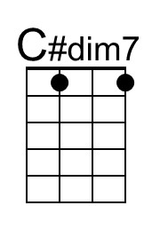
 | 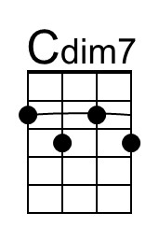
 | Bari
 | 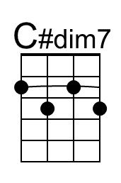
 | 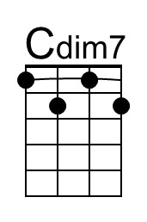

100 Year Old Moon Medley (G)
Songs published between 1908 and 1912
Moonlight Bay by the American Quartet (1912) – Moonlight Bay by Leon Redbone (2004)
Shine On, Harvest Moon by Macdonough & Stevenson (1908) – Shine On, Harvest Moon by Leon Redbone
By The Light of the Silvery Moon by Billy Murray & the Haydn Quartet (1909) – By The Light of the Silvery Moon by Al Jolson (1946)

Intro:  D7 G#dim7 D7 G | C7 G  As we sang love’s old sweet song on Moonlight Bay.  Gdim7 G Am G Gdim7 G  We were sailing along on Moonlight Bay,  G#dim7 D7 G G#dim7 D7  You could hear the voices ringing – They seemed to say,  G C G Am G Gdim7 G  “You have stolen my heart, now don’t go ‘way”  D7 G#dim D7 G | C7 G  As we sang Love’s Old Sweet Song on Moonlight Bay.  G D7 G  Oh, won’t you  E7 A7 A  Shine on, shine on harvest moon up in the sky  D7 G Gdim7 C G  I ain’t had no lovin’ since January, February, June or July  E7 A7 A  Snow time ain’t no time to stay outdoors and spoon  D7 G C7 G  So shine on, shine on, harvest moon for me and my gal.  G Gdim7 G  By the light (not the dark but the light)  G7 C E7 A7  Of the silvery moon, (not the sun but the moon)  D7 G#dim7 D7  I wanna spoon, (not knife, but spoon)  G G#dim7 D7  To my honey, I’ll croon love’s tune  G Gdim7 G  Honey moon, (not the sun but the moon)  G7 C E7 Am  Keep a-shinin’ in June (not July but June)  G ↓ Am ↓ G ↓  Your silvery beams will bring love’s dreams,  Em A7 D7 G C7 G  We’ll be cuddlin’ soon - By the silvery moon. Tremolo | 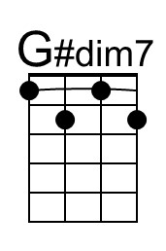
 | 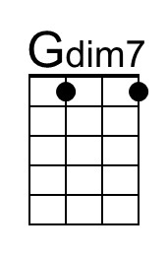
 | Bari
 | 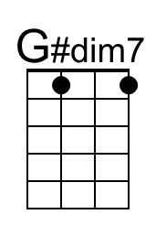
 | 