Fifty Ways to Beat Corona (With thanks to Paul Simon)

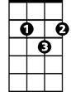
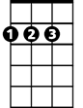
G D C B
G
D
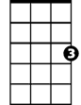
This problem’s real, it’s not fake news said Anthony
C
Em B Am B
The answer’s easy if you take it logically
Em D C Am
If you care enough to keep our country virus free
Em Am Em
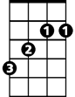
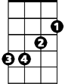
There must be fifty ways to beat Corona
B
Em

G Bb
Don’t hop on the bus, Gus Stay away from the pack, Jack
C G
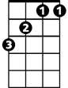
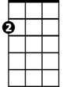
Sneeze in your sleeve, Steve To keep virus free
Bb
Am

G Bb
Stop touching your face, Grace Stay back to six feet, Pete
C G
Keep washing your hands, Stan And heed CDC

G Bb
Don’t visit your Gran, Jan Wipe down every toy, Roy
C G
Don’t hoard all the food, Dude Buy sensibly
G Bb
BARITONE
Just use some Purell, Mel Keep wipes near at hand, man
G
C G
Don’t listen to Don, John You don’t need more TP

G Bb
This isn’t Spring Break, Jake Stay home if you’re sick, Dick
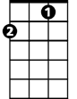
C G
C
D
Give the workers your thanks, Hank And listen to me
G Bb
Just follow the rules, fools Wear a mask when you go, Moe
C G
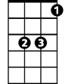
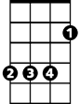
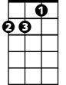
It’s your main job, Bob To stay virus free
Bb
Em
B
Am

Em Am Em
There must be fifty ways to beat Corona
Am Em
Fifty ways to beat Corona

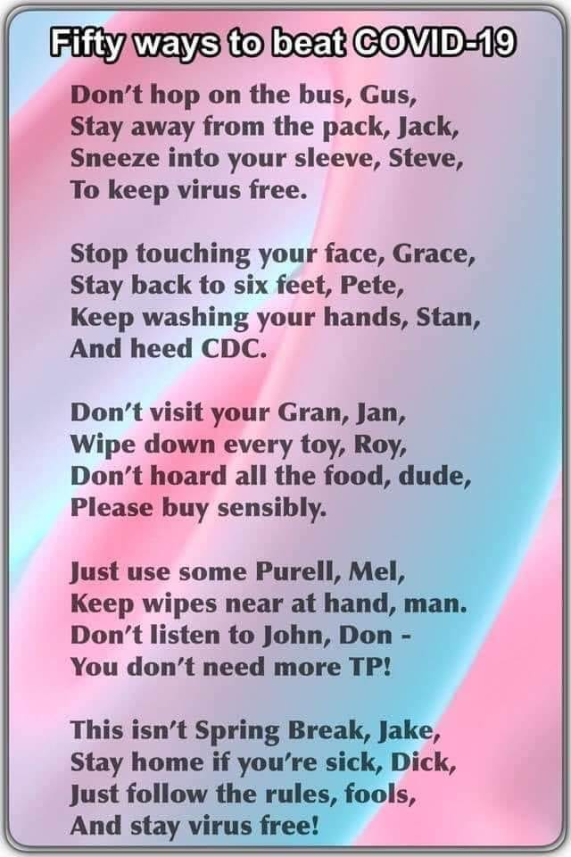
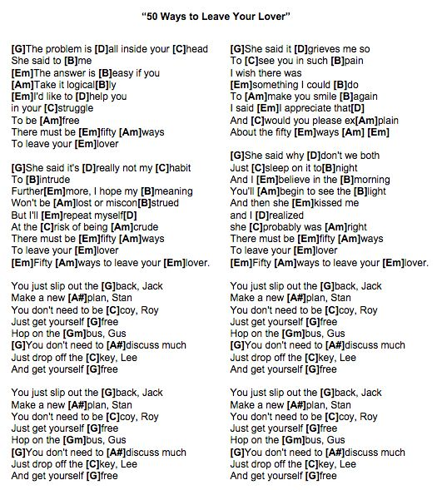

https://i.pinimg.com/originals/7c/4f/2a/7c4f2a4293260cc726bec4552d2d9d90.jpg

