**50 Ways to Leave Your Lover (Paul Simon)**



G

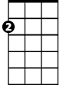

Am

**Am G F7**

"The problem is all inside your head",

**E7**

She said to me,

**Am G F E7**

The answer is easy if you take it logically.

**Am G F7 E7**

I'd like to help you in your struggle to be free.

**Am Dm Am**

There must be - fifty ways to leave your lover."

**Am G F7 E7**

She said: "It's really not my habit to intrude,

**Am G**

Furthermore I hope my meaning won't be

**F E7**

Lost or mis-construed,

**Am G F7 E7**

But I'll repeat myself, at the risk of being crude.

**Am Dm Am**

There must be - fifty ways to leave your lover."

**Dm Am**

Fifty ways to leave your lover."

**Chorus:**

**C**

Just slip out the back Jack,

**Eb**

Make a new plan Stan,

**F7 C**

No need to be coy Roy, just get yourself free

**C**

Hop on the bus Gus,

**Eb**

You don't need to discuss much,

**F7 C**

Just drop off the key Lee, and get yourself free.

**C Eb**

Slip out the back Jack, make a new plan Stan,

**F7**

You don't need to be coy Roy,

**C**

you just listen to me.



F

**C**

Hop on the bus Gus,

**Eb**

You don't need to discuss much,

**F7 C**

Just drop off the key Lee, and get yourself free.

**Am G**

She said: "It grieves me so

**F7 E7**

To see you in such pain.

**Am G**

I wish there was something I could do

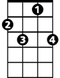

F7

**F E7**

E7

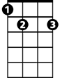

To make you smile again."

**Am G**

I said: "I appreciate that

**F7 E7**

And would you please explain

**Am Dm Am**

F



About the - fifty ways."

**Am G**

She said: "Why don't we both just

**F7 E7**

Sleep on it tonight,

**Am G**

And I believe that in the morning

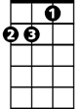

Dm

**F E7**

You'll begin to see the light."

**Am G**

Then she kissed me and I realized,

**F7 E7**

She probably was right,

**Am Dm Am**

There must be fifty ways to leave your lover,



C

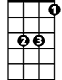

Eb

**Dm Am**

Fifty ways to leave your lover.

**(Chorus)**

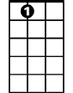

E7

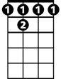

F 7



G



Am

C

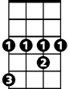

Eb

**BARITONE**

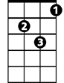

Dm

**50 Ways to Leave Your Lover (Paul Simon)**

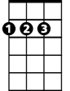

D

Em

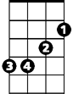

**Em D C7**

"The problem is all inside your head",

**B7**

She said to me,

**Em D C B7**

The answer is easy if you take it logically.

**Em D C7 B7**

I'd like to help you in your struggle to be free.

**Em Am Em**

There must be - fifty ways to leave your lover."

**Em D C7 B7**

She said: "It's really not my habit to intrude,

**Em D**

Furthermore I hope my meaning won't be

**C E7**

Lost or mis-construed,

**Em D C7 B7**

But I'll repeat myself, at the risk of being crude.

**Em Am Em**

There must be - fifty ways to leave your lover."

**Am Em**

Fifty ways to leave your lover."

**Chorus:**

**G**

Just slip out th e back Jack,

**Bb**

Make a new plan Stan,

**C7 G**

No need to be coy Roy, just get yourself free

**G**

Hop on the bus Gus,

**Bb**

You don't need to discuss much,

**C7 G**

Just drop off the key Lee, and get yourself free.

**BARITONE**

**G Bb**

Slip out the back Jack, make a new plan Stan,

**C7**

You don't need to be coy Roy,

**G**



G

You just listen to me.

C



Am

**G**

Hop on the bus Gus,

**Bb**

You don't need to discuss much,

**C7 G**

Just drop off the key Lee, and get yourself free.

**Em D**

She said: "It grieves me so

**C7 B7**

To see you in such pain.

**Em D**

I wish there was something I could do

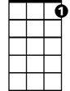

C7

**C B7**

To make you smile again."

**Em D**

I said: "I appreciate that

**C7 B7**

And would you please explain

**Em Am Em**



C

About the - fifty wa -ys."

**Em D**

She said: "Why don't we both just

**C7 B7**

Sleep on it tonight,

**Em D**



Am

And I believe that in the morning

**C B7**

You'll begin to see the light."

**Em D**

Then she kissed me and I realized,

**C7 B7**

She probably was right,

**Em Am Em**

There must be - fifty ways to leave your lover."

**Am Em**



G



Bb

Fifty ways to leave your lover.

**(Chorus)**



Bb



E7



C7



D



Em