**A Groovy Kind of Love (Carol Bayer Sager / Tony Wine)**

**Intro:**

**G C F G C G**

*Wouldn't you agree - baby you and me got a groovy kind of love?*



G



C

F



**C F G**

When I'm feeling blue all I have to do

**C F G**

Is take a look at you then I'm not so blue

**Am G**

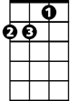

Dm

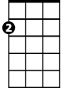

Am

When you're close to me I can feel your heartbeat

**C F Am G**

I can hear you breathing in my ear

**C F G C**

Wouldn't you agree - baby you and me got a groovy kind of love?

**G C G**

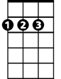

D

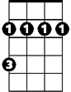

Bm

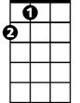

A

(Groovy kind of love) We’ve got a groovy kind of love

**C F G**

Anytime you want to you can turn me into

**C F G**

Anything you want to anytime at all

**Dm Am**

**BARITONE**

When I kiss your lips oooh I start to shiver



G

C



**F G**

Can't control the quiver-ing inside

**C F G C**

Wouldn't you agree - baby you and me got a groovy kind of love?

**G C A**

(Groovy kind of love) We’ve got a groovy kind of love



A



F



Am

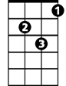

Dm

**D G A**

*When I'm feeling blue all I have to do*

**D G A**

*Is take a look at you then I'm not so blue*

**Bm A**

When I'm in your arms nothing seems to matter



D

Bm

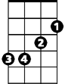

**D G Bm A**

My whole world could shatter I don't care

**D G A D**

Wouldn't you agree - baby you and me got a groovy kind of love?

**A D (2x)**

(Groovy kind of love) We got a groovy kind of love