**A Hard Day’s Night (Lennon/McCartney) Key C**

**Intro: C7sus4 (break)**

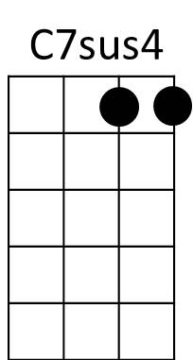

**C F C**

It's been a hard d ay's night

**Bb C**

And I've been working like a dog.

**C F C**



C

It's been a hard day's night

**Bb C**

I should be sleeping like a log.

**F**

But w hen I get home to you

**G**

F



Bb

I find th e things that you do

**C F C**

Will make me feel all right.

**F C**

You know I work all day



G

**Bb C**

To get you money to buy you things

**F C**

And it's worth it just to hear you say

**Bb C**

You're gonna give me everything

Em

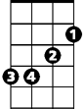

**F**

So why on earth should I moan

**G**

'Cause when I get you alone

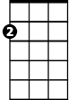

Am

**C F C**

You know I'll feel O .K.

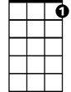

C7

**Bridge:**

**Em**

When I'm home

**Am Em**

Everything seems to be right

**C**

When I'm home

**Am Bb G**

Feeling you holding me tight, tight yeah!!

**(First Verse)**

**(Instrumental)**

**C F C**

*You know I work all day*

**Bb C**

*To get you money to buy you things*

**F C**

*And it's worth it just to hear you say*

**Bb C**

*You're gonna give me everything*

**F**

So why on earth should I moan

**G**

'Cause when I get you alone

**C F C**

You know I'll feel O .K.

**(Bridge)**

**(First Verse)**

**F C F C**

You know I feel all right

**F C C7 C7sus4 C**

You know I feel all right.

**BARITONE**

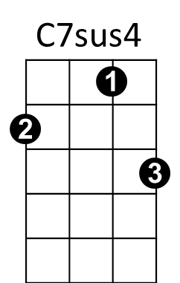

C

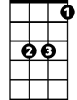

Bb



F

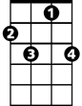

C7



Em

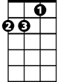

Am



G

**A Hard Day’s Night (Lennon/McCartney) Key G**

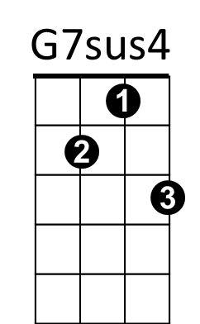**Intro: G7sus4 (break)**

**G C G**

It's been a hard d ay's night

**F G**

And I've been working like a dog.

**G C G**



G

It's been a hard day's night

**F G**

I should be sleeping like a log.

**C**

But w hen I get home to you

**D**



C

F



I find th e things that you do

**G C G**

Will make me feel all right.

**C G**

You know I work all day

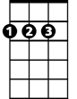

D

**F G**

To get you money to buy you things

**C G**

And it's worth it just to hear you say

**F G**

You're gonna give me everything

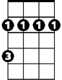

Bm

**C**

So why on earth should I moan

**D**

'Cause when I get you alone

Em



**G C G**

You know I'll feel O .K.

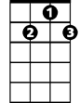

G7

**Bridge:**

**Bm**

When I'm home

**Em Bm**

Everything seems to be right

**G**

When I'm home

**Em F D**

Feeling you holding me tight, tight yeah!!

**(First Verse)**

**(Instrumental)**

**G C G**

*You know I work all day*

**F G**

*To get you money to buy you things*

**C G**

*And it's worth it just to hear you say*

**F G**

*You're gonna give me everything*

**C**

So why on earth should I moan

**D**

'Cause when I get you alone

**G C G**

You know I'll feel O .K.

**(Bridge)**

**(First Verse)**

**C G C G**

You know I feel all right

**C G G7 G7sus4**

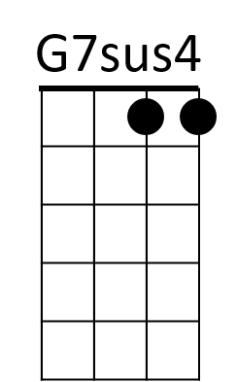 You know I fee all right.



G

C



F



D

Bm



Em



G7

**BARITONE**