**A Hazy Shade of Winter (Paul Simon)**

**Am G F E7 2x**

**Am G**

Time, Time, Time, see what's become of me,

**Dm Am**

While I looked around, for my possiblities,

**G**

I was so hard to please,

**Am G**

But look around, leaves are brown,

**F E7 Am**

And the sky is a hazy shade of winter.

**G F**

Hear the Salvation Army band.- Down by the

Riverside, it’s bound to be a better ride

**Am**

Than what you've got planned.

**G**

Carry your cup in your hand,

**Am G**

And look around, leaves are brown now,

**F E7 Am**

And the sky- is a hazy shade of winter.

**G**

Hang onto to your hopes my friend,

**F**

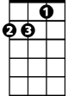

Dm

That's an easy thing to say –

But if your hopes should pass away

**Am**

Then simply pretend –

**G**

That you can build them again!

**Am G F**

Look around, the grass is high, the fields are ripe,

**BARITONE**

**E7 Am F**

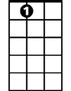

E7



G



F



Am

It’s the spring time of my life...... Ahhhh

**C**

Seasons change with the scenery,

**G**

Weaving time in a tapestry,

**Am Em Am**

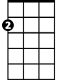

Em

C



Won't you stop and re-mem-ber me,

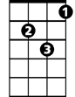

Dm

**G**

At any convenient time,

**F**

Funny how my memory slips

While looking over manuscripts

**Am**

Of unpublished rhyme,

**G**

Drinking my Vodka and lime,

**Am, G F**

I look around, leaves are brown now, and the sky,

**E7 Am**

Is a hazy shade of winter

**(3X)**

**G F**

Look around, leaves are brown,

**E7 Am**

There's a patch of snow on the ground

.

E7

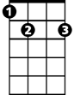

F



Am



G

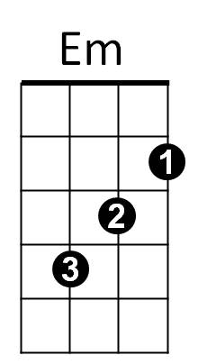



C