**A Holly Jolly Christmas**

C09B

**by Johnny Marks**

**C Cmaj7 C6 C Cmaj7 G7**

Have a holly, jolly Christmas, it's the best time of the year,

**C**

I don't know if there'll be snow, but have a cup of cheer.

**C Cmaj7 C6 C Cmaj7 G7**

Have a holly, jolly Christmas, and when you walk down the street,

**C C7**

Say hello to friends you know and everyone you meet.

**F Em F C**

Hey, ho, the mistletoe, hung where you can see,

**Dm Am D7 Am D7 G G7**

Somebody's waiting there, kiss her once for me.

**C Cmaj7 C6 C Cmaj7 G7**

Have a holly, jolly Christmas and in case you didn't hear,

**C D7 G7 C**

Oh, by golly, have a holly, jolly Christmas this year.

**Repeat From Top**

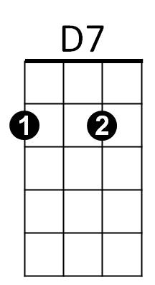

Em

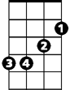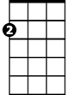

Am

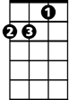

Dm

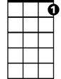

C7

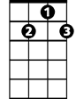

G7

F



C

**BARITONE**



D7



Am



Em

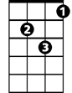

Dm

C



F



G7

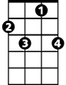

C7