**A Holly Jolly Christmas**

C09

**by Johnny Marks**

Have a holly, jolly Christmas, it's the best time of the year,

I don't know if there'll be snow, but have a cup of cheer.

Have a holly, jolly Christmas, and when you walk down the street,

Say hello to friends you know and everyone you meet.

Hey, ho, the mistletoe, hung where you can see,

Somebody's waiting there, kiss her once for me.

Have a holly, jolly Christmas and in case you didn't hear,

Oh, by golly, have a holly, jolly Christmas this year.

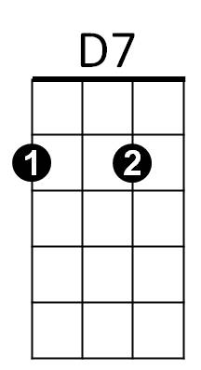

Em

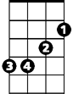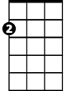

Am

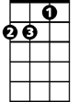

Dm

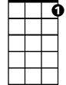

C7

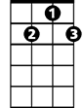

G7

F



C

**BARITONE**



D7



Am



Em

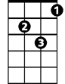

Dm

C



F



G7

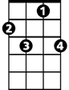

C7