
A Holly Jolly Christmas – Version 2
C104 C
Johnny Marks (1962) – A Holly Jolly Christmas by Burl Ives

Intro (Chords of last line) G7 C D7 G7 C G7

C Cmaj7 C6 C Cmaj7 G7
Have a holly, jolly Christmas, it's the best time of the year,
C
I don't know if there'll be snow, but have a cup of cheer.
C Cmaj7 C6 C Cmaj7 G7
Have a holly, jolly Christmas, and when you walk down the street,
C C7
Say hello to friends you know and everyone you meet.

F Em F C
Hey, ho, the mistletoe, hung where you can see,
Dm Am D7 Am D7 G G7
Somebody's waiting there, kiss her once for me.

C Cmaj7 C6 C Cmaj7 G7
Have a holly, jolly Christmas and in case you didn't hear,
C D7 G7 C
Oh, by golly, have a holly, jolly Christmas this year.

Repeat From Top
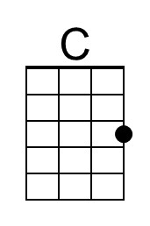 | 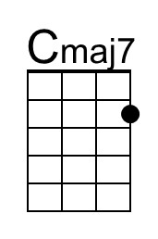 | 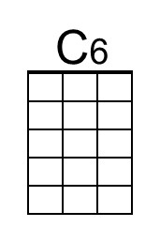 | 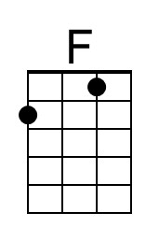 | 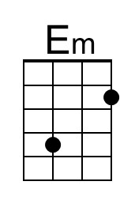
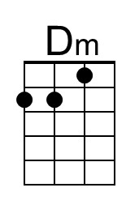 | 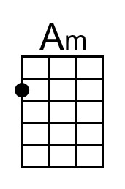 | 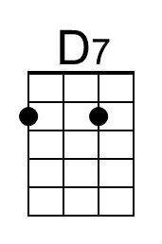 | 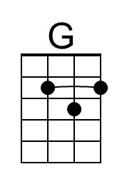 | 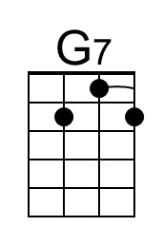
Baritone | 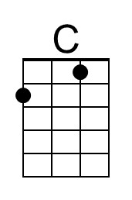 | 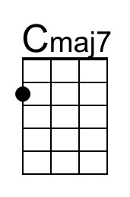 | 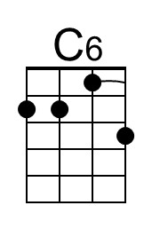 | 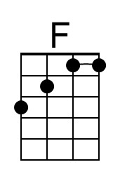 | 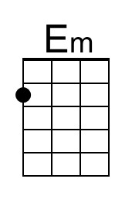
 | 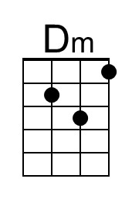 | 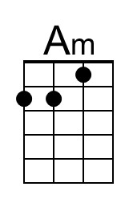 | 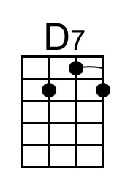 | 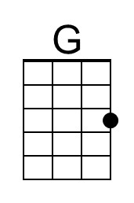 | 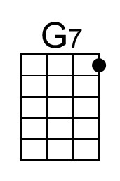

A Holly Jolly Christmas – Version 2
C104 G
Johnny Marks (1962) – A Holly Jolly Christmas by Burl Ives

Intro (Chords from last line) D7 G A7 D7 G D7

G Gmaj7 G6 G Gmaj7 D7
Have a holly, jolly Christmas, it's the best time of the year,
G
I don't know if there'll be snow, but have a cup of cheer.
G Gmaj7 G6 G Gmaj7 D7
Have a holly, jolly Christmas, and when you walk down the street,
G G7
Say hello to friends you know and everyone you meet.

C Bm C G
Hey, ho, the mistletoe, hung where you can see,
Am Em A7 Em A7 D D7
Somebody's waiting there, kiss her once for me.

G Gmaj7 G6 G Gmaj7 D7
Have a holly, jolly Christmas and in case you didn't hear,
G A7 D7 G
Oh, by golly, have a holly, jolly Christmas this year.

Repeat From Top
 | 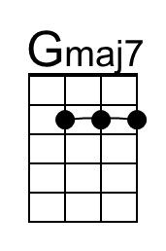 | 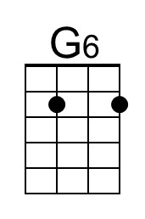 |  | 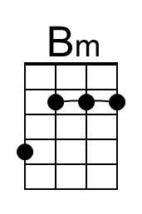
 |  | 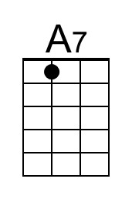 | 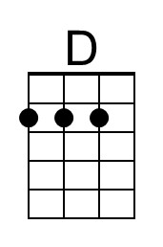
Baritone |  | 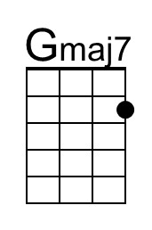 | 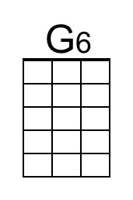 |  | 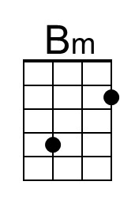
 |  |  | 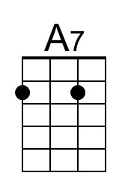 | 