**A Hundred Pounds of Clay (Bob Elgin, Luther Dixon and Kay Roger) 1961 Key G**

**Intro: G Em Am D7**

**G Em**

He took a hundred pounds of clay

**Am D7**

And then He said "Hey, listen"

**G Em**

"I'm gonna fix this-a world today"

**Am D7**

"Because I know what's missin' "

**C D7**

Then He rolled his big sleeves up

**C D7**

And a brand-new world began

**G Em**

He created a woman and -

**Am D7 G**

Lots of lovin' for a man

**Em C D7**

Whoa-oh-oh, yes he did

**G Em**

With just a hundred pounds of clay

**Am D7**

He made my life worth livin'

**G Em**

And I will thank Him every day

**Am D7**

For every kiss you're givin'

**C D7**

And I'll thank Him every night

**C D7**

For the arms that are holdin' me tight

**G Em**

And He did it all with

**Am D7 G**

Just a hundred pounds of clay

**C G D7**

Yes he did, whoa-oh, yes He did

**G**

Now can'tcha just see Him a-walkin'

**G#dim**

'round and 'round

**Am D7**

Pickin' the clay up off of the ground?

**G G#dim**

Doin' just what He should do

**Am D7**

To make a livin' dream like you

**C D7**

He rolled his big sleeves up

**C D7**

And a brand-new world began

**G Em**

He created a woman and -

**Am D7 G**

Lots of lovin' for a man

**Em C**

Whoa-oh-oh, yes he did

**D7 G**

With just a hundred pounds of clay

**Em C**

People, let me tall ya what He did

**D7 G**

With just a hundred pounds of clay

**G Em Am D7 C D Am G**

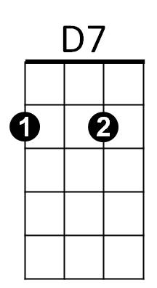

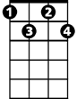

G#dim



C

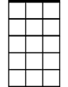

Am7



G

Em

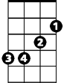

G

**BARITONE**

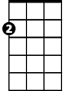

Em

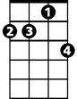

Am7

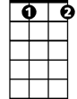

G#dim

C

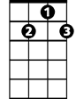

D7

**A Hundred Pounds of Clay (Bob Elgin, Luther Dixon and Kay Roger) 1961 Key C**

**Intro: C Am Dm G7**

**C Am**

He took a hundred pounds of clay

**Dm G7**

And then He said "Hey, listen"

**C Am**

"I'm gonna fix this-a world today"

**Dm G7**

"Because I know what's missin' "

**F G7**

Then He rolled his big sleeves up

**F G7**

And a brand-new world began

**C Am**

He created a woman and -

**Dm G7 C**

Lots of lovin' for a man

**Am F G7**

Whoa-oh-oh, yes he did

**C Am**

With just a hundred pounds of clay

**Dm G7**

He made my life worth livin'

**C Am**

And I will thank Him every day

**Dm G7**

For every kiss you're givin'

**F G7**

And I'll thank Him every night

**F G7**

For the arms that are holdin' me tight

**C Am**

And He did it all with

**Dm G7 C**

Just a hundred pounds of clay

**F C G7**

Yes he did, whoa-oh, yes He did

**C**

Now can'tcha just see Him a-walkin'

**C#dim**

'round and 'round

**Dm G7**

Pickin' the clay up off of the ground?

**C C#dim**

Doin' just what He should do

**Dm G7**

To make a livin' dream like you

**F G7**

He rolled his big sleeves up

**F G7**

And a brand-new world began

**C Am**

He created a woman and -

**Dm G7 C**

Lots of lovin' for a man

**Am F**

Whoa-oh-oh, yes he did

**G7 C**

With just a hundred pounds of clay

**Am F**

People, let me tell ya what He did

**G7 C**

With just a hundred pounds of clay

**C Am Dm G7 F G Dm C**



C#dim

F



C



Am

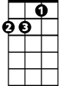

Dm



G7

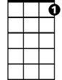

G7

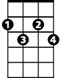

C#dim



F

C



Am

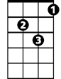

Dm

**BARITONE**