A Kind Of Hush (Geoff Stephens & Les Reed, 1966) (C)

Intro: C G7 C G7

C E7 Am C7 F G7
There's a kind of hush all over the world to-night, all over the world you can hear the sounds
C G7 C E7 Am C7
Of lovers in love, you know what I mean. Just the two of us, and nobody else in sight,
F G7 C C7
There's nobody else and I'm feeling good, just holding you tight

Chorus
F Dm FΔ7 Dm C C7
So listen very carefully, closer now and you will see what I mean - It isn't a dream
F Dm FΔ7 Dm G
The only sound that you will hear, is when I whisper in your ear: I love you,
G+
For ever and ever

C E7 Am C7
There's a kind of hush all over the world to-night
F G7 C
All over the world you can hear the sounds of lovers in love
C E7 Am C7
La la la la la laaaa la la la la la la la la laaaaaa
F G7 C C7
La la la la laaa la la la la laaaa la la la laaaa. Chorus

C E7 Am C7 F G7
There's a kind of hush all over the world to-night, all over the world people just like us
C G7 C G7 C G7 (Pause)
Are falling in love, are falling in love. __ They're falling in love
C
They’re falling in love.

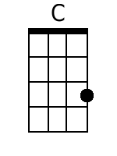 | 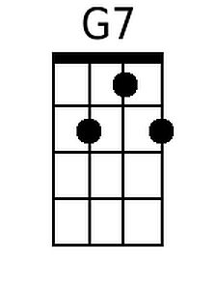 | 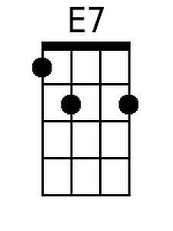 | 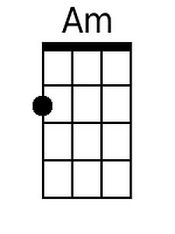 | 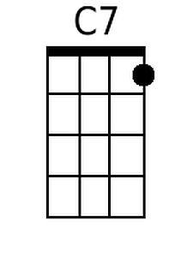 | 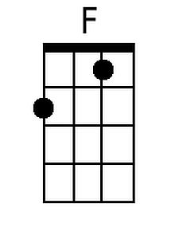 | 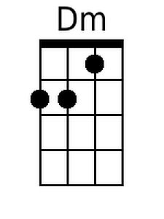 | 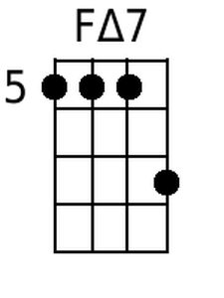 | 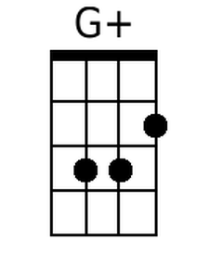
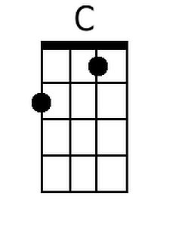 | 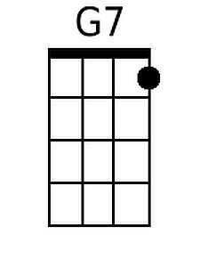 | 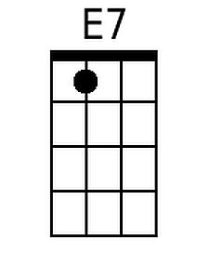 | 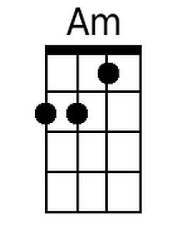 | 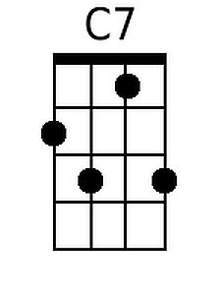 | 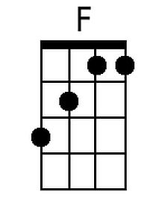 | 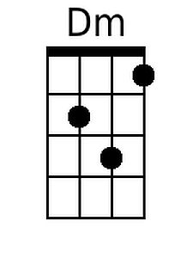 | 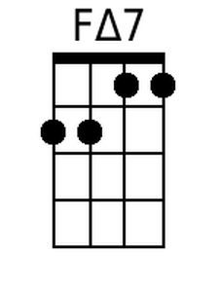 | 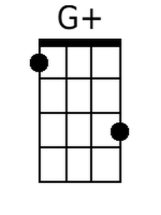

A Kind Of Hush (Geoff Stephens & Les Reed, 1966) (G)

Intro: G D7 G D7

G B7 Em G7 C D7
There's a kind of hush all over the world to-night, all over the world you can hear the sounds
G D7 G B7 Em G7
Of lovers in love, you know what I mean. Just the two of us, and nobody else in sight,
C D7 G G7
There's nobody else and I'm feeling good, just holding you tight

Chorus
C Am CΔ7 Am G G7
So listen very carefully, closer now and you will see what I mean - It isn't a dream
C Am CΔ7 Am D
The only sound that you will hear, is when I whisper in your ear: I love you,
D+
For ever and ever

G B7 Em G7
There's a kind of hush all over the world to-night
C D7 G
All over the world you can hear the sounds of lovers in love.
G B7 Em G7
La la la la la laaaa la la la la la la la la laaaaaa
C D7 G G7
La la la la laaa la la la la laaaa la la la laaaa. Chorus

G B7 Em G7 C D7
There's a kind of hush all over the world to-night, all over the world people just like us
G D7 G D7 G D7 (Pause)
Are falling in love, are falling in love. __ They're falling in love
G
They're falling in love.

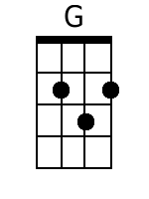 | 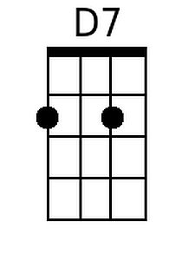 | 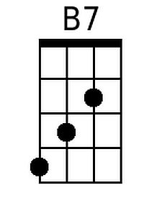 | 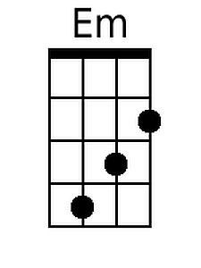 |  |  |  | 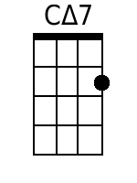 | 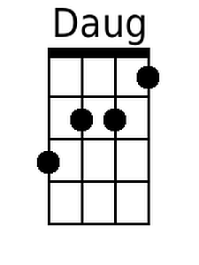
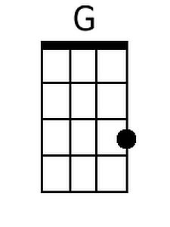 | 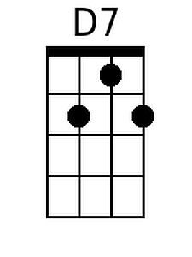 | 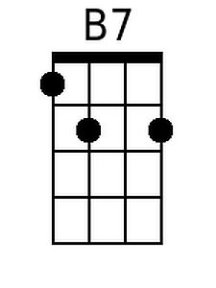 | 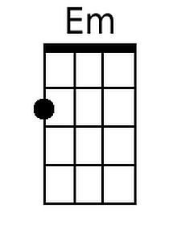 |  |  |  | 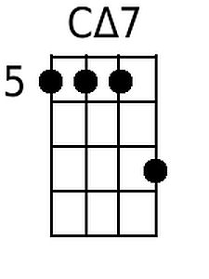 | 