**Kind Of Hush (Geoff Stephens / Les Reed)**

**Intro: C G7 C G7**

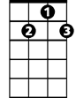

G7

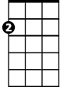

Am

E7

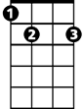

C

**C E7 Am C7**

There's a kind of hush all over the world to-night

**F G7**

All over the world you can hear the sounds

**C G**

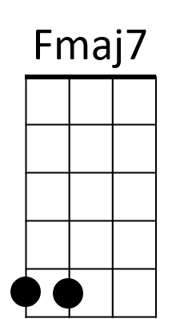Of lovers in love you know what I mean

F

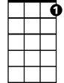

C7

**C E7 Am C7**

Just the two of us and nobody else in sight

**F G7**

There's nobody else and I'm feeling good

**C C7**

Just holding you tight

**Chorus:**

**F Dm**

So listen very carefully

**Fmaj7 Dm C C7**

Closer now and you will see what I mean - It isn't a dream

**F Dm**

The only sound that you will hear

**Fmaj7 Dm G**

Is when I whisper in your ear I love you

**Gaug**

For ever and ever

**C E7 Am C7**

There's a kind of hush all over the world to-night

**F G7 C**

All over the world you can hear the sounds of lovers in love

**C E7 Am C7**

C

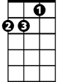

Am



G7

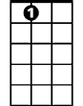

E7

**BARITONE**

La la la la la laaaa la la la la la la la la laaaaaa

**F G7 C C7**

La la la la laaa la la la la laaaa la la la laaaa

**(Chorus)**

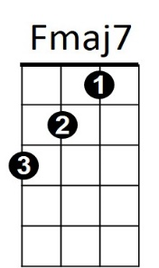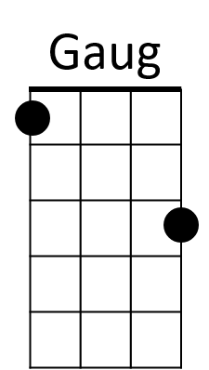 **C E7 Am C7**



F

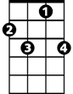

C7

There's a kind of hush all over the world to-night

**F G7**

All over the world people just like us

**C G7 C G7**

Are falling in love - are falling in love

**C G7 (PAUSE)**

They're falling in love

**C**

They’re falling in love