**A Love Song (Kenny Loggins/Donna Lyn George)**

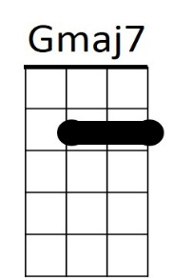

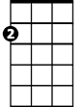

Am



G

**Intro: G Gmaj7 Am D Am D G**

**G Em7**

There's a wren in a willow wood, flies so high, sings so good,

**Am D Am D**

And he brings to you - what he sings to you.

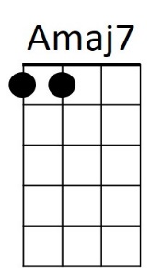**G Gmaj7**

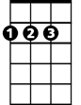

D

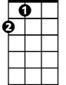

A

And the love in his lullaby seemed to tell me if I try

**Am D Am D**

I could fly for you, and lover I want to try for you 'cause

**CHORUS:**

**G Gmaj7 Am D**

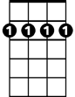

Bm7

Em7

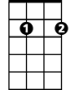

E7

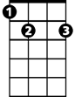

I want to sing you a love song

**Am D G**

I want to rock you in my arms all night long.

**Gmaj7 Am D Am**

I want to get to know you, I want to show you

**D G**

The peaceful feeling of my home.

**G Em7**

Summer thunder on moon bright days, northern lights and skies ablaze

**Am D Am D**

**BARITONE**

I'll bring to you, if you'll let me sing to you.

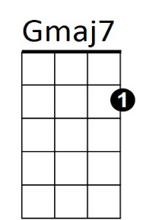**G Gmaj7**



G

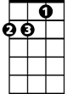

Am

Silver wings in a fiery sky show the trail of our love

**Am D Am D**

And I'll sing to you, love is what I bring to you

**Am D**

I want to sing to you. Oh,



D



A

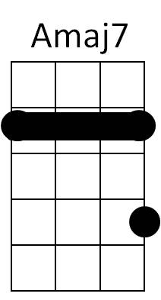**(CHORUS)**

**Bm7 Em7**

**A Amaj7 Bm7 E7 / Bm7 Em7 A**

**A Amaj7 Bm7 E7**

I want to sing you a love song

Bm7

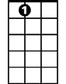

E7

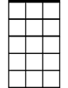

Em7

**Bm7 E7 A**

I want to rock you in my arms all night long.

**Amaj7 Bm7 E7 Bm7**

I want to get to know you, I want to show you

**Em7 A**

The peaceful feeling of my home.

**A Amaj7** **Bm7 E7 / Bm7 E7 A / Bm7 E7 / Bm7 E7 A**