A Natural Woman (Carole King and Gerry Goffin) (D)

D A C G G G G
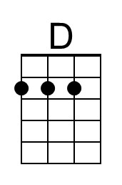
Looking out on the morning rain, I used to feel unin-spired.
D A
And when I knew I had to face another day
C G G G - G
Lord, it made me feel so tired.
Em A Em A6
Before the day I met you, life was so un-kind
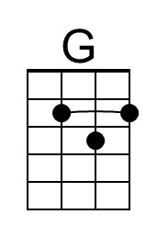
Em A6 G A7
But your love was the key to my peace of mind., ‘cause

Chorus
D G D
You make me feel, you make me feel,
G D G D Em - A
You make me feel like a natural woman.

D A C G
When my soul was in the lost-and-found, you came along to claim it
D A C G
I didn't know just what was wrong with me. Bill your kiss helped me name
Em A Em A6 it.
Now I'm no longer doubtful of what I'm living for
Em A6 G
'Cause if I make you happy I don't need to do more. Chorus

D C Cmaj7 C Cmaj7 C6
Oh, baby, what you've done to me (what you've done to me)
D C - Gmaj7
You make me feel so good inside (good inside)
Fmaj7 G
And I just want to be (want to be) close to you,
G Em
You make me feel so a-live. Chorus (2x)

Outro
A A7 D
Natur-al woman.

 |  |  |  |  |  | 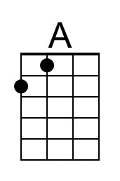 | 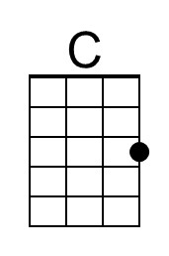
 |  |  |  |  |  | 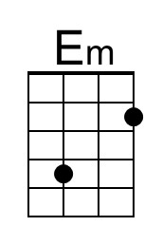 | 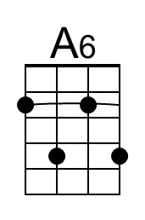
 |  |  |  |  |  | 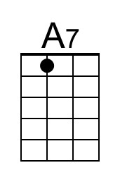 | 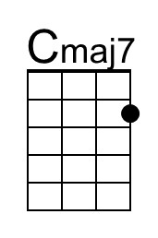
 |  |  |  |  |  | 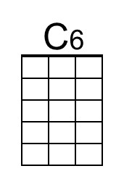 | 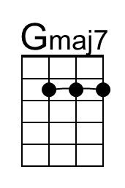
 |  |  |  |  |  | 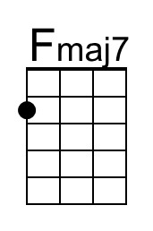
 | Bari | 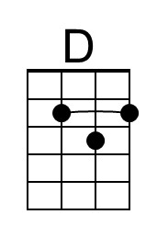 | 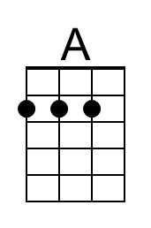 | 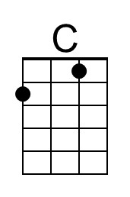 | 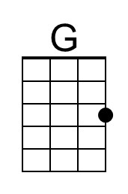 | 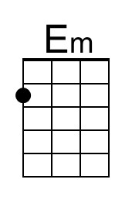 | 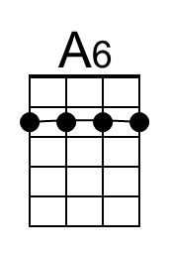
 |  | 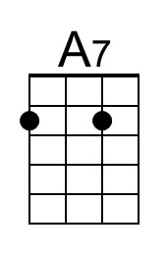 | 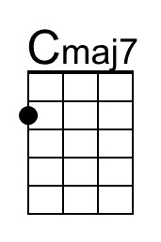 | 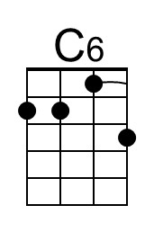 | 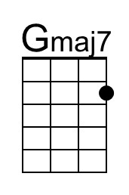 | 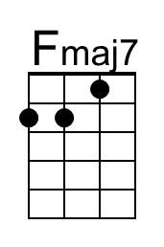

A Natural Woman (Carole King and Gerry Goffin) (G)

G D F C C C C
Looking out on the morning rain, I used to feel unin-spired.
G D
And when I knew I had to face another day
F C C C - C
Lord, it made me feel so tired.
Am D Am D6
Before the day I met you, life was so un-kind
Am D6 C D7
But your love was the key to my peace of mind., 'cause

Chorus
G C G
You make me feel, you make me feel,
C G C G Am - D
You make me feel like a natural woman.

G D F C
When my soul was in the lost-and-found, you came along to claim it
G D F C
I didn't know just what was wrong with me. Bill your kiss helped me name it
Am D Am D6
Now I'm no longer doubtful of what I'm living for
Am D6 C
'Cause if I make you happy I don't need to do more. Chorus

G F Fmaj7 F Fmaj7 F6
Oh, baby, what you've done to me (what you've done to me)
G F - Cmaj7
You make me feel so good inside (good inside)
Bbmaj7 C
And I just want to be (want to be) close to you,
C Am
You make me feel so a-live. Chorus (2x)

Outro
D D7 G
Natur-al woman.

 |  |  |  |  |  |  | 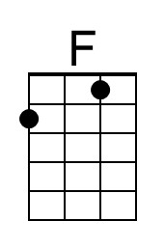
 |  |  |  |  |  | 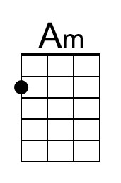 | 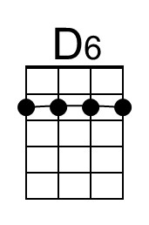
 |  |  |  |  |  | 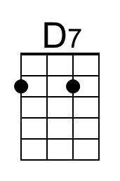
 |  |  |  |  |  | 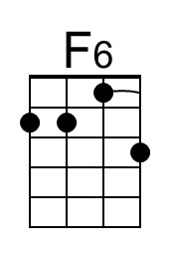
 |  |  |  |  |  | 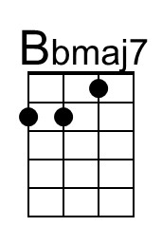
 | Bari |  |  | 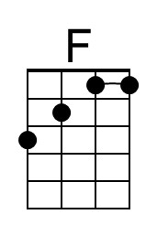 |  | 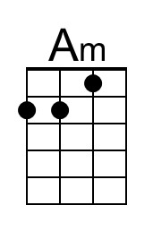 | 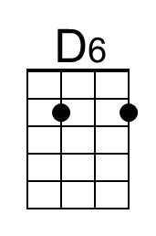
 |  | 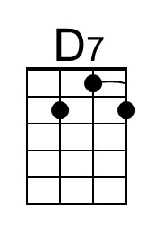 |  | 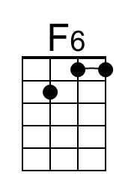 |  | 