**A Scottish Soldier (Green Hills of Tyrol)**

**G**

There was a soldier, a Scottish soldier

**D G**

Who wandered far away and soldiered far away

**G**

There was none bolder, with good broad shoulders

**D D7 G**

He fought in many a fray, and fought and won

**G**

He’d seen the glory, he’d told the story

**D G**

Of battles glorious and deeds victorious

**G**

But now he’s sighing, his heart is crying

**D D7 G**

To leave these green hills of Tyrol

**Chorus:**

**C G**

Because those green hills are not Highland Hills

**D G**

Or the Island Hills, they’re not my land’s hills

**C G**

And fair as these green foreign hills may be,

**D D7 G**

They are not the hills of home

**G**

And now this soldier, this Scottish soldier

**D G**

Who wandered far away and soldiered far away

**G**

Sees leaves are falling, and Death is calling

**D D7 G**

And he will fade away in that far land

**BARITONE**



G

**G**

He called his piper, his trusty piper

**D G**

And bade him sound a lay a pibroch sad to play

**G**

Upon a hillside, a Scottish hillside

**D D7 G**

Not on these green hills of Tyrol

**(Chorus)**

**G**

And now this soldier, this Scottish soldier

**D G**

Will wander far no more and soldier far no more

**G**

And on a hillside, a Scottish hillside

**D D7 G**

You’ll see a piper play his soldier home

**G**

He’s seen the glory, he’s told the story

**D G**

Of battles glorious and deeds victorious

**G**

The bugles cease now, he is at peace now

**D D7 G**

Far from those green hills of Tyrol

**(Chorus)**

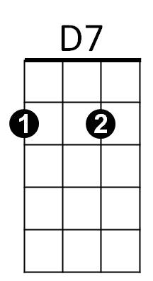



C



G

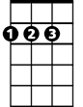

D



D

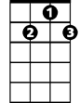

D7

C

