A Summer Song (Chad Stuart, Clive Metcalfe & Keith Noble, 1964) (A)
A Summer Song by Chad and Jeremy (A)
4/4 Time – Tempo 124 bpm

Intro | A C#m | D E | (2x)  A C#m D E A C#m D  Trees swaying in the summer breeze  E A C#m D E A  Showing off their silver leaves as we walked by  C#m D E A C#m D  Soft kisses on a summer’s day  E A C#m  Laughing all our cares a-way  D E A C#m D E  Just you and I  A C#m D E A C#m D  Sweet sleepy warmth of summer nights  E A C#m D  Gazing at the distant lights  E A C D A  In the starry sky  Bridge  D E A F#m  __They say that all good things must end, some-day,  D E F#m ( ↓ _ ↓ ↓ _ ↓ _ ↓ ↓)  Autumn leaves must fall  A C#7  But don’t you know, that it hurts me so,  F#m C#m Bm  To say goodbye to you-ooo,  F#m E F#m E  __ Wish you didn’t have to go. __ No, no, no, no…  A C#m D  And when the rain  E A C#m D  Beats against my window pane  E A C#m D  I’ll think of summer days a-gain  E A C# | D E | A C | D A |  And dream of you. | 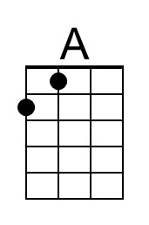 | 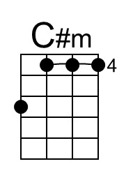
 | 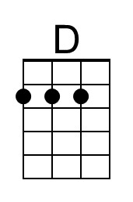 | 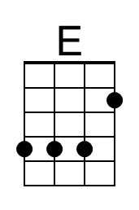
 | 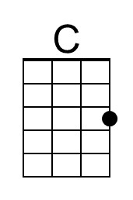 | 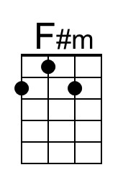
 |  | 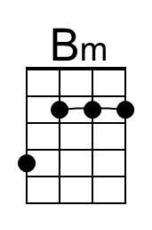
 | 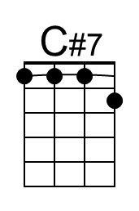
 | 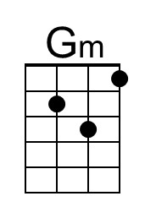 | 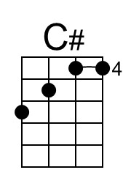
 |  |  | 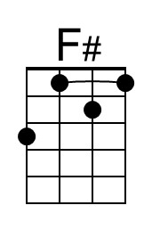

A Summer Song (A) – Page 2

Bridge  D E A F#m  __They say that all good things must end, some-day,  D E F#m ( ↓ _ ↓ ↓ _ ↓ _ ↓ ↓)  Autumn leaves must fall  A C#7  But don’t you know, that it hurts me so,  F#m C#m Gm  To say goodbye to you-ooo,  F#m E F#m E  __ Wish you didn’t have to go. __ No, no, no, no…  A C#m D  And when the rain  E A C#m D  Beats against my window pane  E A C#m D  I’ll think of summer days a-gain  E A C#m D  And dream of you.  E A C# | D E | F#  And dream of you. (Hold) | 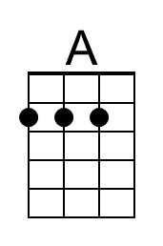 | 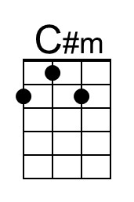
 | 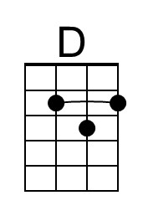 | 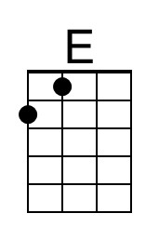
 | 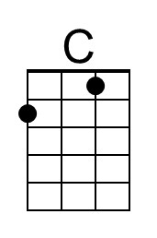 | 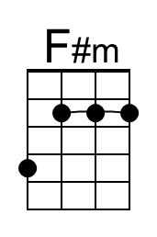
 | 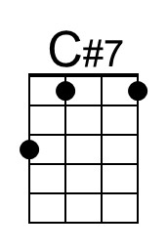 | 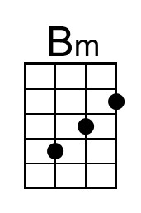
 | 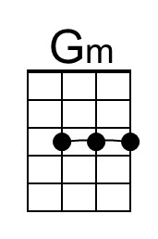 | 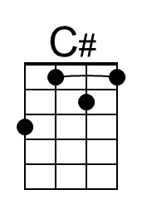
 |  | 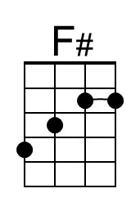

A Summer Song (Chad Stuart, Clive Metcalfe & Keith Noble, 1964) (G)
A Summer Song by Chad and Jeremy (A)
4/4 Time – Tempo 124 bpm

Intro | G Bm | C D | (2x)  G Bm C D G Bm C  Trees swaying in the summer breeze  D G Bm C D G  Showing off their silver leaves as we walked by  Bm C D G Bm C  Soft kisses on a summer’s day  D G Bm  Laughing all our cares a-way  C D G Bm C D  Just you and I.  G Bm C D G Bm C  Sweet sleepy warmth of summer nights  D G Bm C  Gazing at the distant lights  D G A# C G  In the starry sky  Bridge  C D G Em  __They say that all good things must end, some-day,  C D Em  Autumn leaves must fall ( ↓ _ ↓ ↓ _ ↓ _ ↓ ↓)  G B7  But don’t you know, that it hurts me so,  Em Bm Am  To say goodbye to you-ooo,  Em D Em D  __ Wish you didn’t have to go. __ No, no, no, no…  G Bm C  And when the rain  D G Bm C  Beats against my window pane  D G Bm C  I’ll think of summer days a-gain  D G B | C D | G A# | C G |  And dream of you. | 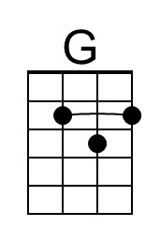
 | 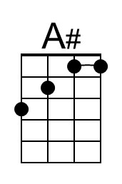 | 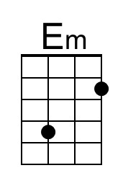
 | 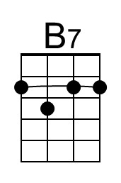 | 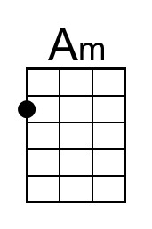
 | 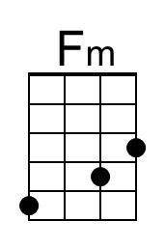 | 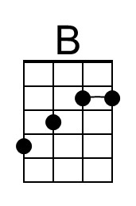

A Summer Song (G) – Page 2

Bridge  C D G Em  __They say that all good things must end, some-day,  C D Em  Autumn leaves must fall ( ↓ _ ↓ ↓ _ ↓ _ ↓ ↓)  G B7  But don’t you know, that it hurts me so,  Em Bm Fm  To say goodbye to you-ooo,  Em D Em D  __ Wish you didn’t have to go. __ No, no, no, no…  G Bm C  And when the rain  D G Bm C  Beats against my window pane  D G Bm C  I’ll think of summer days a-gain  D G Bm C  And dream of you.  D G B | C D | E  And dream of you. (Hold) | 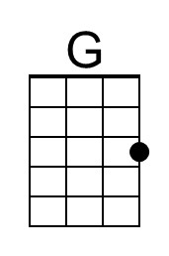
 | 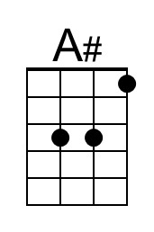 | 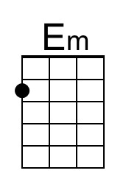
 | 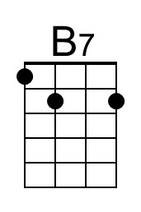 | 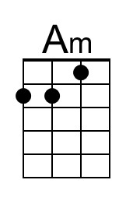
 | 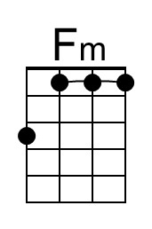 | 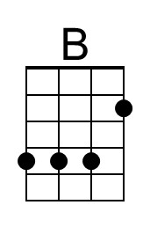
 |  | 