A Summer Song (Chad Stuart, Clive Metcalfe, & Keith Noble, 1964) (C)

Intro: C . Em . F . G . C . Em . F . G .  C . Em . F . G . C . Em . F .  Trees swaying in the sum--- mer breeze-,  G . C . Em . F . G . C .  Showing off their sil--- ver leaves--- as we walk by.  Em . F . G . C . Em . F .  Soft kisses on a sum-mer's day, laughing all our cares--- a- way  G . C . Em . F . G . C . Em . F . G .  Laughing all our cares--- a- way. Just you and I.  C . Em . F . G . C . Em . F .  Swee------eet-- sleepy warmth of sum-mer nights,  G . C . Em . F . G . C . E♭ . F . C . . .  Gazing at the distant--- lights. In the star ry sky------------  Bridge:  F . . . G . . . C . . . Am . . .  They say that all good things must end - some day.  F . . . G . . . Am / // Am / //  Au------ tumn leaves must fall.  C . . . E7 . . .  But don't you know that it hurts me so,  Am . . . Em . Dm .  To say good-bye to you,  Am . . . G . . . Am . . . G . .  Wish you didn't have to go. No, no, no, no.  . C . Em . F . G . C . Em . F .  And when the rain------------- beats a-gainst my window pane  G . C . Em . F . G . C . Em . F . G  I'll think of summer days--- a-gain, and dream of you.  Repeat From Bridge  . G . C . Em . F . G . A  And dream of you. |  |  |  |  |  |  |  | 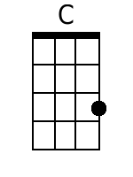 |  |  | 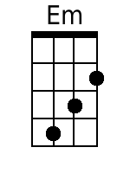
 |  |  |  |  |  |  |  | 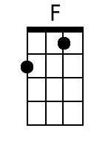 |  | 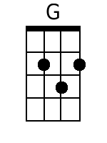
 |  |  |  |  |  |  |  | 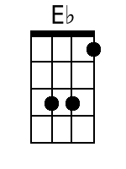 |  | 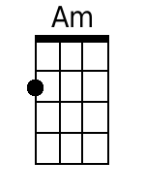
 |  |  |  |  |  |  |  | 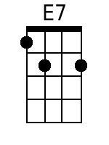 |  | 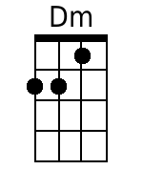
 |  |  |  |  |  |  |  | 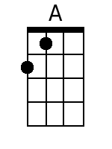
Bari
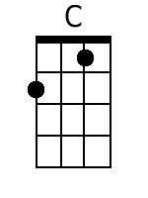 | 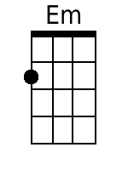 | 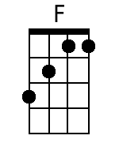 | 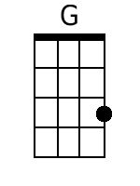 | 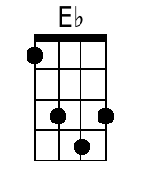 | 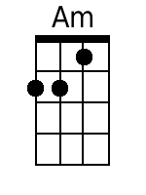 | 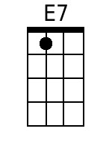 | 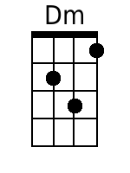 |  | 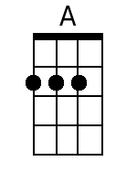

A Summer Song (Chad Stuart, Clive Metcalfe, & Keith Noble, 1964) (G)

Introduction: G . Bm . C . D . G . Bm . C . D .  G . Bm . C . D . G . Bm . C .  Trees swaying in the sum--- mer breeze.  D . G . Bm . C . D . G .  Showing off their sil--- ver leaves--- as we walk by.  Bm . C . D . G . Bm . C .  Soft kisses on a sum-mer's day---  D . G . Bm . C . D . G . Bm . C . D .  Laughing all our cares away. Just you and I.  G . Bm . C . D . G . Bm . C .  Swee------eet-- sleepy warmth of summer nights.  D . G . Bm . C . D . G . B♭ . C . G . . .  Gazing at the distant lights, In the star ry sky.  Bridge:  C . . . D . . . G . . . Em . . .  They say that all good things must end - some day.  C . . . D . . . Em \ \\ Em \ \\  Au- tumn leaves must fall.  --- G . . . B7 . . .  But don't you know that it hurts me so,  Em . . . Bm . Am .  To say good-bye to you  Em . . . D . . . Em . . . D . .  Wish you didn't have to go. No, no, no, no.  . G . Bm . C . D . G . Bm . C .  And when the rain beats against my window pane.  D . G . Bm . C . D . G . Bm . C . D .  I'll think of summer days a-gain, and dream of you  Repeat From Bridge  . D . G . Bm . C . D . E  And dream of you . |  |  |  |  |  |  |  |  |  | 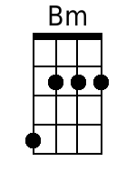
 |  |  |  |  |  |  |  |  |  | 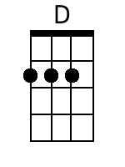
 |  |  |  |  |  |  |  | 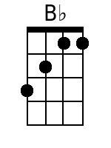
 |  |  |  |  |  |  |  | 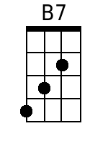
 |  |  |  |  |  |  |  | 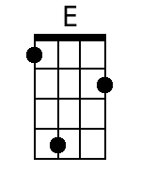
Bari
 | 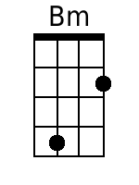 |  | 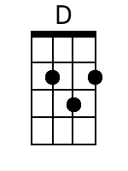 | 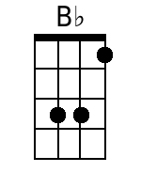 |  | 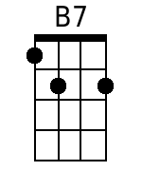 |  |  | 