A Summer Song (Chad Stuart, Clive Metcalfe & Keith Noble, 1964) (C)
A Summer Song by Chad and Jeremy

Intro C Em F G (2x)  C Em F G C Em F  Trees swaying in the summer breeze  G C Em F G C  Showing off their silver leaves as we walked by  Em F G C Em F  Soft kisses on a summer’s day  G C Em  Laughing all our cares a-way  F G C Em F G  Just you and I  C Em F G C Em F  Sweet sleepy warmth of summer nights  G C Em F  Gazing at the distant lights  G C Eb F C  In the starry sky.  Bridge  F G C Am  They say that all good things must end, some-day,  F G Am [ ↓ _ ↓ ↓ _ ↓ _ ↓ ↓ ]  Autumn leaves must fall.  C E7  But don’t you know, that it hurts me so,  Am Em Dm  To say goodbye to you ooo,  Am G Am G  Wish you didn’t have to go, No, no, no, no.  C Em F  And when the rain  G C Em F  Beats against my window pane  G C Em F  I’ll think of summer days a-gain  G C Eb F C (Repeat from Bridge)  And dream of you  To Outro: C Em F G  Outro  G C Em F G C [Hold]  And dream of you. | 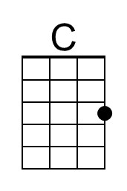 | 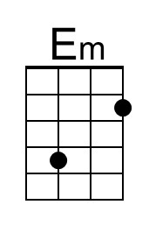 | 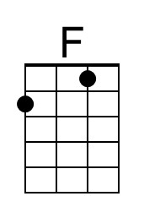
 | 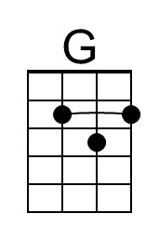 | 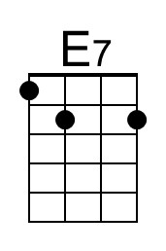 | 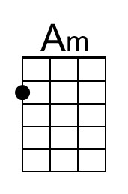
 | 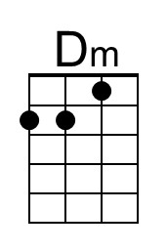 | 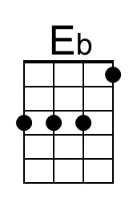 | 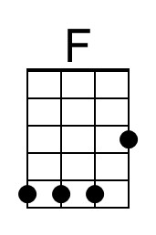
 | Bari
 | 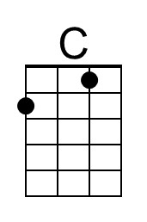 | 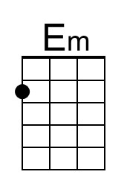 | 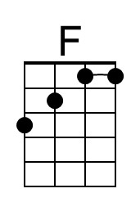
 | 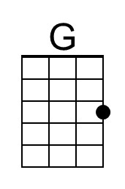 | 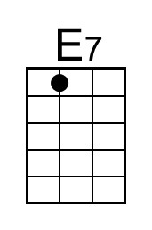 | 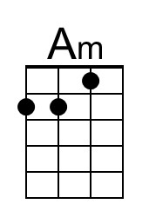
 | 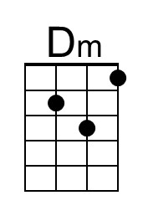 | 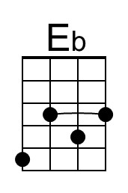 | 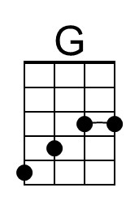

A Summer Song (Chad Stuart, Clive Metcalfe & Keith Noble, 1964) (F)
A Summer Song by Chad and Jeremy

Intro F Am Bb C (2x)  F Am Bb C F Am Bb  Trees swaying in the summer breeze  C F Am Bb C F  Showing off their silver leaves as we walked by  Am Bb C F Am Bb  Soft kisses on a summer’s day  C F Am  Laughing all our cares a-way  Bb C F Am Bb C  Just you and I  F Am Bb C F Am Bb  Sweet sleepy warmth of summer nights  C F Am Bb  Gazing at the distant lights  C F Ab Bb F  In the starry sky  Bridge  Bb C F Dm  They say that all good things must end, someday,  Bb C Dm [ ↓ _ ↓ ↓ _ ↓ _ ↓ ↓ ]  Autumn leaves must fall  F A7  But don’t you know, that it hurts me so,  Dm Am Gm  To say goodbye to you ooo,  Dm C Dm C  Wish you didn’t have to go, No, no, no, no…  F Am Bb  And when the rain  C F Am Bb  Beats against my window pane  C F Am Bb  I’ll think of summer days a-gain  C F Ab Bb F (Repeat from Bridge)  And dream of you  To Outro: F Am Bb C  Outro  C F Am Bb C F (Hold)  And dream of you. |  |  | 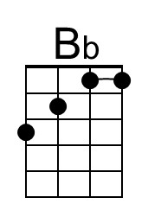
 |  |  | 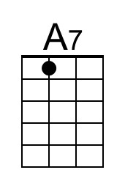
 | 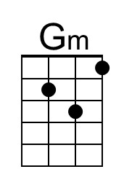 | 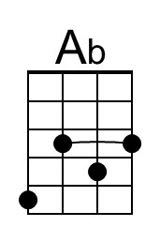 | 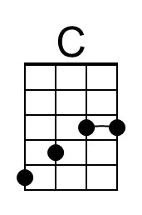
 | Bari
 |  |  | 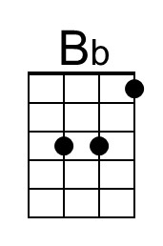
 |  |  | 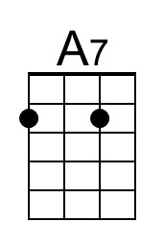
 | 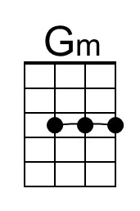 | 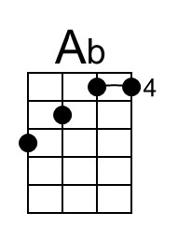 | 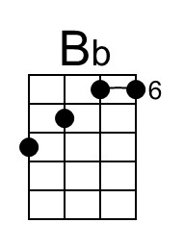

A Summer Song (Chad Stuart, Clive Metcalfe & Keith Noble, 1964) (D)
A Summer Song by Chad and Jeremy

Intro D F#m G A (2x)  D F#m G A D F#m G  Trees swaying in the summer breeze  A D F#m G A D  Showing off their silver leaves as we walked by.  F#m G A D F#m G  Soft kisses on a summer’s day  A D F#m  Laughing all our cares a-way  G A D F#m G A  Just you and I.  D F#m G A D F#m G  Sweet sleepy warmth of summer nights  A D F#m G  Gazing at the distant lights  A D F G A  In the starry sky.  Bridge  G A D Bm  They say that all good things must end, someday,  G A Bm  Autumn leaves must fall [ ↓ _ ↓ ↓ _ ↓ _ ↓ ↓ ]  D F#7  But don’t you know, that it hurts me so,  Bm F#m Dm  To say goodbye to you ooo,  Bm A Bm A  Wish you didn’t have to go, No, no, no, no…  D F#m G  And when the rain  A D F#m G  Beats against my window pane  A D F#m G  I’ll think of summer days a-gain  A D F G A (Repeat from Bridge)  And dream of you  To Outro: D F#m G A  Outro  A D F#m G A D  And dream of you | 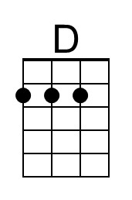 | 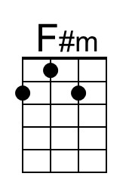
 | 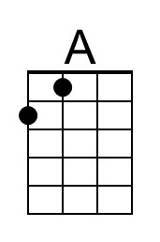 |  | 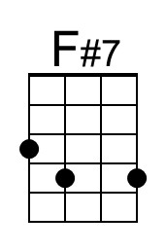
 |  | 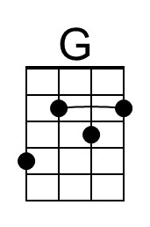
 | Bari
 | 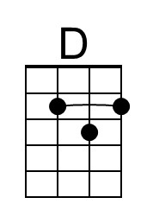 | 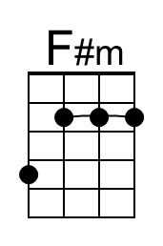
 | 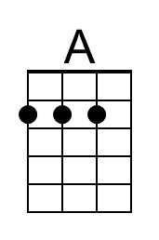 | 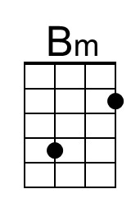 | 