**A Summer Song (Chad & Jeremy) Key C**

**Intro:** **C** **Em** **F** **G**

**C** **Em** **F** **G C Em F**

Trees swaying in the summer breeze

**G** **C Em F G C**

Showing off their silver leaves as we walked by

**Em** **F G C Em F**

Soft kisses on a summer’s day

**G C Em**

Laughing all our cares a-way

**F** **G C** **Em** **F G**

Just you and I

**C Em** **F** **G C Em F**

Sweet sleepy warmth of summer nights

**G C Em F**

Gazing at the distant lights

**G C Em** **F** **G**

In the starry sky

**BRIDGE**:

**F** **G** **C Am**

They say that all good things must end, someday,

**F** **G Am**

Autumn leaves must fall

**C E7**

But don’t you know, that it hurts me so,

**Am Em Dm**

To say goodbye to you ooo,

**Am** **G Am G**

Wish you didn’t have to go, No, no, no, no…

**C Em** **F**

And when the rain

**G C Em F**

Beats against my window pane

**G C Em F**

I’ll think of summer days a-gain

**G C Em** **F** **G**

And dream of you

**BARITONE**

C

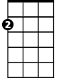

Em



G



F

**(BRIDGE)**

**C Em** **F**

And when the rain

**G C Em F**

Beats against my window pane

**G C Em F**

I’ll think of summer days a-gain

**G C Em** **F**

And dream of you

**G C Em** **F** **G** **C**

And dream of you

F



G

Em

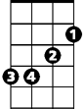

C

E7

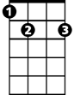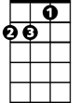

Dm



Am

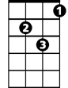

Dm



Am

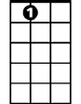

E7