A Summer Song (Chad Stuart, Clive Metcalfe & Keith Noble, 1964) (F)
A Summer Song by Chad and Jeremy (A)
4/4 Time – Tempo 124 bpm
Intro F Am B♭ C (2x)  F Am B♭ C F Am B♭  Trees swaying in the summer breeze  C F Am B♭ C F  Showing off their silver leaves as we walked by  Am B♭ C F Am B♭  Soft kisses on a summer’s day  C F Am  Laughing all our cares a-way  B♭ C F Am B♭ C  Just you and I  F Am B♭ C F Am B♭  Sweet sleepy warmth of summer nights  C F Am B♭  Gazing at the distant lights  C F A♭ B♭ F  In the starry sky  Bridge  B♭ C F Dm  __They say that all good things must end, some-day,  B♭ C Dm ↓ _ ↓ ↓ _ ↓ _ ↓ ↓  Autumn leaves must fall  F A7  But don’t you know, that it hurts me so,  Dm Am Gm  To say goodbye to you-ooo,  Dm C Dm C  __ Wish you didn’t have to go. __ No, no, no, no…  F Am B♭  And when the rain  C F Am B♭  Beats against my window pane  C F Am B♭  I’ll think of summer days a-gain  C F A | B♭ C | F A♭ | B♭ F |  And dream of you. | 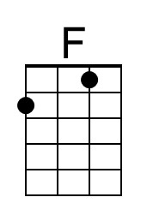 | 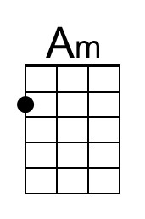
 | 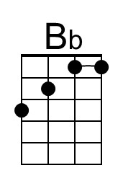 | 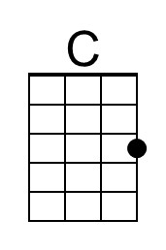
 | 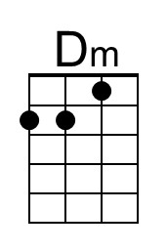 | 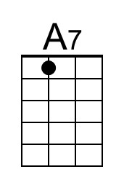
 | 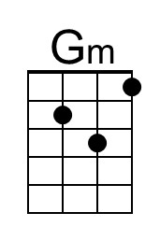
 | 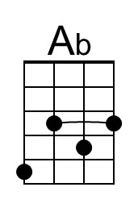 | 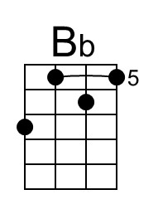
 |  | 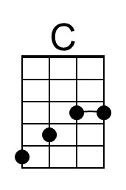

A Summer Song (F) – Page 2

Bridge  B♭ C F Dm  __They say that all good things must end, some-day,  B♭ C Dm ↓ _ ↓ ↓ _ ↓ _ ↓ ↓  Autumn leaves must fall  F A7  But don’t you know, that it hurts me so,  Dm Am Gm  To say goodbye to you-ooo,  Dm C Dm C  __ Wish you didn’t have to go. __ No, no, no, no…  F Am B♭  And when the rain  C F Am B♭  Beats against my window pane  C F Am B♭  I’ll think of summer days a-gain  C F Am B♭  And dream of you.  C F A | B♭ C | D (Hold)  And dream of you. | 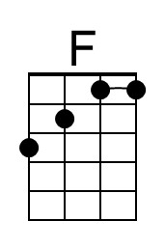 | 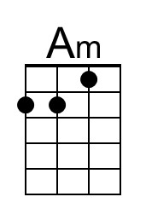
 | 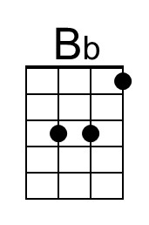 | 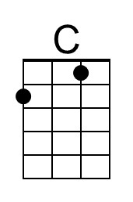
 | 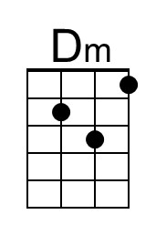 | 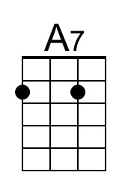
 | 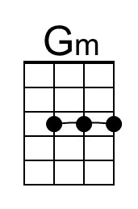 | 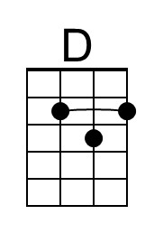
 | 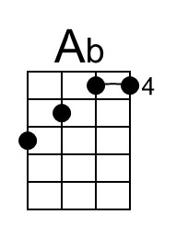 | 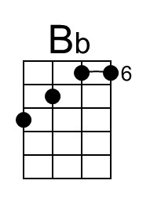
 |  | 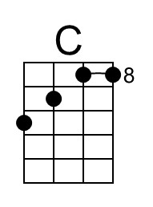

A Summer Song (Chad Stuart, Clive Metcalfe & Keith Noble, 1964) (A)
A Summer Song by Chad and Jeremy (A)
4/4 Time – Tempo 124 bpm

Intro | A C#m | D E | (2x)  A C#m D E A C#m D  Trees swaying in the summer breeze  E A C#m D E A  Showing off their silver leaves as we walked by  C#m D E A C#m D  Soft kisses on a summer’s day  E A C#m D E A C#m D E  Laughing all our cares a-way, Just you and I.  A C#m D E A C#m D  Sweet sleepy warmth of summer nights  E A C#m D E A C D A  Gazing at the distant lights In the starry sky  Bridge  D E A F#m  __They say that all good things must end, some-day,  D E F#m ( ↓ _ ↓ ↓ _ ↓ _ ↓ ↓)  Autumn leaves must fall  A C#7  But don’t you know, that it hurts me so,  F#m C#m Bm  To say goodbye to you - ooo,  F#m E F#m E  __ Wish you didn’t have to go. __ No, no, no, no…  A C#m D  And when the rain  E A C#m D  Beats against my window pane  E A C#m D  I’ll think of summer days a-gain  E A C# | D E | A C | D A |  And dream of you. | 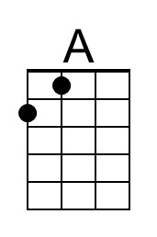 | 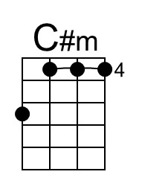
 | 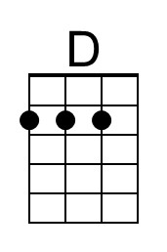 | 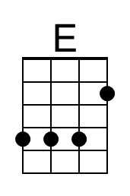
 |  | 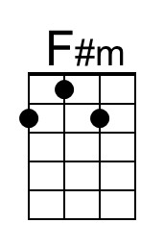
 |  | 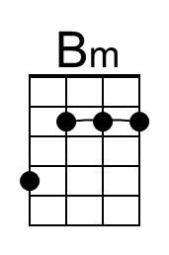
 | 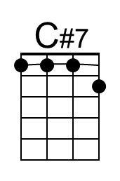
 |  | 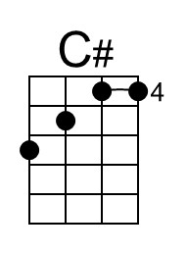
 |  | 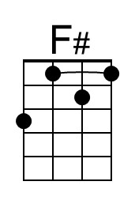

A Summer Song (A) – Page 2

Bridge  D E A F#m  _They say that all good things must end, some-day,  D E F#m ( ↓ _ ↓ ↓ _ ↓ _ ↓ ↓)  Autumn leaves must fall  A C#7  But don’t you know, that it hurts me so,  F#m C#m Gm  To say goodbye to you - ooo,  F#m E F#m E  __ Wish you didn’t have to go. __ No, no, no, no…  A C#m D E A C#m D  And when the rain Beats against my window pane,  E A C#m D  I’ll think of summer days a-gain,  E A C#m D  And dream of you.  E A C# | D E | F#  And dream of you. (Hold) | 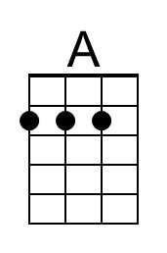 | 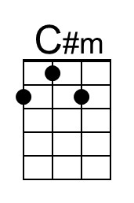
 |  | 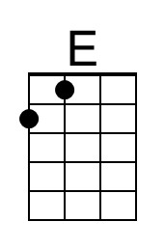
 |  | 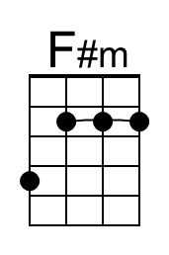
 | 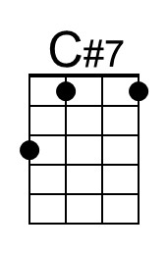 | 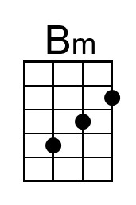
 |  | 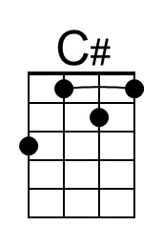
 |  | 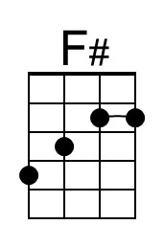

A Summer Song (Chad Stuart, Clive Metcalfe & Keith Noble, 1964) (C)
A Summer Song by Chad and Jeremy (A)
4/4 Time – Tempo 124 bpm

Intro | C Em | F G | (2x)  C Em F G C Em F  Trees swaying in the summer breeze  G C Em F G C  Showing off their silver leaves as we walked by  Em F G C Em F  Soft kisses on a summer’s day  G C Em F G C Em F G  Laughing all our cares a-way, Just you and I.  C Em F G C Em F  Sweet sleepy warmth of summer nights  G C Em F  Gazing at the distant lights  G C D# F C  In the starry sky  F G C Am  __They say that all good things must end, some-day,  F G Am  Autumn leaves must fall ( ↓ _ ↓ ↓ _ ↓ _ ↓ ↓)  C E7  But don’t you know, that it hurts me so, Bridge  Am Em Dm  To say goodbye to you-ooo,  Am G Am G  __ Wish you didn’t have to go. __ No, no, no, no…  C Em F G C Em F  And when the rain Beats against my window pane,  G C Em F  I’ll think of summer days a-gain  G C E | F G | C D# | F C |  And dream of you. |  | 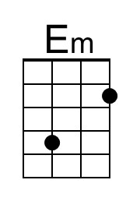
 |  | 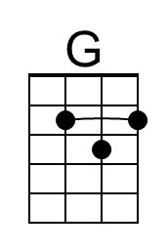
 | 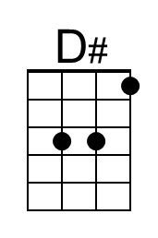
 | 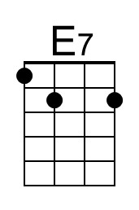
 | 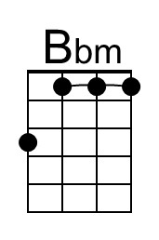

A Summer Song (C) – Page 2

Bridge  F G C Am  __They say that all good things must end, some-day,  F G Am  Autumn leaves must fall ( ↓ _ ↓ ↓ _ ↓ _ ↓ ↓)  C E7  But don’t you know, that it hurts me so,  Am Em Bbm  To say goodbye to you-ooo,  Am G Am G  __ Wish you didn’t have to go. __ No, no, no, no…  C Em F G C Em F  And when the rain Beats against my window pane  G C Em F G C Em F  I’ll think of summer days a-gain And dream of you.  G C E | F G | A  And dream of you. (Hold) |  | 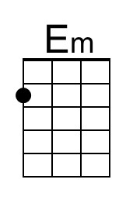
 |  | 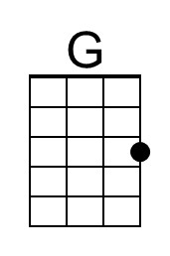
 | 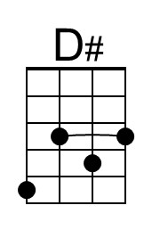
 | 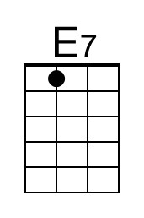
 | 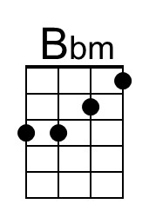

A Summer Song (Chad Stuart, Clive Metcalfe & Keith Noble, 1964) (G)
A Summer Song by Chad and Jeremy (A)
4/4 Time – Tempo 124 bpm

Intro | G Bm | C D | (2x)

G Bm C D G Bm C
Trees swaying in the summer breeze
D G Bm C D G
Showing off their silver leaves as we walked by
Bm C D G Bm C
Soft kisses on a summer’s day
D G Bm C D G Bm C D
Laughing all our cares a-way, Just you and I.

G Bm C D G Bm C
Sweet sleepy warmth of summer nights
D G Bm C
Gazing at the distant lights
D G A# C G
In the starry sky

Bridge
C D G Em
__They say that all good things must end, some-day,
C D Em
Autumn leaves must fall ( ↓ _ ↓ ↓ _ ↓ _ ↓ ↓)
G B7
But don’t you know, that it hurts me so,
Em Bm Am
To say goodbye to you-ooo,
Em D Em D
__ Wish you didn’t have to go. __ No, no, no, no…

G Bm C D G Bm C
And when the rain Beats against my window pane,
D G Bm C
I’ll think of summer days a-gain
D G B | C D | G A# | C G |
And dream of you.
 | 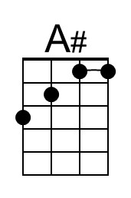
 | 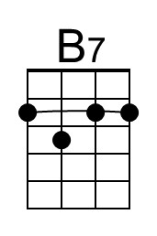
 | 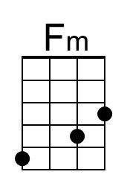 | 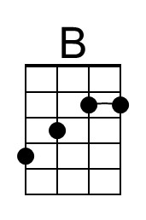

A Summer Song (G) – Page 2

Bridge
C D G Em
__They say that all good things must end, some-day,
C D Em
Autumn leaves must fall ( ↓ _ ↓ ↓ _ ↓ _ ↓ ↓)
G B7
But don’t you know, that it hurts me so,
Em Bm Fm
To say goodbye to you-ooo,
Em D Em D
__ Wish you didn’t have to go. __ No, no, no, no…

G Bm C D G Bm C
And when the rain Beats against my window pane
D G Bm C D G Bm C
I’ll think of summer days a-gain And dream of you.
D G B | C D | E
And dream of you. (Hold)

 | 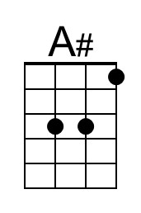
 | 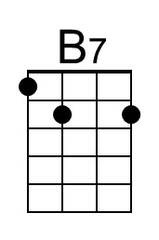
 | 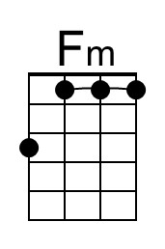 | 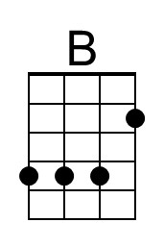
 |  | 