
A Summer Song (Chad Stuart, Clive Metcalfe & Keith Noble, 1964) (F)
A Summer Song by Chad and Jeremy

Intro F Am Bb C (2x)  F Am Bb C F Am Bb  Trees swaying in the summer breeze  C F Am Bb C F  Showing off their silver leaves as we walked by  Am Bb C F Am Bb  Soft kisses on a summer’s day  C F Am  Laughing all our cares a-way  Bb C F Am Bb C  Just you and I  F Am Bb C F Am Bb  Sweet sleepy warmth of summer nights  C F Am Bb  Gazing at the distant lights  C F Ab Bb F  In the starry sky  Bridge  Bb C F Dm  They say that all good things must end, someday,  Bb C Dm [ ↓ _ ↓ ↓ _ ↓ _ ↓ ↓ ]  Autumn leaves must fall  F A7  But don’t you know, that it hurts me so,  Dm Am Gm  To say goodbye to you ooo,  Dm C Dm C  Wish you didn’t have to go, No, no, no, no…  F Am Bb  And when the rain  C F Am Bb  Beats against my window pane  C F Am Bb  I’ll think of summer days a-gain  C F (To Bridge) Ab Bb F  And dream of you  To Outro: F Am Bb  Outro  C F Am Bb C F (Hold)  And dream of you. | 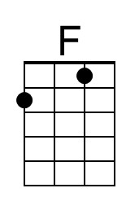 | 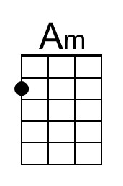 | 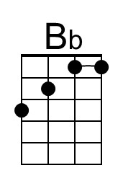
 | 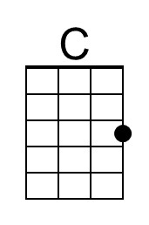 | 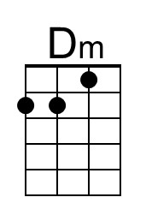 | 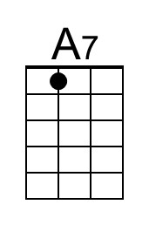
 | 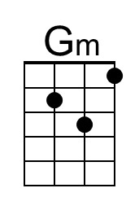 | 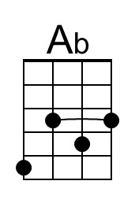 | 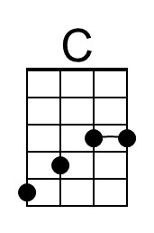
 | Bari
 | 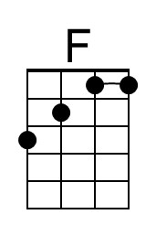 | 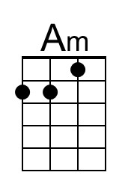 | 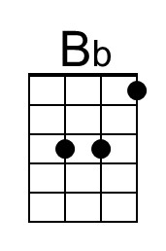
 | 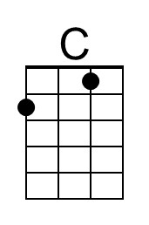 | 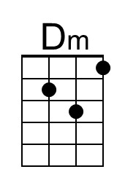 | 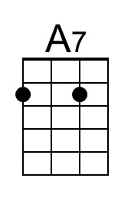
 | 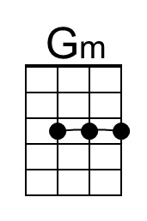 | 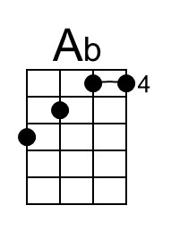 | 