A Summer Song
Words and Music: Chad Stuart, Clive Metcalfe, & Keith Noble, 1964.
Recorded by Chad & Jeremy (Chad Stuart & Jeremy Clyde)
YouTube: https://www.youtube.com/watch?v=_D2XD341xHo
Key of F

Intro: F . Am . B♭ . C . F . Am . B♭ . C .

F . Am . B♭ . C . F . Am . B♭ .
Trees--------- swaying in the sum--- mer breeze---
C . F . Am . B♭ . C . F .
Showing off their sil--- ver leaves--- as we walk by-----
Am . B♭ . C . F . Am . B♭ .
Soft------ kisses on a sum-mer's day---------
C . F . Am . B♭ .
Laughing all our cares--- a- way----
C . F . Am . B♭ . C .
Just you and I----------

F . Am . B♭ . C . F . Am . B♭ .
Swee------eet-- sleepy warmth of sum-mer nights-----
C . F . Am .
Gazing at the distant--- lights-
B♭ . C . F . Ab . B♭ . F . . .
--- In the star ry sky------------

Bridge:
B♭ . . . C . . . F . . . Dm . . .
They say that all good things must end-- some day------
B♭ . . . C . . . Dm Dm
Au------ tumn leaves must fall-------------------
--- F . . . A7 . . .
But don't you know that it hurts me so-----
Dm . . . Am . Gm .
To say good-bye to you--u--u--u---
Dm . . . C . . .
Wish you didn't have to go------
Dm . . . C . .
-- No, no-no--- no---------

. F . Am .
And when the rain--------------
B♭ . C . F . Am . B♭ .
-------- beats a-gainst my win--- dow pane---------
C . F . Am .
I'll think of summer days--- a-gain-----
B♭ . C . F . Am . B♭ . C
--- and dream of you---------------

Repeat From Bridge

. C . F . Am . B♭ . C . D
And dream of you ------------------------
A Summer Song
Words and Music: Chad Stuart, Clive Metcalfe, & Keith Noble, 1964.
Recorded by Chad & Jeremy (Chad Stuart & Jeremy Clyde)
YouTube: https://www.youtube.com/watch?v=_D2XD341xHo
Key of C

Intro: C . Em . F . G . C . Em . F . G .

C . Em . F . G . C . Em . F .
Trees--------- swaying in the sum--- mer breeze---
G . C . Em . F . G . C .
Showing off their sil--- ver leaves--- as we walk by-----
Em . F . G . C . Em . F .
Soft------ kisses on a sum-mer's day---------
G . C . Em . F .
Laughing all our cares--- a- way----
G . C . Em . F . G .
Just you and I----------

C . Em . F . G . C . Em . F .
Swee------eet-- sleepy warmth of sum-mer nights-----
G . C . Em .
Gazing at the distant--- lights-
F . G . C . Eb . F . C . . .
--- In the star ry sky------------

Bridge:
F . . . G . . . C . . . Am . . .
They say that all good things must end-- some day------
F . . . G . . . Am / // Am / //
Au------ tumn leaves must fall-------------------
--- C . . . E7 . . .
But don't you know that it hurts me so-----
Am . . . Em . Dm .
To say good-bye to you--u--u--u---
Am . . . G . . .
Wish you didn't have to go------
Am . . . G . .
-- No, no-no--- no---------

. C . Em .
And when the rain--------------
F . G . C . Em . F .
-------- beats a-gainst my win--- dow pane---------
G . C . Em .
I'll think of summer days--- a-gain-----
F . G . C . Em . F . G
--- and dream of you---------------

Repeat From Bridge
. G . C . Em . F . G . A
And dream of you ------------------------
A Summer Song
Words and Music: Chad Stuart, Clive Metcalfe, & Keith Noble, 1964.
Recorded by Chad & Jeremy (Chad Stuart & Jeremy Clyde)
YouTube: https://www.youtube.com/watch?v=_D2XD341xHo
Key of G

Introduction: G . Bm . C . D . G . Bm . C . D .

G . Bm . C . D . G . Bm . C .
Trees--------- swaying in the sum--- mer breeze---
D . G . Bm . C . D . G .
Showing off their sil--- ver leaves--- as we walk by-----
Bm . C . D . G . Bm . C .
Soft------ kisses on a sum-mer's day---------
D . G . Bm . C .
Laughing all our cares--- a- way----
D . G . Bm . C . D .
Just you and I----------

G . Bm . C . D . G . Bm . C .
Swee------eet-- sleepy warmth of sum-mer nights-----
D . G . Bm .
Gazing at the distant--- lights-
C . D . G . B♭ . C . G . . .
--- In the star ry sky------------

Bridge:
C . . . D . . . G . . . Em . . .
They say that all good things must end-- some day------
C . . . D . . . Em \ \\ Em \ \\
Au------ tumn leaves must fall-------------------
--- G . . . B7 . . .
But don't you know that it hurts me so-----
Em . . . Bm . Am .
To say good-bye to you--u--u--u---
Em . . . D . . .
Wish you didn't have to go------
Em . . . D . .
-- No, no-no--- no---------

. G . Bm .
And when the rain--------------
C . D . G . Bm . C .
-------- beats a-gainst my win--- dow pane---------
D . G . Bm .
I'll think of summer days--- a-gain-----
C . D . G . Bm . C . D
--- and dream of you---------------

Repeat From Bridge

. D . G . Bm . C . D . E
And dream of you ------------------------
A Summer Song
Words and Music: Chad Stuart, Clive Metcalfe, & Keith Noble, 1964.
Recorded by Chad & Jeremy (Chad Stuart & Jeremy Clyde)
YouTube: https://www.youtube.com/watch?v=_D2XD341xHo
Key of C

GCEA          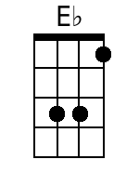         | Intro: C . Em . F . G . C . Em . F . G .  C . Em . F . G . C . Em . F .  Trees--------- swaying in the sum--- mer breeze---  G . C . Em . F . G . C .  Showing off their sil--- ver leaves--- as we walk by-----  Em . F . G . C . Em . F .  Soft------ kisses on a sum-mer's day---------  G . C . Em . F .  Laughing all our cares--- a- way----  G . C . Em . F . G .  Just you and I----------  C . Em . F . G . C . Em . F .  Swee------eet-- sleepy warmth of sum-mer nights-----  G . C . Em .  Gazing at the distant--- lights-  F . G . C . E♭ . F . C . . .  --- In the star ry sky------------  Bridge:  F . . . G . . . C . . . Am . . .  They say that all good things must end-- some day------  F . . . G . . . Am / // Am / //  Au------ tumn leaves must fall-------------------  --- C . . . E7 . . .  But don't you know that it hurts me so-----  Am . . . Em . Dm .  To say good-bye to you--u--u--u---  Am . . . G . . .  Wish you didn't have to go------  Am . . . G . .  -- No, no-no--- no---------  . C . Em .  And when the rain--------------  F . G . C . Em . F .  -------- beats a-gainst my win--- dow pane---------  G . C . Em .  I'll think of summer days--- a-gain-----  F . G . C . Em . F . G  --- and dream of you---------------  Repeat From Bridge  . G . C . Em . F . G . A  And dream of you ------------------------ | Bari          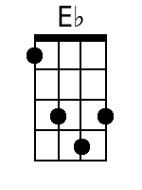        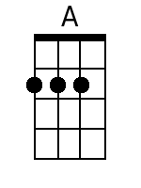

A Summer Song
Words and Music: Chad Stuart, Clive Metcalfe, & Keith Noble, 1964.
Recorded by Chad & Jeremy (Chad Stuart & Jeremy Clyde)
YouTube: https://www.youtube.com/watch?v=_D2XD341xHo
Key of F

GCEA  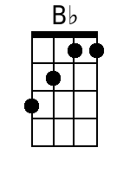  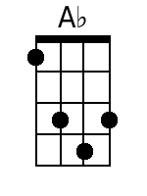      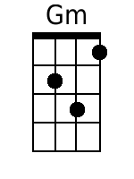 | Intro: F . Am . B♭ . C . F . Am . B♭ . C .  F . Am . B♭ . C . F . Am . B♭ .  Trees--------- swaying in the sum--- mer breeze---  C . F . Am . B♭ . C . F .  Showing off their sil--- ver leaves--- as we walk by-----  Am . B♭ . C . F . Am . B♭ .  Soft------ kisses on a sum-mer's day---------  C . F . Am . B♭ .  Laughing all our cares--- a- way----  C . F . Am . B♭ . C .  Just you and I----------  F . Am . B♭ . C . F . Am . B♭ .  Swee------eet-- sleepy warmth of sum-mer nights-----  C . F . Am .  Gazing at the distant--- lights-  B♭ . C . F . A♭ . B♭ . F . . .  --- In the star ry sky------------  Bridge:  B♭ . . . C . . . F . . . Dm . . .  They say that all good things must end-- some day------  B♭ . . . C . . . Dm Dm  Au------ tumn leaves must fall-------------------  --- F . . . A7 . . .  But don't you know that it hurts me so-----  Dm . . . Am . Gm .  To say good-bye to you--u--u--u---  Dm . . . C . . .  Wish you didn't have to go------  Dm . . . C . .  -- No, no-no--- no---------  . F . Am .  And when the rain--------------  B♭ . C . F . Am . B♭ .  -------- beats a-gainst my win--- dow pane---------  C . F . Am .  I'll think of summer days--- a-gain-----  B♭ . C . F . Am . B♭ . C  --- and dream of you---------------  Repeat From Bridge  . C . F . Am . B♭ . C . D  And dream of you ------------------------ | Bari  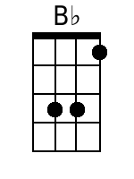  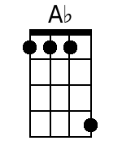      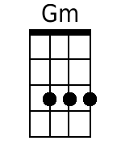

A Summer Song
Words and Music: Chad Stuart, Clive Metcalfe, & Keith Noble, 1964.
Recorded by Chad & Jeremy (Chad Stuart & Jeremy Clyde)
YouTube: https://www.youtube.com/watch?v=_D2XD341xHo
Key of G

GCEA  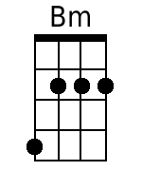  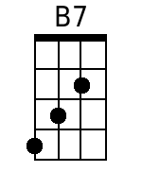  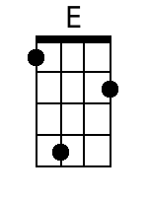 | Introduction: G . Bm . C . D . G . Bm . C . D .  G . Bm . C . D . G . Bm . C .  Trees--------- swaying in the sum--- mer breeze---  D . G . Bm . C . D . G .  Showing off their sil--- ver leaves--- as we walk by-----  Bm . C . D . G . Bm . C .  Soft------ kisses on a sum-mer's day---------  D . G . Bm . C .  Laughing all our cares--- a- way----  D . G . Bm . C . D .  Just you and I----------  G . Bm . C . D . G . Bm . C .  Swee------eet-- sleepy warmth of sum-mer nights-----  D . G . Bm .  Gazing at the distant--- lights-  C . D . G . B♭ . C . G . . .  --- In the star ry sky------------  Bridge:  C . . . D . . . G . .  They say that all good things must end--  . . Em . . .  Some day------  C . . . D . . . Em \ \\ Em \ \\  Au------ tumn leaves must fall-------------------  --- G . . . B7 . . .  But don't you know that it hurts me so-----  Em . . . Bm . Am .  To say good-bye to you--u--u--u---  Em . . . D . . .  Wish you didn't have to go------  Em . . . D . .  -- No, no-no--- no---------  . G . Bm .  And when the rain--------------  C . D . G . Bm . C .  -------- beats a-gainst my win--- dow pane---------  D . G . Bm .  I'll think of summer days--- a-gain-----  C . D . G . Bm . C . D  --- and dream of you---------------  Repeat From Bridge  . D . G . Bm . C . D . E  And dream of you ------------------------ | Bari  

