A Summer Song
Words and Music: Chad Stuart, Clive Metcalfe, & Keith Noble, 1964.
Recorded by Chad & Jeremy (Chad Stuart & Jeremy Clyde)
YouTube: https://www.youtube.com/watch?v=_D2XD341xHo
Keys of C, F & G

"A Summer Song" was a 1964 Top Ten hit by Chad & Jeremy. The song was written and composed by duo partner Chad Stuart (Jeremy Clyde made few contributions to Stuart's and his repertoire) with Clive Metcalfe and Keith Noble.

Like the duo's breakthrough selection, "Yesterday's Gone," "A Summer Song" is a reminiscence of a summer romance. However, "A Summer Song" eschews the "Merseybeat" sound of "Yesterday's Gone" in favor of a gentler folk-influenced arrangement, with the lyrics also being wistful in tone.

Stuart would recall, on The Steel Pier Radio Show, that his "A Summer Song" collaborators, Clive Metcalfe and Keith Noble, were themselves a musical duo with whom he and Clyde had become friendly, and that "A Summer Song" was written and composed in Stuart's flat in London: "We were sitting around jamming on four chords and we came up with 'A Summer Song.'" "We never thought 'Summer Song' could possibly be a single," he recalled another time. "It was just a pretty, romantic song. Or so we thought...you never can tell, can you?"

Source: Wikipedia
https://en.wikipedia.org/wiki/A_Summer_Song

A Summer Song
Words and Music: Chad Stuart, Clive Metcalfe, & Keith Noble, 1964.
Recorded by Chad & Jeremy (Chad Stuart & Jeremy Clyde)
YouTube: https://www.youtube.com/watch?v=_D2XD341xHo
Key of C

GCEA  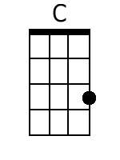  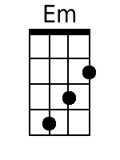  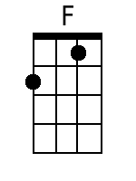  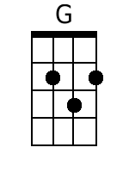  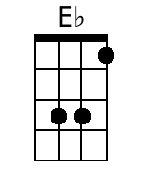  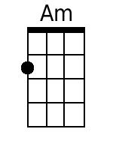  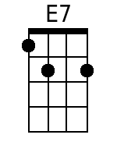  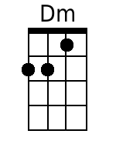  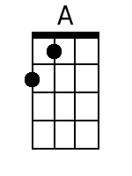 | Intro: C . Em . F . G . C . Em . F . G .  C . Em . F . G . C . Em . F .  Trees--------- swaying in the sum--- mer breeze---  G . C . Em . F . G . C .  Showing off their sil--- ver leaves--- as we walk by-----  Em . F . G . C . Em . F .  Soft------ kisses on a sum-mer's day---------  G . C . Em . F .  Laughing all our cares--- a- way----  G . C . Em . F . G .  Just you and I----------  C . Em . F . G . C . Em . F .  Swee------eet-- sleepy warmth of sum-mer nights-----  G . C . Em .  Gazing at the distant--- lights-  F . G . C . E♭ . F . C . . .  --- In the star ry sky------------  Bridge:  F . . . G . . . C . . . Am . . .  They say that all good things must end - some day---  F . . . G . . . Am / // Am / //  Au------ tumn leaves must fall-------------------  --- C . . . E7 . . .  But don't you know that it hurts me so-----  Am . . . Em . Dm .  To say good-bye to you--u--u--u---  Am . . . G . . .  Wish you didn't have to go------  Am . . . G . .  -- No, no-no--- no---------  . C . Em .  And when the rain--------------  F . G . C . Em . F .  -------- beats a-gainst my win--- dow pane---------  G . C . Em .  I'll think of summer days--- a-gain-----  F . G . C . Em . F . G  --- and dream of you---------------  Repeat From Bridge  . G . C . Em . F . G . A  And dream of you ------------------------ | Bari  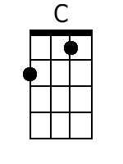  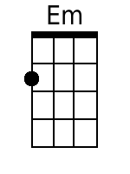  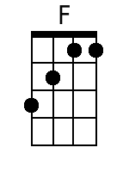  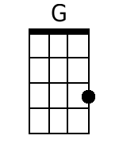  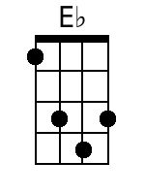  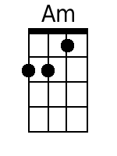  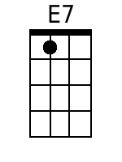  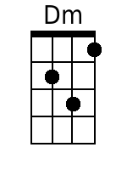  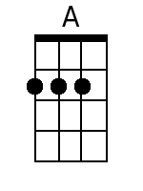

A Summer Song
Words and Music: Chad Stuart, Clive Metcalfe, & Keith Noble, 1964.
Recorded by Chad & Jeremy (Chad Stuart & Jeremy Clyde)
YouTube: https://www.youtube.com/watch?v=_D2XD341xHo
Key of F

GCEA  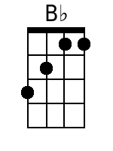  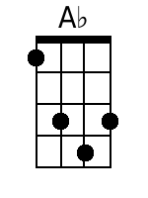  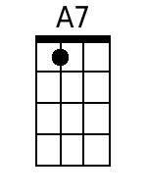  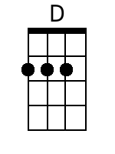  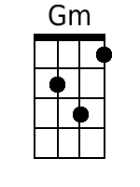 | Intro: F . Am . B♭ . C . F . Am . B♭ . C .  F . Am . B♭ . C . F . Am . B♭ .  Trees--------- swaying in the sum--- mer breeze---  C . F . Am . B♭ . C . F .  Showing off their sil--- ver leaves--- as we walk by-----  Am . B♭ . C . F . Am . B♭ .  Soft------ kisses on a sum-mer's day---------  C . F . Am . B♭ .  Laughing all our cares--- a- way----  C . F . Am . B♭ . C .  Just you and I----------  F . Am . B♭ . C . F . Am . B♭ .  Swee------eet-- sleepy warmth of sum-mer nights-----  C . F . Am .  Gazing at the distant--- lights-  B♭ . C . F . A♭ . B♭ . F . . .  --- In the star ry sky------------  Bridge:  B♭ . . . C . . . F . . . Dm . . .  They say that all good things must end -- some day--  B♭ . . . C . . . Dm / // Dm / //  Au------ tumn leaves must fall-------------------  --- F . . . A7 . . .  But don't you know that it hurts me so-----  Dm . . . Am . Gm .  To say good-bye to you--u--u--u---  Dm . . . C . . .  Wish you didn't have to go------  Dm . . . C . .  -- No, no-no--- no---------  . F . Am .  And when the rain--------------  B♭ . C . F . Am . B♭ .  -------- beats a-gainst my win--- dow pane---------  C . F . Am .  I'll think of summer days--- a-gain-----  B♭ . C . F . Am . B♭ . C  --- and dream of you---------------  Repeat From Bridge  . C . F . Am . B♭ . C . D  And dream of you ------------------------ | Bari  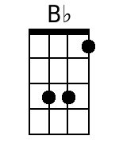  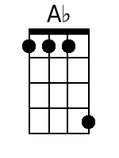  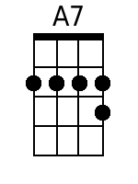  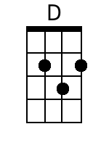  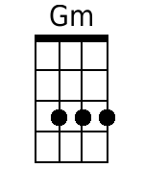

A Summer Song
Words and Music: Chad Stuart, Clive Metcalfe, & Keith Noble, 1964.
Recorded by Chad & Jeremy (Chad Stuart & Jeremy Clyde)
YouTube: https://www.youtube.com/watch?v=_D2XD341xHo
Key of G

GCEA  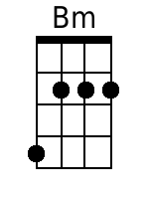  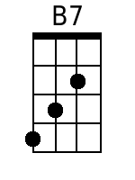  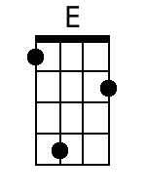 | Introduction: G . Bm . C . D . G . Bm . C . D .  G . Bm . C . D . G . Bm . C .  Trees--------- swaying in the sum--- mer breeze---  D . G . Bm . C . D . G .  Showing off their sil--- ver leaves--- as we walk by-----  Bm . C . D . G . Bm . C .  Soft------ kisses on a sum-mer's day---------  D . G . Bm . C .  Laughing all our cares--- a- way----  D . G . Bm . C . D .  Just you and I----------  G . Bm . C . D . G . Bm . C .  Swee------eet-- sleepy warmth of sum-mer nights-----  D . G . Bm .  Gazing at the distant--- lights-  C . D . G . B♭ . C . G . . .  --- In the star ry sky------------  Bridge:  C . . . D . . . G . . . Em . . .  They say that all good things must end - some day---  C . . . D . . . Em \ \\ Em \ \\  Au------ tumn leaves must fall-------------------  --- G . . . B7 . . .  But don't you know that it hurts me so-----  Em . . . Bm . Am .  To say good-bye to you--u--u--u---  Em . . . D . . .  Wish you didn't have to go------  Em . . . D . .  -- No, no-no--- no---------  . G . Bm .  And when the rain--------------  C . D . G . Bm . C .  -------- beats a-gainst my win--- dow pane---------  D . G . Bm .  I'll think of summer days--- a-gain-----  C . D . G . Bm . C . D  --- and dream of you---------------  Repeat From Bridge  . D . G . Bm . C . D . E  And dream of you ------------------------ | Bari  