A Teenager in Love (Doc Pomus and Mort Shuman, 1959) (C)
A Teenager in Love by Dion and The Belmonts (1959) (C#) (capo on fret 1)
4/4 Time – Tempo = 79 BPM

Intro (Chords of First line)  C Am F G7 C Am F G7  Oooooo..oooo..wah-oooo..oooo.. Oooooo..oooo..wah-oooo..oooo..  C Am F G7  Each time we have a quarrel, it almost breaks my heart,  C Am F G7  Cause I am so afraid that we will have to part.  Chorus 1  C Am F G7  Each night I ask .. the stars up a-bove:  C Am F G7///  _ “Why must I be a teen-ager in love?”  C Am F G7  One day I feel so happy, next day I feel so sad  C Am F G7  I guess I'll learn to take, the good with the bad.  Chorus 2  C Am F G7  Each night I ask the stars up a-bove  C Am F C7///  _ “Why must I be a teen-ager in love?”  Bridge  F G7 F G7  I cried a tear, for nobody but you.  F G7 F G7  I'll be a lonely one if you should say were through.  C Am F G7  Well if you want to make me cry, that won't be hard to do  C Am F G7  And if you say goodbye, I'll still go on loving you.  Repeat from Chorus 2.  Chorus 1  Outro  C Am F G - G7  _ “Why must I be a teen-ager in love?” (3x. End on G) | 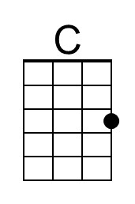 | 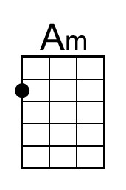
 | 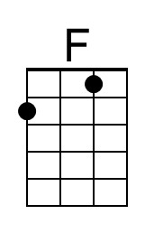 | 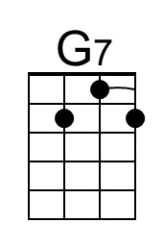
 | 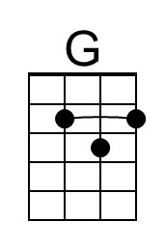
 | Bari
 | 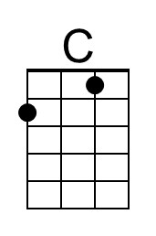 | 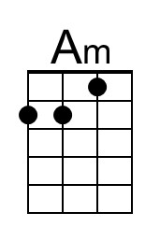
 | 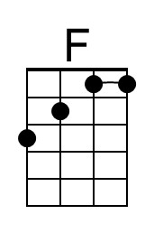 | 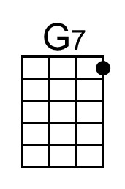
 | 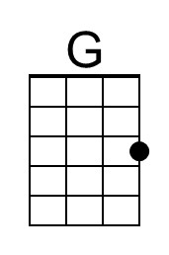

A Teenager in Love (Doc Pomus and Mort Shuman, 1959) (G)
A Teenager in Love by Dion and The Belmonts (1959) (C#)
4/4 Time – Tempo = 79 BPM

Intro (Chords of First line)  G Em C D7 G Em C D7  Oooooo..oooo..wah-oooo..oooo.. Oooooo..oooo..wah-oooo..oooo..  G Em C D7  Each time we have a quarrel, it almost breaks my heart,  G Em C D7  Cause I am so afraid that we will have to part.  Chorus 1  G Em C D7  Each night I ask .. the stars up a-bove:  G Em C D7///  _ “Why must I be a teen-ager in love?”  G Em C D7  One day I feel so happy. next day I feel so sad  G Em C D7  I guess I'll learn to take. the good with the bad.  Chorus 2  G Em C D7  Each night I ask the stars up a-bove  G Em C G7///  _ “Why must I be a teen-ager in love?”  Bridge  C D7 C D7  I cried a tear, for nobody but you.  C D7 C D7  I'll be a lonely one if you should say were through.  G Em C D7  Well if you want to make me cry, that won't be hard to do  G Em C D7  And if you say goodbye, I'll still go on loving you.  Repeat from Chorus 2  Chorus 1  Outro  G Em C D - D7  _ “Why must I be a teen-ager in love?” (3x. End on D) |  | 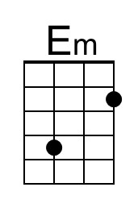
 |  | 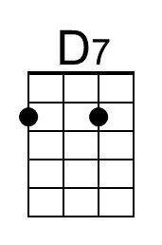
 | 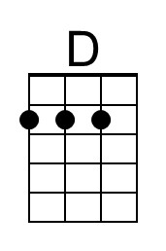
 | Bari
 |  | 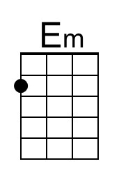
 |  | 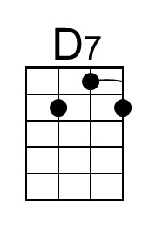
 | 