Bari Uke  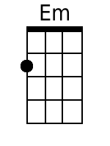  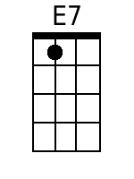  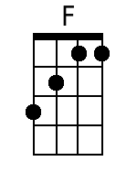  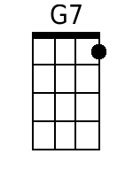  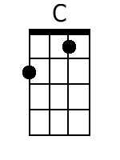  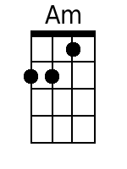  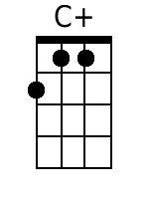  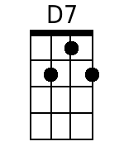 | A Travelin' Man  Authors: Scott Turner and Harry Nilsson, 1963.  Key of C. “Slowly, with expression.” 3/4 time. Baritone Ukulele  Recorded by The New Christy Minstrels on their 1963 album Ramblin'  4 Measure Intro (Last Line of Chorus):  ♫ |Em . E7 |F . . |G7 . .|C . |  Chorus:  C F E7 Am  A travel-in' man always longs for a home,  Em E7 F G7 C  'Cause a travel-in' man is always a-lone.  Last Time Through Add:  C F E7 Am  Yes, a travel-in' man always longs for a home  Em E7 F G7 C - C  'Cause a travel-in' man is always a-lone.  Verse 1:  C F E7 Am  I've traveled from Maine to the Barbary shore,  Em E7 F G7 C  But I'm gettin' so weary, I can't travel no more.  C F E7 Am  I rambled the highways and sailed 'cross the sea,  Em E7 F G7 C  Wond'rin', always wond'rin' where the next stop would be. Chorus.  Bridge:  C E7 F G7 C  Seen the mansions of England, the villas of Rome;  C+ F D7 G7  Each man has his castle, but the road's been my home.  Verse 2:  C F E7 Am  So fair-thee-well ladies, there's none quite so fair,  Em E7 F G7 C  But a travel-in' man has only one prayer:  C F E7 Am  To be just a farmer with a plow and a hoe,  Em E7 F G7 C  In-stead of a drifter with no place to go. Chorus.

